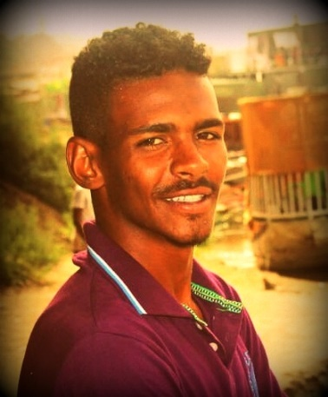Profile
I have a technical diploma from Abdulatif Al_hamad University of technology - Faculty of Engineering - Department of Electrical and Electronic Engineering. I have three years’ experience as a trainee in Al_Ikhlas engineering workshop
And I have the analytical capabilities, technical skills and knowledge required to design electrical applications, commissioning testing and maintenance. As I have an excellent ability to deal with the computer and its applications.

FAISAL MOHAMED HASSAN ALI

Electrical technical
Sex: Male - Date of Birth: 20/09/1995 - Nationality: Sudanese
Address: Sudan, the northern state
-E-mail: faisalskyh@gmail.com
-Tel : 00249129386877
Education & Academic Performance:
D.Sc.  (first class) | Abdulatif al_hamad university of technology, faculty of engineering department of Electrical and Electronic Engineering | 2013-2016
Sudanese Certificate | Merowe Secondary School | MAR 2013
Primary Certificate in | Merowe Primary School | Feb2009
Career Objective:

To expand my knowledge in all fields related to Electrical Engineering and management. Working to raise the level of the organization and achieve its objectives for the good service of citizens and achieve high profit and the development of its systems and maintain its level and development of it.

Training & experience:
- Training:

Sudanese Electric Distribution Company Ltd.(Karima City Department)  Al_Ikhlas engineering workshop |  | 1th may-1thjuly (2016)  (2016 - 2019 )

About Me:
- Leader ship.
- Team working.
- Self-learning.
- Planning skills.
- Communication skills
- experience:
- I have three years’ experience in Al_Ikhlas engineering workshop and I familiar with :
- High voltage electrical networks (33kva).
- Low voltage electrical networks (415v).
- Electrical connections for agricultural projects.
- winding motors

- Skills:
Language | Arabic: (mother tongue), very good in Spoken, Reading & Writing. English: Good in reading, writing .

Design & Analysis Tools | . Familiar with all computer application (MS windows, MS office).

