Curriculum Vitae

Abdalazim Abd alrhman mohmed Ahmed

•Personal Information:
Name: Abdalazim Abd alrhman mohmedAhmed

Date of birth: August 22th, 1980
Marital Status: married
Nationality: Sudanese
Religion: Muslim
Languages known:
- Arabic: Mother tongue
- English: Good
- Address: Khartoum, Sudan Contact:
- E-mail: azimrh27@gmail.com
- Tell:
MTN: (+249)928693270
Zain: 0910719242

•Job Title:
Project manager.

•Educational Qualifications:

- The Degree of Bachelor (Honours) in Civil from sinnar University College of Engineering , Sudan {2007}.

•Work Experience:
- Site engineer in (Dar consultant, animal’s resources bank project)
- Site engineer in (arabesque for contracting company, sinnar state government building project).
- Project managerin (arabesque for contracting company, ministry of interior, office building and police accommodation project- alajazira state, wad madani).
- Project manager in (alosuse alhaditha company, KSA, abha
infra-structure projects).
- Project manager in (alosuse alhaditha company, KSA, abha
infra-structure projects ((extension and connection sanitary pipe lines)).
- Project manager in (alosuse alhaditha company, KSA, abha
infra-structure projects (sewage treatment plant and office building of station).
- Project manager in (arabesque for contracting company, sinnar historical museum project).
- Project manager in (arabesque for contracting company, republican guard offices and housing building)- presidentship.

  •Technical Skills &Courses:
❖ Graduate Affairs Administration, Faculty of engineering, University of Khartoum:
- AutoCAD.
- ETABS &Safe.
- Total Station.

❖ Khartoum Training Center Of Engineers:
Effective Supervision Of The Implementation Of Buildings.
- Microsoft Office Suite.
- Manual estimation of building quantities.

•Personal Qualities:
- Good communications skills.
- Good use of computer.
- Driving (driving license).

•References:

- ENG. Abdalrhim Mohamed Ahmed
Tell: 00249912300695
Khartoum, Sudan

- Mr. Mahmoud Ahmed Khojali
Sudan University of Science and Technology
Faculty of Engineering, School of Civil Engineering
Tell: 00249912327769
Khartoum, Sudan

Some of the executed projects:
*SINNAR HISTORICAL MUSIEM (duration 24 months):
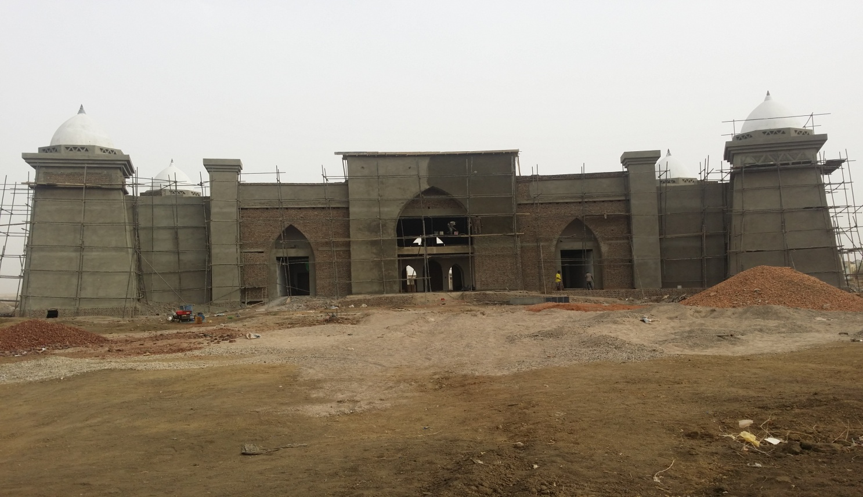

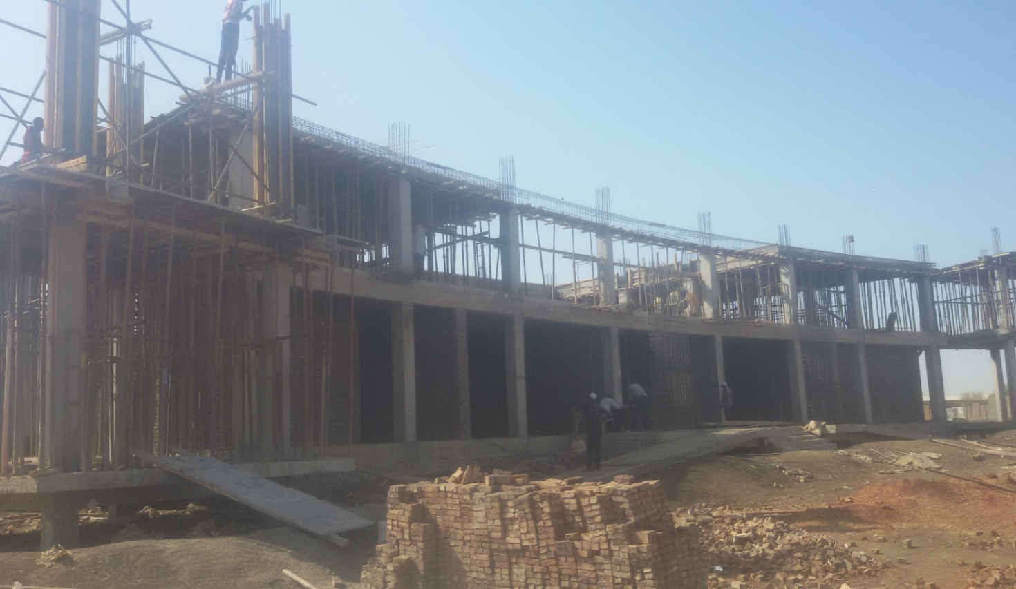
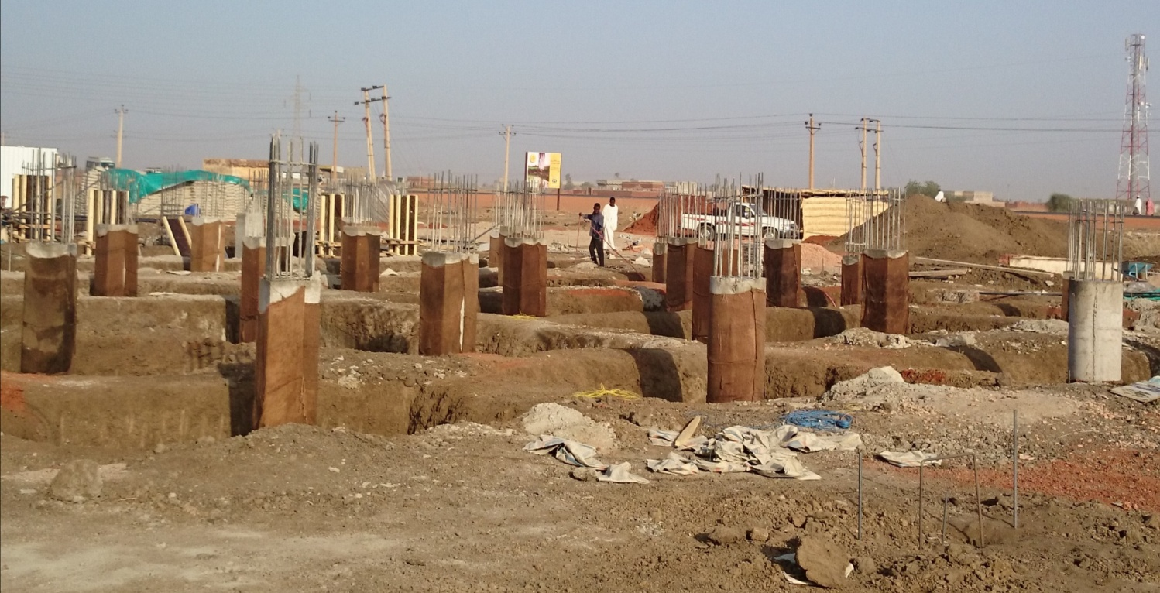

REPUBLICAN GUARD RESIDENCE (duration 6 months):

