Name and Profession: Abdalla Hassan Mohammed Ibrahim, DCS Operator (DCU)
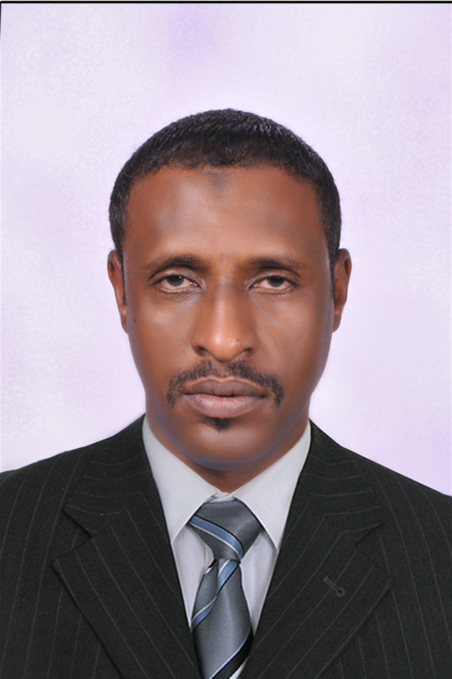
Personal information:
Address: Khartoum Refinery Company Ltd
Cell phone : (+249) 912662775
Home Tel No. (Home): (+249)912146158
Email Address: abdllahassan2014@Gmail.com
Personal profile:
A well-qualified and experienced oil industry professional with a wide knowledge of oil refinery operation. Strong intercultural and communication skills.

Skills:
Strong communication skills; supervisory skills; safety conscious; well acquainted with working with refinery equipment’s; familiar with company regulations & able to work in compliance with them; strong data management and interpretation skills; capability to establish strong coordination across all levels; highly efficient in formulating plants and executing the determined actions; early prediction of problems and deal with them; ability to handle multiple responsibilities at once and ensure its successful execution.
Technical Skills: Strong technical competence in operating the navigation and communication devices.
Computer Skills: Good knowledge of MS; Word and internet.

Work history and experience:
2010 till present: Panel operator, Khartoum Refinery Company. I check instruments in control room from Control Panel to ensure they work properly for the instrument crew. DCS at DCU delayed coke unit include fraction tower ,coke tower, furnace , gas treatment unit LPG sweeting system, amine regenartion system ,gas compressor ,
I am well versed with all the start up operating and shutdown procedures of (centrifugal, reciprocating pumps). I also have the necessary capability in analyzing and troubleshooting pump problems. I am also well versed with all necessary safety procedures to be followed for the safety of equipment and personnel. I have full awareness of the general hazards involved in a refinery as well as procedures to operate various firefighting equipment.
2001 -2010: Operator, Port Sudan Refinery. I worked in different areas as 2001
follows: Crude processing unit; Hydro treated unit; Plat format unit; Water treatment unit; Boiler; Power plant (steamer & diesel); Instrument air Compressor; Fire fighting system; Manual taking; Terminal (crude receiving/draining/transferring). During that period I worked at PODC marine terminal, PETRODAR operating company

2010 till now | DCS at DCU
2008__2010 | Gas treatment and sweeting system
2004----2008 | CDU field operator
2003--2004 | HTU field operator
2002--2003 | Steam turbine field operator
2001--2002 | Boiler field operator

Qualifications:
Higher Secondary (12th) Science).

References:
Available on request

