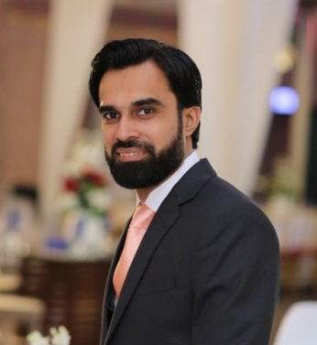
ABDUL WALEED KHAN
H # B-51, Sec 11-B, North Karachi, Karachi
Cell: +92-301-3335120
+92-333-3214744
Home: +92-213-6998799
Email:abdwaleedkhan@hotmail.com
LinkedIn Profile: https://www.linkedin.com/in/abdul-waleed-khan-30a23046/

OBJECTIVE

To obtain a suitable position that will enable me to utilize my technical and management skills for achieving the targets and delivering the best performance in an esteemed organization. I would like to implement my innovative ideas, skills and creativity for completing the projects.

CAREER SUMMARY

More than 7 years of experience as an Electrical Engineer in oil refining plant with major experience in Project construction. I have performed jobs related with design (Earth networks, lighting and cable selection), modifications in the current ongoing system, execution, pre-commissioning, commissioning and maintenance. I possess strong analytical, problem solving, effective communicating and organizational abilities.
EDUCATION

2017 – 2018 Bahria University, Karachi.
MS in Project Management 1st Division
2007 – 2011 NED University Of Engineering and Technology, Karachi.
B.E Electrical Engineering 1st Division
2005 – 2007 Govt. Dehli College, Karachi.
Intermediate A - 1 Grade
2003 – 2005 Ladybird Grammar School, Karachi.
Matriculation A - 1 Grade

CORE COMPETENCIES

- Cost Estimation/Budget Development | - SOPs Development
- Project Planning | - Electrical Testing and Commissioning
- Project Co-ordination | - Troubleshooting

WORK EXPERIENCE

BYCO Petroleum Pakistan limited 120,000 BPD July 2012 to present
Senior Officer, Projects
(Execution department)

- Installation and testing of switchgears (11 KV, 3.3 KV and 415 V).
- Installation, testing, parameters and commissioning of 3.3 KV ABB VFD drive ACS 1000 for Crude Charge Pump and 415 V ABB VFD drive ACS 880 for Furnace Blower motors.
- Relay Installation, testing, configuration and parameter setting with ABB (ABB relays REF542 plus, REF615 and REM615) and Siemens (Siemens relays 7SK60, 7SK80 and 7SJ80) Team.
- Designed heat tracing cable, Luminaries selection, Load calculation and cable selection for various systems.
- Installation and commissioning of Furnace Soot Blower Panel.
- Worked with E&I design section for finalizing of cable schedule, cable layout plan, cable tray layout, lighting lay out & earth layouts.
- Installation of control panels as per lay out, refurbishment of switchgears with relays & CT testing, hi-pot test of bus bar.
- Design review of ABB Switchgears and PEL transformers.
- Trouble shooting and modify drawings (SLD, schematic and logic drawings).
- Testing of transformers open circuit, short circuit, ratio and hi-pot tests.
- Fire Panel Installation, testing and commissioning with smoke detectors and firebreak glass (non-addressable).

PROJECTS

- Construction of Crude Furnace.
- Plat former Unit Electrical Works.
- Modification in firefighting system with installation of new panels.
- Electrification done in new turbine system.
- Electrical design and Execution works at Mehmood Kot Oil terminal (MKT).

TRAININGS

- Power System Protection Training conducted by Siemens Pakistan.
- Fire Fighting Training conducted by BYCO Petroleum Pakistan Ltd.

COMPUTER SKILLS
- MS-Office
- Primavera P6

PERSONAL INFORMATION

- Date of Birth : 18th August, 1990
- Nationality : Pakistani
- CNIC Number : 42101-1852403-7
- PEC Registration # : ELECT/34078
- Language : English (Proficient) / Urdu (Native)

References available upon request

