AYSHA IDRIS ABDELKARIM, CMA, IFRS

Mobile :( +249) 905653670
E-mail:Aysha.Idrise@gmail.com
Passport No. : P03219646

JOB OBJECTIVE
Seeking a challenging position in a professional work environment that will effectively utilize my academic qualifications, professional experience and skills and hence lead to a successful and fulfilling career

WORK EXPERIENCE
Bank of Khartoum since August 2016_Present
- Internal Auditor from 18.08.2016 till 17.10.2019.
- Finance Assistant from 20.10.2019 (On the head of my job).

PROFESSIONAL QUALIFICATION
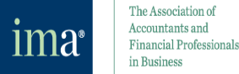
- Certified Management Accountant (CMA) as of December 2018, (CMA Credential Number: 65183)

• International Financial Reporting Standards Diploma (IFRS Holder as of December 2019)

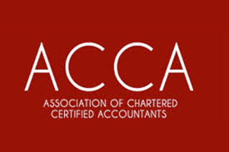
EDUCATION
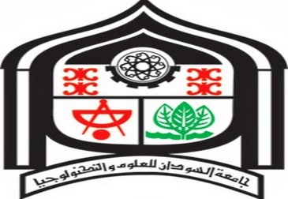
- B.Sc. - Sudan University of Science and Technology, Faculty of Business Banking and Finance specialization.
- Year of graduation: 2015.
- Grade: Second Class – Division One (2.9).

TRAINING COURSES
- Risk Management Basic, Sudan
- Anti Money Laundering, Combating the Financing of Terrorism ( AML /CFT )
- Effective Reports Writing.
- English Language.
- International financial reporting standards (IFRS).

COMPUTER SKILLS
      - Good command of Microsoft office package.

Languages
- Arabic (Mother tongue )
- English (Very good)

