`
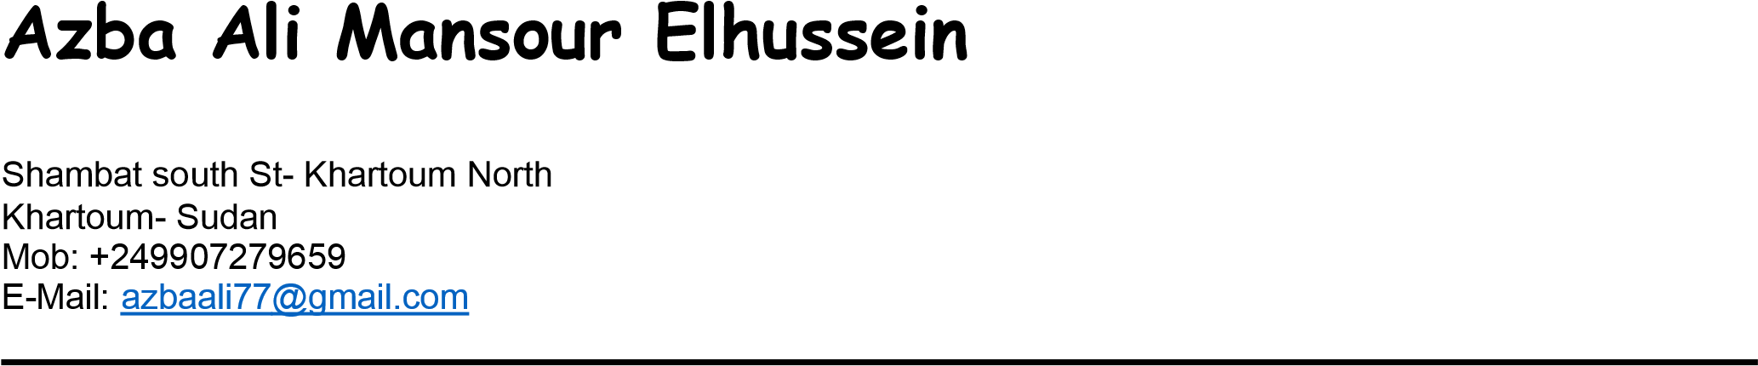

PERSONAL INFORMATION:
Date of Birth:  Gender: | March 15_{th},1995 Female
Marital Status: | Single
Nationality: | Sudanese
Religion: | Muslim
EDUCATION:
2016 Bachelor of Science in Economic and social studies

(Economics and Economic Development)
University of Khartoum - Faculty of Economic and social studies Khartoum – Sudan

TRAINING AND COURSES:

August – November 2019 DAL Food Industries Company Ltd – DAL Food Khartoum –Sudan
Human resourse

Trainee in HR department
HR operations (staffing, training development and employee services) in addition I have good knowledge with HR system

July – August 2019 DAL Food Industries Company Ltd – DAL Food Coolers Sales

Sales Service Admin
- Cooler Department
Trained in
- Daily Operation Report (Daily).
- Daily Make Complain (Daily).
- Daily Spare Parts Report (Daily).
- Capo Maintenance Report (Daily).
- Cola Maintenance Report (Daily).
- Daily Cooling Units Report (Daily).
- Prepare PRs and Prepare Petty Cash.
- Business trip & settlement and following up with the finance.
- Manufacturing New Coolers In The Sage.
- Leaves.
- Casual Payment Report. (Weekly).
- Prepare and calculate the Overtime. (Monthly).
- Prepare the Coolers KPI’s & Incentive.
March – April 2017 DAL Dairy Factory (Capo)
Khartoum– Sudan
Procurement Department:
Trained in:
- Company existing system.
- File management and record system.
- Procurement Documents.
- Purchase order process.
- Writing formal emails and follow up.
- And other tasks

October 2017 – April 2019 British Council (English course)
Levels (intermediate 2, intermediate 3, Upper intermediate 1, Upper intermediate 2 , Upper intermediate 3 , advanced 1 , advanced 2 )

JUN 2017
Hr course Open Universities Australia
Open 2Study
Online based – Australia
Online Course

Trained in:
- The Evolution of People Management.
- Recruitment in the Digital Age.
- Learning and Development in Context.
Performance Management

PERSONAL SKILLS:
.
    - Excellent communication and report writing skills.
    - Friendly, with high ability to work in teams and individually.
    - Highly motivated and initiative character with the will to make differences.
    - Self-motivated with ability to work under high pressure.
    - Have a reputation for being honest and open in everything.
    - Building and maintaining relationships.* Good ability to deal with customers.

LANGUAGE:
    - English: Excellent
    - Arabic: Native

REFERENCES:
  - Contact : Aziza Wagieallah , Senior process analyst at Dal Motors email Azizawagiealla23@hotmail.com Phone :249913700707

