Resume
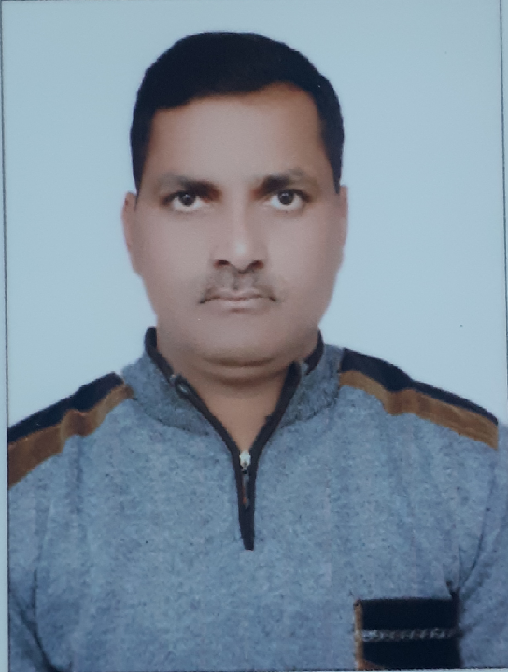
Name | : | Brij Kishore Pathak
Mailing Address | : | Vill- Parewa Kothi
 | : | PO- Kapur Pakari Via Dhaka
 | : | Dist- East Champaran
 | : | Bihar, Pin- 845418
Email ID | : | pathak.brijkishore@gmail.com
Skype ID | : | brijkishore.pathak
Contact Number | : | +918002948562, +917352925837
Passport Details | : | Passport Number-M3153432
Issued On | : | 05-11-2014
Valid Upto | : | 04-11-2024
A. Profile Summery :
Φ Overall 15 years’ experience in Refinery, Oil & Gas, Offshore Projects, Power Plant & Steel Plant.
Φ 2 Years offshore experience in Cairn Energy Raava offshore field.
Φ 8 Years’ experience in Refinery & steel plant Piping Projects (including offshore).
Φ 2 Years’ experience in Power plant projects.
Φ 10 years overall project supervision Experience.
Φ 5 years’ experience in oil & gas operations & maintenance.

B. Responsiblities handled :
Operations & Maintenance Responsibilities:

Φ CNG Processing, operations & maintenance (Nigeria & UAE)
Φ Handled 5 Industrial CNG projects (GIB) in UAE (Project, commissioning, O&M)
Φ Experience in preventive maintenance & troubleshooting in cooling towers, RO system, centrifugal pumps, piston pumps, multistage pumps, valves, reciprocating compressors, dryers, filters etc
Φ Plant maintenance & routine maintenance checks.
Φ Preparation & documentation of daily, weekly, monthly & periodic checklists & history.
Φ Compliance to PTW system. Able to ensure that all HSE procedures are met and maintained.
Φ Maintaining spare parts list & inventory coordination with stores department.
Φ Working Knowledge of Auto Cad. Proficient in MS Word, Excel, Power point.
Φ Completing all duties according to applicable safety measures and published procedures
Φ Daily inspections at each well head including recording flow rates, pressures and temperature data, checking fluid levels, the electrical generator, dryers, compressors inlet & outlet, venting of KODs, cooling tower, safety valves and produce daily reports from the data collected. Report any maintenance requirements.

Φ Attend minor leaks, gland leaks, flange leak, Valve stems cleaning and greasing Small coolers, strainers, filters cleaning etc.
Φ Centrifugal pump repairs & mechanical seal replacement. RO system maintenance & backwash.
Φ Handling compressor & its engine maintenance. Spark plug cleaning, replacement, rocker arm setting, starter motor replacement etc. along with routine maintenance.
Φ Leading team of technicians & helpers by assigning them responsibilities for routine maintenance activities & other tasks.
Φ Operations & Mechanical Maintenance of Gas Plant, , Compressors, Pumps, plant operations, CNG booster station, loading of CNG in CNG skids & storage tanks, Pressure reducing skids etc.
Φ Carrying out preventative maintenance, plant maintenance, overhauling.
Φ Interpreting test plans and procedures.
Φ Consulting with senior colleagues regarding technical issues.
Φ Handling utilities like, fuel gas conditioning unit and instrument air dryer, cooling water system, RO system
Φ Start up, control, monitoring and shut down of gas plant system
Φ Familiar with process flow diagram (PFD) and Piping and instrumentation diagram
Φ Involving emergency response plan
Φ. R Working Experience of electrical & instrument maintenance also.

Project Execution Responsibilities:

Φ. R Project Execution experience in Refinery, Steel Plant & Power Plant & Offshore.
Φ. R Responsible for all aspects of the day-to-day fabrication and erection activities of the project in terms of safety, Quality and in timely manner
Φ. R Attending daily production meetings, sending DPR, arranging TBT, & following safety.
Φ. R Preparing BOQs, MTOs, weekly & monthly plans for work.
Φ. Monitoring the progress and performance of the fabrication & erection Crew in order to ensure the productivity, Quality and standards are maintained.
Φ. R Responsible for carrying out Mechanical Clearance, Conducting Hydro and Pneumatic tests, fulfilling commissioning and Pre-Commissioning requirements for the project.
Φ. R Ensure that hydro test/pneumatic reinstatement is to be done as per procedure
Φ. R Ensure that all punch list items are resolved; client handover is satisfactorily concluded.
Φ. R Coordinating with Engineering and Construction and liaise with the Client on detail engineering requirements.
Φ. Handling all piping technical queries and investigating all field pipe work related problems, including the drawing of field sketches when necessary..
Φ. R Ensure labor force allocated on the job is productively used.
Φ. R Preparations of measurement of work for client billing purpose & store reconciliation.
Φ. R Checking of contractor bill quantities.
Φ. R Pipeline projects in refinery unit piping project, tank farm piping, sleeper piping, rack piping & underground piping.
Φ. R Fabrication of pipe supports, built up beams, columns & purlines & their erection.
Φ. R Structural projects Execution of Turbine House building, ESP, ID & FD Fans, pipe supports, EOT crane rail assembly, Blast Furnace piping & flue ducting.
Φ. R Offshore water separator project, Glycol unit equipment & piping installation Platform Power Pack Crane installation, heat exchanger installation Hydrocycolones installation
Φ. R Jetty Extension Project

C. WorkExperience:
Company | : | Cloud Energi Gas LLC
Position | : | Senior CNG Technician
Site | : | Dubai
Period | : | Aug 2017 To May 2019
Tasks Handled | : | Installation Of CNG PRS Skids, installation of pipelines for supply of gas, its operations & maintenance including gas modules, & field coordination between client & vendor. Electrical & instrument Troubleshooting
Company | : | Sterling Energy Exploration & Production Company
Position | : | CNG Gas Plant Mechanical Operator
Site | : | Kwale, Delta State, Nigeria
Period | : | December 2014 To June 2017
Tasks Handled | : | Jetty Extension project, Installation of crude export pumps, firewater pumps, compressors installation including piping, testing, CNG Plant operations, Onshore Terminal facilities maintenance, Gas Compressor, CNG Transport Pipelines Cooling towers, maintenance, pumps & compressor maintenance
Company | : | Cairn India Limited (C2C Technosoft)
Position | : | Project Engineer
Site | : | Raava Terminal/Raava Offshore, Rajahmundry, A.P.
Period | : | December 2012 to November 2014
Tasks Handled | : | RSGDP project, water separation project, onshore heat exchanger project, etc.
Company | : | M/s Span Erectors Pvt Ltd.
Position | : | Site Supervisor
Site | : | New Blast Furnace Project, SAIL RSP, Rourkela
Client | : | Tata Projects Limited
Period | : | Dec 2011 to :Oct 2012
Projects Handled | : | Blast Furnace 5 Ducting & Piping Work
Company | : | M/s Simplex Infrastructures Ltd.
Position | : | Supervisor
Site | : | Adani Power Ltd., Mundra, Gujarat
Client | : | SEPCO-III (China)
Period | : | October 2009 to Oct 2011
Projects Handled | : | 5X660 MW Power Project turbine house erection, ID & FD Fans
Company | : | M/s Gannon Dunkerley & Co. Ltd.
Position | : | Piping Supervisor
Site | : | Reliance JERP PP, Jamnagar, Gujarat
Client | : | Reliance Petroleum Ltd
Period | : | January 2008 to August 2009
Projects Handled | : | Mega Poly Propylene Unit Piping Fabrication & Erection Work
Company | : | M/s Bridge & Roof Co. (I) Ltd.
Position | : | Supervisor Piping
Site | : | Gandhar Petrochemicals, Dahej
Site |  | Reliance JERP Project, Jamnagar, Gujarat
Period | : | January2006 to January 2008
Projects Handled | : | RTF Piping Work, tank farm piping, sleeper piping
Company | : | M/s Constant Engg. Pvt Ltd.
Position | : | Supervisor Structural
Site | : | Essar Steel Ltd, Hazira, Surat, Gujarat
Client | : | Essar Construction Ltd.
Period | : | May 2003 to December 2005
Projects Handled | : | Structural Works at Module V

D. Educational Qualifications & Professional Certifications :
Φ Diploma In Mechanical Engineering.
Φ Higher Secondary Exam (10+2) under Bihar Intermediate Education Council
Φ Matriculation under Bihar School Examination Board
Φ Personal Survival Techniques (PST) Course for Offshore.
Φ Helicopter Under Water Escape Training (HUET) Course for Offshore.
Φ Basic 1st Aid
Φ Basic Fire Fighting
Φ Hazardous Chemical Transport
Φ ASNT Level II MPT
Φ ASNT Level II DPT
Φ UAE Driving Licen

E. Personal Attributes :
¶ Achievement Orientation
¶ Workalcholalic
¶ Strongly committed to Safety
¶ Capacity to take higher responsibility
¶ Enthusiastic

F. Personal Details :
Fathers Name : Sri Ram Subansh Pathak
Permanent Address : Vill – ParewaKothi, PO – Kapur Pakari, Via Dhaka
Dist – East Champaran, Bihar
Pin – 845418
Ph- +917782809781
Date of Birth : 05-08-1981
Marital Status : Married
Nationality : Indian

Date: Signature:

