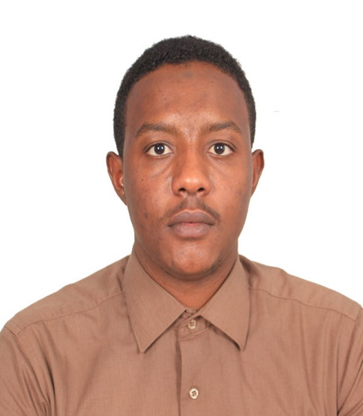 MOHAMED MAYSRA MUSTAFA MODATHER

Personal Bio-Data:
Place & Date of Birth: Sudan – Omrawaba – 09/9/1992
Marital State: Single
Nationality: Sudanese
Address: Sudan -Khartoum – Jabra – Blok No :( 4) House No (209)
Mobile No: +249927580117 - +249960509076
E-mail: mohmaysra.1992@gmail.com
Educational Establishment:
Primary in Al-Qabbass School – Secondary in AL-maaly School
University:
Academy Of Engineering and Medical Sciences
Graduation date: August 2016
Qualifications Academic:
B.Scs. (Honor) In: Electrical engineering (Telecommunication Engineering)
With grade: Second Class-Division Two
Good knowledge in:
Good user of (PC) - Excellent in writing report - Good knowledge in Microsoft Office programs - Leadership skills and individual and collective work - Drive test
Public relations - Call Center - Work under pressure - Initiatives to solve problems and find ideal solutions - Good behavior, ethics and dealing with people - Service Contract – Network design – Router Switch configuration VPN Server.
Languages:
Arabic: mother tongue.
English: good
Training:
* Al Baraka Bank in the Network Technology section. (Jan14 - Mar14)
* Qabbani Company for maintenance of software / Hardware. (Dec14 – Feb2015)
* Sudatel Group department in Institutions and Companies section. (dec15 – Mar16)
Experience:
* National Telecommunications Corporations (NTC): Technical examination officer - Standards Quality of service and frequency section. (Nov16 – May17)
* CM/PM in Shabakat Telecom field (BTS Huawei). (Oct17 – Mar18)
* FUTURE Solution Co .LTD Drive Test PROJECT planning and optimization 2G/3G/4G Use TEMS Tools for Mobile Network Testing. (Apr18 – May19)

