C.V
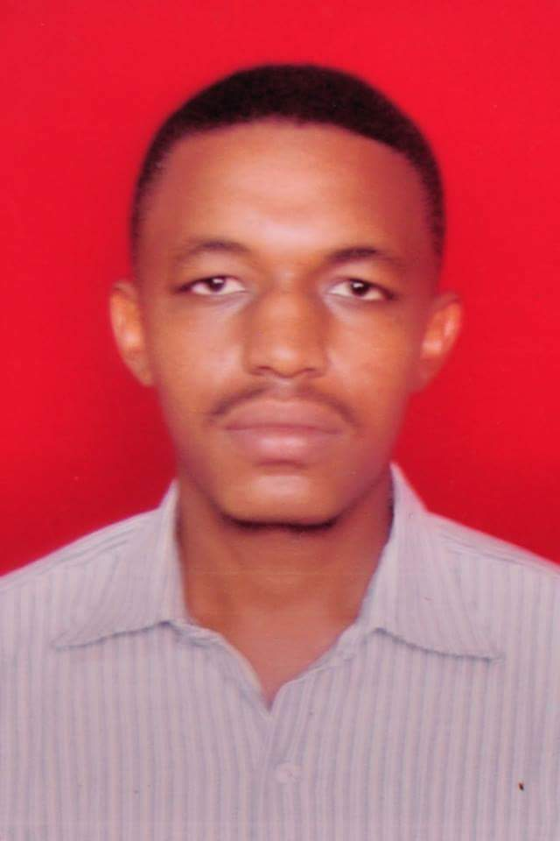

Personal data:

Name: Ghasan Esameldin Ahmed Abdelghani.
Date of birth: 27/2/1993.
Nationality: Sudanes
Address: Omdurman-Sudan-Althawra,zone21-house1164.
Mobile: +249-128078989 - +249912714789
E-mail: ghassan72010@hotmail.com.

Languages:
Arabic (native).
English (modest).
International English Language Testing System (IELTS): Overall band score 5.5

Education and certificates:
- Bachelor of Engineering (Honours) in Nuclear Engineering- Sudan University of Science and Technology (SUST), Khartoum, November-2015.
- A Certificate on basic radiation safety -Radiation Safety Institute(RSI)-Sudan Atomic Energy Commission, March 2012.
- Short training period at the nuclear safety directorate of the Sudan Nuclear and Radiological Regulatory Authority(SNRRA)-July 2017.

