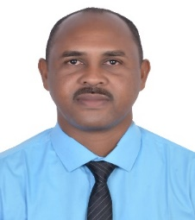
Sudan – Blue Nile- Edamazin.
Email : aelfaki@internationalmedicalcorps.org - moanphil@gmail.com Mobile Phone : 0911692959 - 0917686601
Abdelmoniem Elfaki Mohammed Elfaki

Professional Attributes | - Qualified Bachelor of Science in ( Architecture) from Lyceum-Northwestern University, Philippines.  - To pursue a challenging career in which my belief in the importance of intelligence and creativity, skill and initiative should be put to the best use.
Skills | - Very good in Auto Cad  - Very good in Revit Architecture.  - Excellent in computer skills include MS Office applications.  - Ability to prioritize and plan effectively.  - Flexible and willing to travel.  - Ensuring confidentiality at all times.  - Able to communicate effectively both verbally and writing in English and Arabic language.  - In-depth understanding of the construction industry and able to resolve problems and issues that arise during construction.  - Competent with dealing with letters and emails.  - Ability to work under pressure and with different partners.  - Communication and presentations Skills.
Experience  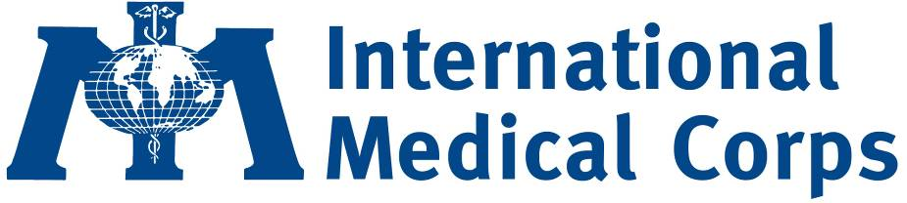  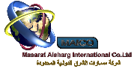  PADCO-AECOM  International Rescue Committee (IRC) | International Medical Corps- Sudan- Blue Nile office as Procurement officer from July-2019 up to now.  Responsibilities:  - Responsible for the perfect implementation of the procurement procedure.  - Organize procurement activities and processes, including preparation and conduct of Request for Quotations, Invitations to Bid or Requests for Proposals, the opening and evaluation of tenders.  - Review and analyze all vendors/suppliers, supply, and price options.  - Ensure that the products and supplies are high quality.  - Creates purchase orders, ensuring relevant procurement procedures have been applied and all supporting documentation is attached.  - Ensuring all invoices received reconcile to purchase orders and created and matching receipts to purchase orders.  - Ensure all documents to be submitted to finance team for payment to vendor on time.  - Coordinate contract negotiations, prepare request for award of contract for the review and approval of relevant authorities, as required.  - Prepare and Delivers the Purchase orders (PO) to the selected suppliers.  - Collects the items from the suppliers. Presents the items to the warehouse officer.  - Collaborates to the redaction of the Weekly and Monthly report providing:  - Entering all PRs in online procurement tracking sheet (PTS).  - Registration of vendors in online system.  - Checking of vendor ID in Bridger insight system (watchlist report).  - Insure the overall online reporting is done in adequate/accurate manner.  Masarat Alsharg International Company- Sudan-Khartoum as site Architect from October-2018 up to June-2019.  Responsibilities:  - Monitor all the construction activities on site and take appropriate actions to deal with the results of delays or emergencies at construction site.  - Supervise all projects activities and make sure they are in line with the contract requirements.  - Liaising with clients and their representatives (architects, engineers and surveyors), including attending regular meetings to keep them informed of progress.  - Overseeing quality control and health and safety matters on site.  - Preparing reports as required.  MC Scotland Organization–Sudan as Construction Engineer from June/2010 up to April/ 2011.  Responsibilities:  - Assist in the development of the bill of quantities (BoQs) in accordance to the rehabilitation needs and the available budget.  - Monitor the rehabilitation and construction work in all respective localities in Blue Nile.  - Oversee the technical quality of the work and adherence to the agreed scope of work and advice the office or Site Manager.  - Checking the quality of rehabilitation materials, before rehabilitation work is commenced or upon request of organization.  - Close monitoring Technical specification of the rehabilitation works.  - Submitted a written report on each monitoring site visit with comments the progress of work, technical quality and recommendations.  - Follow up the agreed work schedule and implementation of the rehabilitation work.  - Assist Organization in any technical discussions with the contactors.  - Support the Site/Office Manager with the information required for preparation of service received notes, payment certificates and completion certificates in payments of the installments to the contractors.  - Assess the availability of local materials in the field and assist the logistic team in procurement of the respective required materials.  - Follow up the transportation of the rehabilitation materials, including the receiving and releasing of items.  - Ensure the waybill, GRNs and GIOs are signed, collected and sent back to office.  - Ensure the safety and security of the rehabilitation materials.  - Ensure the received materials are used for the targeted activities only.  - Assist in the selection of the rehabilitation labor contractors.  - Assist in mobilization the community to provide their contributions.  - Assist the Site/Office Manager in reviewing the final output of the project upon completion and after 30 days and give recommendations.  - Submit final rehabilitation report up on completion of the rehabilitation work for each clinic.  PADCO | AECOM International Sudan USAID Program–Sudan as Construction Engineer from March 2008 up to March 2009.  Responsibilities:  - Assist in the development of the bill of quantities (BoQs) in accordance to the rehabilitation needs and the available budget.  - Monitor the rehabilitation and construction work in all respective localities in Blue Nile.  - Oversee the technical quality of the work and adherence to the agreed scope of work and advice the office or Site Manager.  - Checking the quality of rehabilitation materials, before rehabilitation work is commenced or upon request of organization.  - Close monitoring Technical specification of the rehabilitation works.  - Submitted a written report on each monitoring site visit with comments the progress of work, technical quality and recommendations.  - Follow up the agreed work schedule and implementation of the rehabilitation work.  - Assist Organization in any technical discussions with the contactors.  - Support the Site/Office Manager with the information required for preparation of service received notes, payment certificates and completion certificates in payments of the installments to the contractors.  - Assess the availability of local materials in the field and assist the logistic team in procurement of the respective required materials.  - Follow up the transportation of the rehabilitation materials, including the receiving and releasing of items.  - Ensure the waybill, GRNs and GIOs are signed, collected and sent back to office.  - Ensure the safety and security of the rehabilitation materials.  - Ensure the received materials are used for the targeted activities only.  - Assist in the selection of the rehabilitation labor contractors.  - Assist in mobilization the community to provide their contributions.  - Assist the Site/Office Manager in reviewing the final output of the project upon completion and after 30 days and give recommendations.  - Submit final rehabilitation report up on completion of the rehabilitation work for each clinic.  International Rescue Committee (IRC)-Sudan –Blue Nile office as Water and Sanitation Officer from August-2007 to February-2008.  Responsibilities:  - Supervise and monitor the implementation of water and sanitation projects (hand pumps, latrines).  - Build the capacity and competence of Public Health and WASH committees.  - Initiate the implementation process as advised by the office.  - Review performance, monitor development and evaluate approaches adopted by partners in water, sanitation and hygiene promotion.  - Review on a regular basis the quantity and quality of water and sanitation services offered in local communities.  - Prepare monthly and weekly reporting on progress of the project implementation as well as field visit report.  - Act as a focal point on water, sanitation and hygiene promotion issues within NGOs and liaise with UN related agencies and governmental and nongovernmental counterparts.
Education | - Lyceum-Northwestern University-college of Architecture - Philippines.  Bachelor of Science in Architecture- November 2015  - Sudan University of Science & Technology-college of Engineering.  Diploma in Architecture (three years) - January 2002
Others:
- Familiar with Radio communication.
- Sudanese driving license (Valid).
References:
- Yousif Mohamed Haroun – Site Manager- IMC-Sudan.
E-mail: ymohammed@InternationalMedicalCorps.org.
Phone No: 00249912137427.
- Mohamed Abdelnour – Logistic Officer.
Mobile NO: +249917686601.
- E-mail: mabdelgadir@InternationalMedicalCorps.org.
Kurmuk87@hotmail.com

