Raghda Adel Aburai Elhassan
0997021440/ raghdaaburai@gmail.com
Personal information:-
- Name:- Raghda Adel Aburai Elhassan
- Date/Place of birth: - 1/9/1997. Bahri, Khartoum,Sudan.
- Nationality:- Sudanese
- Marital Status:- Single
- Languages:- Arabic ( Native speaker)
English (operational level)
- Contact Details:-
- Address:- Khartoum, Bahri, Shambat , square 17, house number 100.
- Mobile number :- 0997021440 /0904667376
- Email: -raghdaaburai@gmail.com

Qualification:-
Bachelor of pharmacy, University of Khartoum, from (22/9/2013 – 28/8/2018) First honor.

Courses and Training:-
- Training on Zydus Cadila (Salmawit ) Company on October 2018, Khartoum Sudan.
- Pharmaceutical marketing course on S.K.I center on September 2018, Khartoum Sudan.
Course contents: - Preparation for the Medical Representative job. Time Management and Communication/ Presentation skills.
- Community pharmacy training on Alameed pharmacy on December 2018, Khartoum, Sudan.
- Community pharmacy training on Alhilali Pharmacy on September 2017, Khartoum, Sudan.
- Individual Strategic Planning course on university of Khartoum faculty of pharmacy Licensed by Better Life Center on May 2014, Khartoum Sudan.
- First Aid Training on university of Khartoum faculty of nursing on June 2015, Khartoum Sudan.

Work experience:-
- Work on Avalon Pharma company on October 2019.
- Work on Rekaz pharmacy (Community Pharmacy) on September 2019.
- Work on Provita Medical company on February 2019.
- Work on Butterfly pharmacy on January 2019.
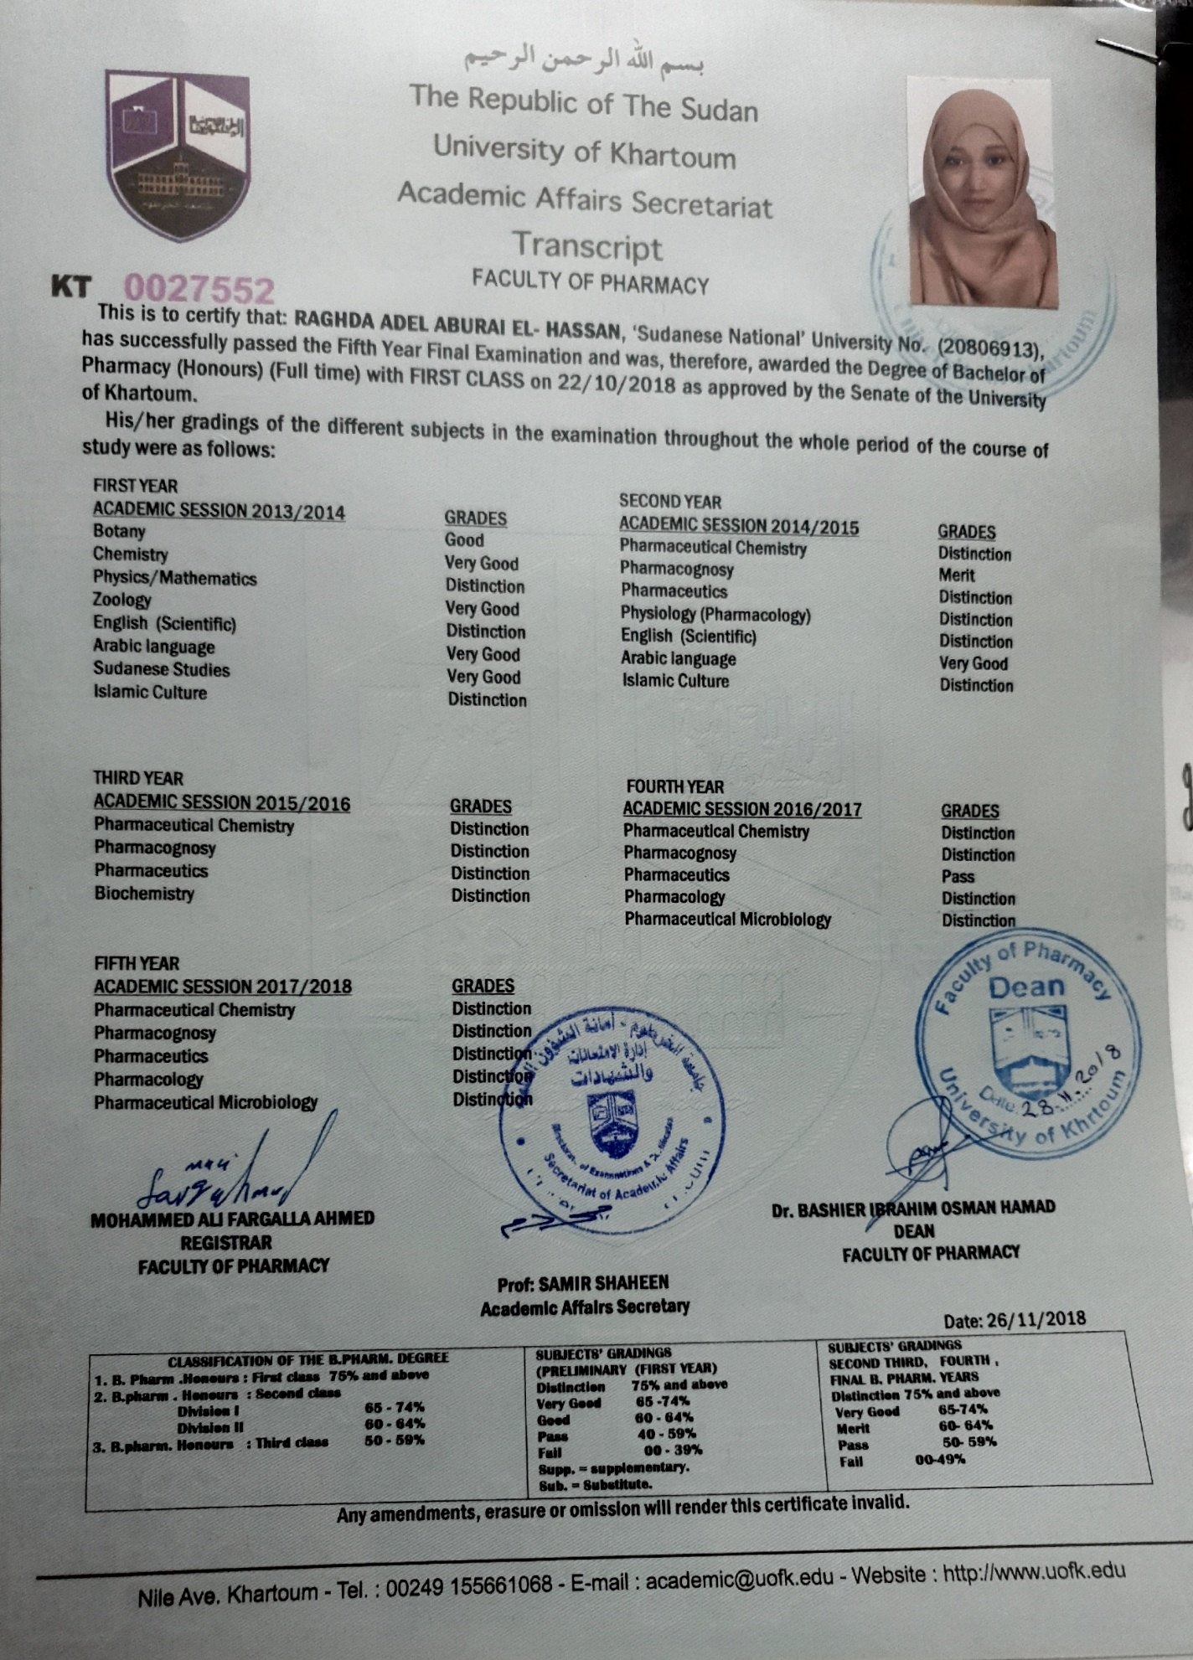
20
