C.V

 | Adil Awad Rahmat Alla Abd Elrahim  Sudan - Khartoum – Omdurman- AL Morada S.  Mobile : +249922224455 | +249116224455 | +249922131614  E- mail : Adel.awad84@gmail.com | 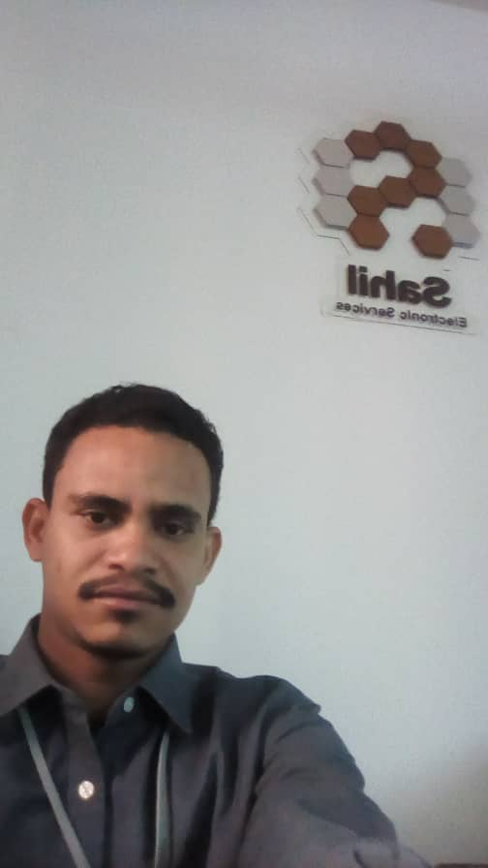
 | Personal Information
- Nationality : Sudanese
- Gender : Male
- Date of Birth : 30th June 1984
- Place of Birth : Omdurman –AL Morada.
- Marital status : Married
- Religion : Muslim

 | Academic Qualification
Diploma (3years)
Department of Electrical Engineering
Faculty of Technology and Human Development
Sudan University of Science & Technology.(SUST)
Graduation Year : January 2007
 | Training Courses & Skills
- Training at the National Electrical Corporation in Granfil station – Omdurman where it was in :
- Medium Voltage Underground Maintenance.
- Medium Voltage overhead Line
- Emergency Maintenance.
- Practical experience in computer Software (word, Excel, etc…) from 28/3/2004 To 31/3/2007 within my National service duty at Army Corps of Engineers :
- Computer Support Engineer.
- Training in the electrical department in Nile Soft Drinks Bottling Factory ( STIM ) company
- Effectively communicate with internal and external customers at all levels.– Good negotiation skills – Building and maintaining excellent relationships with staff and government offices – Numerate, analytical, attention to detail – Excellent communication skills, both oral and written – Judgment abilities to plan and accomplish goals – Multitask ability- Teamwork – Computer and all office application

 | Experience
- Electrical installation Eng at National Electrical Corporation in the high voltage Tower – White Nile Region.
- POS Terminals & Communication Equipment Engineer & Customer Service Officer at the technical division on the IT department in One Prepay Company from 11/01/2010 to 31/07/2014 .
- Operation supervisor in AlMahfaza – digitelize group from 18/8/2014 to 30/3/2015.
- Field operation Supervisor in Sahil Electronic Service Tawasul Electronic Network Solutions and Elnefeidi Group from 01/04/2015 till now.
 | Languages
- Arabic – Mother tongue
- English

References
- Mustafa M. Agab
Managing Director , One Prepay
Tel : 00249912353907
LinkedIn: https://www.linkedin.com/in/mustafa-mohamed-agab-5b70144a
- Eng. Abdallah Mohammed Saied Edris
General Manager , Sahil Electronic Services
Tel : 00249100221111
Email : abdullah.idris@sahil-net.com

