CONTACT
Address
Alrahma Quarter,El_Obeid,Sudan
Phone
00249919705214
Email
alihassan2024@hotmail.com

PROFIL

Birth Day: July 25,1986
Nationality: Sudanese
Military Service: Exampled
Marital status: Single

CAREER OBJECTIVE
I want to contribute effective in any organization , I am working with I always look forward to enrich my knowledge by counseling with seniors and I want to become valuable and viable part of the organization in my opinion learning process only ends with the end of life honesty dedication and sincerity toward are requisites of successful in life

ALI HASSAN MOHAMED ALI
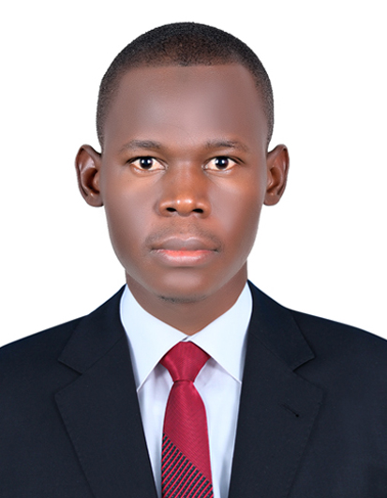
AUTOMATION ENGINEER

ABOUT ME
Over the past eight years, I have worked with several parties, and spent the last five years with the thermal power generating company. During this period, I have acquired deep experience in automation systems by implementing several small and overhaul maintenance projects With the participation of the senior engineers who were my guide gaining knowledge, I have completed many Specialized training programs in instrumentation and control system this helped me to become the chief I&C engineer and I have proven my success in leading the automation team who participated to achieve its overhaul maintenance of steam turbine unit and this in turn has increased my confidence , All these successes are because of I am very ambitious and motivated and I love what I do and challenging myself, I consider myself punctual and always pay attention to details and I am very eager to improve myself.
Technical skills
- Good Knowledge of industrial automation
- I have good experience in Distributed Control System (DCS) system
- I have good experience with PLC, SCADA system based on Siemens
- (F&G) Fire and Gas Alarm System and Emergency Shutdown Systems (ESD)
- Good knowledge of Process instrumentation
- Water treatment process system and Analyzer instrumentation
- Good knowledge of batch process control system
- Good experience of Continuous Emission Monitoring System (CEMS)
- Familiar and conversant with the international standards related to instrumentation engineering (ISA, IEC).
- I have excellent grip of industrial protocols e.g. Modbus, Profibus, OPC Server and well aware of implementation
- • Understanding of process (P&IDS; / PFDS) & engineering drawings and O&M manuals
- Knowledge of maintenance management methods, of predictive inspection tools and of Computer Maintenance Management System(CMMS) based on sedar
- good knowledge of problem solving tools
- good knowledge Project Management
- good knowledge operation Management

WORK EXEPERIENCE
2012 – 2014 Several industry sites
2014 – 2015 Sudanese electricity distribution co. ltd, customer service
January 2015 –To Present Instrumentation & Control Engineer in Sudanese thermal power generating co. steam turbine power plant

EDUCATIONS
2006 – 2011 AL-NEELAIN University, Faculty of Engineering (B.Sc. in Electronic)

Training and Courses
December 2019 Fire Alarm System and firefighting system
November 2018 Substation Automation System (SAS)
October 2018 Distributed Control System (DCS)
July 2017 Certified Automation Professional (CAP) Exam Preparation Course
October 2016 Power Plant Maintenance Course in Harbin Company, China
February 2015 Operation procedure & Troubleshooting of Power Plant & Firefighting System
August 2014 Instrument & Control System in Khartoum Refinery Company (KRC)

Major Responsibilities/Duties:
• Carry out corrective maintenance of a wide range of instrumentation and microprocessor based advanced control systems in power generation plant.
• Perform assigned activities including: routine check, troubleshooting, and instrument calibration in accordance with company quality procedures
• Prepare the technical reports including maintenance troubleshooting, instrumental calibration, material consumables
• Prior preparation for required spare part list for preventive maintenance activities in order to avoid any work delay at the time
soft skills
- Strong performance management skills
- Strong planning, organizing, and integration skills
- Mentoring, coaching and people management skills.
- Decision making and problem solving skills
- Strong interpersonal, relationship building, negotiations, verbal and written communication skills
- Achievement orientation and result oriented skills
- Strong time management skills
- Achievement orientation and result oriented skills
- IT proficiency

I am also fluent in Arabic, and advanced in English, I can also write and understand English fairly well

REFFERNCES

Flow me
Linked in
https://www.linkedin.com/feed/

