Manammal House
Vellangallur Post
Thrissur
Kerala 680 662
India

Phone: +974-30579008

Email: arunmanammal.m@gmail.com

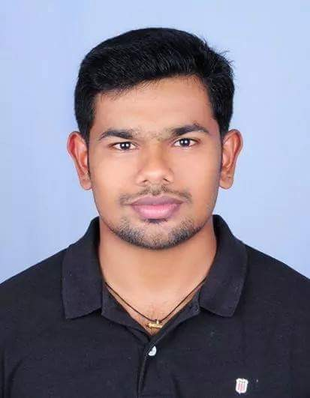
ARUN M

PROFESSIONAL ABRIDGEMENT
I am a firm believer of success through hard work, sincerity and I take immense pride in my work. I believe in individual growth as part of the team and company’s growth I am associated with. I am looking forward for an opportunity which is technically challenging and promising position in a modern, innovative and dynamic organization where I can use my logical and reasoning abilities, technical communication and interpersonal skills effectively which would add value to the prospective operations and contributing effectively towards the success of the organization.
I am highly motivated and optimistic professional, capable of working on own initiative or as a part of a team with excellent analytical and problem solving skills. I sets high standard of quality in any task undertaken and contribute total commitment and dedication to achieve those objectives.

SCHOLASTICS AND PROFESSIONAL AFFILIATIONS
- Secondary School Leaving Certificate from St Marys Higher Secondary School, Irinjalakuda, Thrissur in the year 2009
- Senior Secondary in Commerce from Government Higher Secondary School, Karupadanna in the year 2011
- Bachelor Degree in Commerce from Calicut University in the year 2014
Specialization : Co-Operation
- Master of Business Administration in Finance and HR
( Mahatma Gandhi university in the year 2016 )
- Computer awareness in MS OFFICE

PERSONAL DATA
Name : Arun M
Address : Manammal House,
Vellangallur Post,
Thrissur, Kerala – 680 662
Phone : +974-30579008
Date of Birth : 12th May 1994
Gender : Male
Religion : Hindu
Marital Status : Single
Languages Known : English & Malayalam & Hindi

DECLARATION
I hereby declare that all the information furnished above is true to the best of my knowledge and belief.

` Arun M

