 | CURRICULUM VITAE  Dr. Ahmed Yagoub Mahgoub  (Dentist & Medical Director)  Business Development Manager | 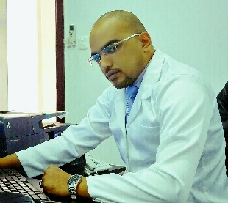

Personal Information:
Name : Ahmed Yagoub Mahgoub
Date of Birth : 1985
Gender : Male
Nationality : Sudanese
Marital Status : married
Language known : Arabic & English Fluent in perfect Command
Contact Mob. :
00212600287111
00966590052677

Education :
- Bachelor of Dental Surgery and Medicine (Honor degree)
National University of Ribat , Khartoum- Sudan 2010.
Experiences:
(Jan 2014 – Jan 2018) Dentist and Executive Medical Director at agsan alelewi medical center , Saudi Arabia.
(Other Experiences (part timer) at Alengaz Multie activities Co. (branch of medical equipment) as Business Development Manager in Medical Equipment , Pharmaceuticals , Cosmetics & operation of hospitals Field , Sudan from May 2008- Jul 2012 Part Timer).

- Responsibilities :
  - Administrational and professional knowledge of Dental restorations , Cosmetics , Orthodontics , Endodontics.
- Responsible of managing and directing of the company staff and activities.
- Generates leads for possible sales and follow up sales activities.
- Conduct extensive markets researches.
- Prepare a detailed business plans and secure sufficient financial resources for the future development and expansion.
- Contact professional advisors and attend workshops, trade shows and seminars to keep updated.
- Recognize strengths, weaknesses, opportunities and threats for strategic planning of the business future.

References:
- Available upon request and can contact 00966590605021

