CV
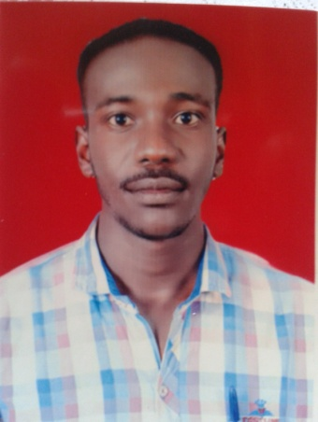
Name:- Khaled Mohammad Abdul Rahman Aldaw
Date of birth:- 9-10-1992
Residence: - Sudan - Khartoum State - Bahri
Marital status: Not married
Phone numbers:- 0928907629-0129158166
Email:- keldaw112@gmail.com
Educational level:-
Dongola University - College of Agricultural Sciences - Department of Agricultural Engineering - Graduation date 2016
Other certificates:-
- Certificate of Administrative Excellence - Khartoum 2012
- Certificate of Capacity Building for Workers in Civil Society Organizations - Northern State - Dongola - 2015
- Training certificate in the workshop of Dal Company 2015
Marketing Course-Khartoum-2016
experience certificate:-
- MTN Subscriber Services Communication Section-2017
-MTN2017-2019 Mobile Cash Division
- Site Supervisor at Asmar Services and Investment Company 2019
- General Supervisor of Asmar Services and Investment Company 2020
- General Supervisor of Technobase Consulting Company (Co-founder of the Environmental Health Department) 2021
Operations Officer at Ghazal Commercial Services Company 2021

