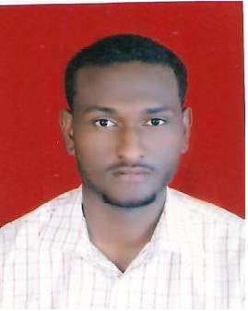

Personal Information

Name | : | Mohamed Salah Mohamed Idres
Mobile | : | +249924410941 - +249968494064.
Email | : | Mohamedd445@gmail.com.
Date of Birth | : | 27.6.1991. Khartoum state - Omdurman.
Driven License | : | Valid.
Language | : | Good verbal, Written English language.  Arabic, mother tongue .
Personal Summary

A competent and organized individual. Able to work as part of a team and manage several priorities at any time. Have positive attitude, strong work ethic and keen desire to learn and grow within affirm, have good knowledge about (CCNA)&(MCSE)tasks. Have extensive experience of working in especially on computer maintenance operating and programming.

Objectives

To a chive the main goal and help to increase the general performance of the organization and share my knowledge , skills and experience with my colleagues.

Qualifications
- B.cs Honors in Communication System Engineering
- (2013).
- University of Science& Technology.
- Khartoum – Sudan.

Courses
- CCNA Network (Certificate).
- MCSA .
- Training in National Telecom Corporation .
- CCTV (Certificate).
- Contac Centre (Zain)

Work experience

- Ministry of labour and administration reform .
(from April till now).in center IT
- One Year Data enter in National Civil Service Bureau.
Skills

- Respect the privacy and confidentiality of information for business and customer.
- Preservation of the integrity and independence in the work.
- Work under pressure, and work in a way that serves the interests of customers.
- PCs setup and maintenance win 7,win 8, win 10 win server :installation & troubleshooting .
- Ms-office 2003,2007, 2010 ,2012 .
- Computer maintenance : software & hardware . Internet , printer.
- Wireless connectivity installation and setup.
- Network installation &maintenance .

