RESUME


ASAD SARFARAZ ALI BASRA
Father Name: Mohammad Sharif Basra
Address: Khanewal road street no 8/D New Naqshband
Colony, Near Islamic Scholar Model School Multan.
Cell #: +92-303-3348177
+92-313-7338321
E-mail: asadbasra47@outlook.com
Nationality: Pakistani
Domicile: Multan/ Punjab
CNIC Number: | 36302-5158644-1
Religion: | Islam
Date of Birth: | 17 November, 1994
Status: | Single
Objective:

To obtain a challenging representative position: where work, ethics and technical knowledge will adapt towards efficient performance and contribute for social development generally for the welfare of the nation.

Qualification:

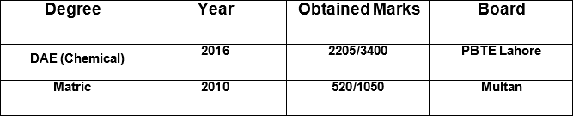

Interpersonal skills:

- Responsible
- Honest, hardworking nature & self-confident.
- Good communication skills
- Ability to work both independent & as a team player.

Professional Experience:

Presently I am working with Ibrahim Fiber Polyester Plant Pvt. Ltd. as a Plant Operator since 15-Jan- 2017.

Sections:

1:- HTM Section.
2:- EGR Section.
3:- MEG Unloading Area.

Key Responsibilities:

- Responsible for safe and smooth plant operation.
- Safe and smooth planned shutdown and startup as and when required.
- Good response during troubleshooting and emergency.
- Responsible for Issuance of Cold, Hot and Confined Space Work Permits for maintenance job and their supervision.
- Maintenance and material quality control safety environment equipment to handle following
  - Pumps Reciprocating Centrifugal.
  - Heat Exchangers double pipe shell tube plate frame.
  - Evaporators.
  - Distillation Column.

Languages known:

- English
- Urdu
- Punjabi

Reference:

Will be furnished on demand

