Dr. Shamsheer Shaik MBBS, MS(ENT)
Flat no. 301, Moksha Enclave, Near HP Gas Godown, Balaji Nagar,
Nellore -524002, AP, India
Mobile: +919908013698
Skype ID: +919908013698
dr.shamsheer.sk@gmail.com

Summary
A devoted ENT Surgeon who has got nearly 8 years of experience in ENT practiced at Narayana medical college hospital, ACSR Government medical college, Nellore & Surakshitha Hospitals, Kurnool, AP, India; which involves diagnosis of patients and their management in ENT diseases including ENT Surgeries and has got a passion for Endoscopic Sinus surgery and Microscopic Ear Surgeries.

Objectives
To join a reputed and growth oriented Health Organization / Hospital in Gulf to challenge my skills and techniques, to work with various types of patients and to enhance my reputation as an excellent ENT specialist.

Academic Qualification
MS(ENT) Kakatiya Medical College Warangal, TS, India
(2010 - 2013)
M B B S Deccan college of medical sciences Hyderabad, TS, India
(2002 - 2008) (Dr.NTR University of health sciences, Vijayawada)

Medical Registration

Andhra Pradesh medical council Reg. no.60370 Vijayawada, AP, India
HAAD / DHA -Dataflow PSV Verification completed & Positive

Professional Experience
1st July 2018 – Till date : Assistant Professor ENT - Narayana Medical College, Nellore, AP, India
(Consultant ENT surgeon in a renowned medical college hospital in Nellore where I see ENT outpatients and inpatients and manage all types of ENT emergencies and perform advanced ENT and Head & Neck Surgeries and also teach Undergraduates and post graduates of ENT)

10th August 2016 - 30th June 2018 : Senior Resident ENT - Narayana Medical College, Nellore, AP, India
(Senior Resident in ENT department in a renowned medical college hospital in Nellore where I see ENT outpatients and inpatients and got trained in Endoscopic sinus surgery Microscopic ear surgeries, MicroLaryngeal Surgeries, etc.)

20th July 2015 – 19th July 2016 : Senior Resident in ENT - ACSR Government Medical College, Nellore, AP, India
(Senior resident in a renowned hospital in Nellore where I was looking after patients with various types of ENT diseases and was trained in all basic ENT surgeries)

7th July 2013 - 7th July 2015 : Consultant ENT Specialist - Surakshitha Hospitals, Kurnool, AP, India
(Fulltime ENT specialist looking after out-patients and In-patients)

2nd May 2010 – 1st May 2013 : Resident Postgraduate Trainee in ENT - Kakatiya Medical College, Warangal, Telangana, AP, India
(Postgraduate training in ENT in a renowned institute in warangal, where I was
trained under great ENT Professors in the day to day management of patients with ENT
diseases including ENT emergencies and ENT Surgeries )

Academic Excellance
- Got 2nd place in Temporal bone dissection workshop at SouthZone ENT Research Centre, Villupuram, Tamilnadu, India
- Attended many conferences, workshops and cadaver dissections.
- Member of Association of Otolaryngologists of India -AP and Hyderabad Branch
- Member of Indian Society of Otology

Research Activities
Scientific Paper Publication - HOARSENESS OF VOICE : A RETROSPECTIVE STUDY OF 251 CASES – INTERNATIONAL JOURNAL OF ADVANCED RESEARCH (Feb.2016, Volume : 4, Issue : 2) http://www.journalijar.com

Strengths and Skills

- Excellent theoretical knowledge and quick learner.
- Extremely motivated towards career.
- Excellent skills in computer applications.
- Excellent Communication skills (Verbal) to help patients during treatment.
- Ability to handle different types of patients in critical situations.

Personal Details
Date of Birth : 01-02-1983
Marital Status : Married
Spouse : Specialist (MD -Dermatology) with more than 5 years of experience
Children : Two ( 1 Boy and 1 Girl )
Languages known : English, Urdu, Hindi, Telugu
Passport details :
Number : R3020374
Date of Issue : 04-08-2017
Date of Expiry : 03-08-2027

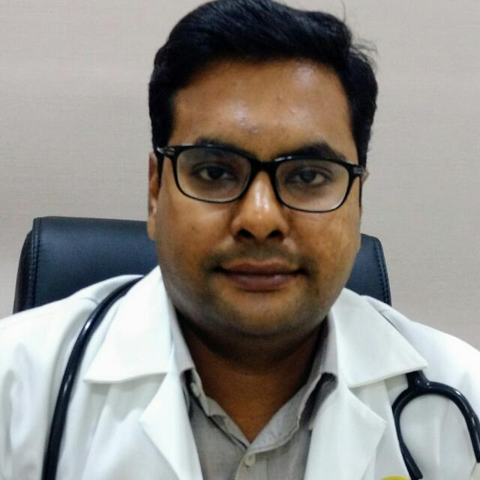
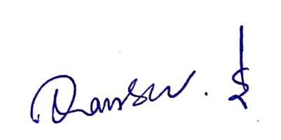 (Dr. Shamsheer Shaik)

