Field Operator-Ethylene

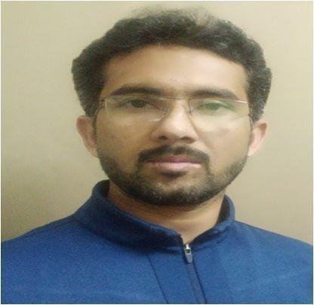
FATEEH ULLAH
E-Mail : fateehkhan@yahoo.com
Skype Id: fateehmughal757
What’s app: +92-334-7251757

CAREER OBJECTIVE:

Ambitious to become a part of a multinational company and grow with a team of professionals, allowing me to develop an insight to understand, discriminate and adapt new technologies.

Experience: 11 year

COMMISSIONING EXPERIENCE

I have worked as commissioning / Pre- Commissioning team member of following units
Sour gas treatment unit (DEA System for H₂S Removal) of Attock Oil Refinery Ltd
Sour Water stripping unit of Attock Oil Refinery Ltd
Sulfur Recovery Unit (Pre- Commissioning)
Amine treating unit (MDEA system for CO2 removal) at Ammonia plant of Pak-American fertilizer ltd
RESPONSIBILITIES

To supervise all the pre-commissioning and commissioning activities of AMU, SWU
Maintaining a complete record of all commissioning activities
Confirmation of all instruments and valves according to P & ID
Checking & verifying unit piping according to P & ID and as per HEC Specs.
To provide technical support and advice on commissioning activities
To support punch list activities and equipment’s internal inspection activities

ATTOCK REFINERY LIMITED (ARL) | Dec2014-Present

I am currently working as FIELD OPERATOR at Amine unit and SWS Unit.
AMINE TREATMENT UNIT:-
H2S Absorption using DEA from Refinery fuel gases, NHT & DHDS Units.
Regeneration & Filtration system using activated charcoal.

SOUR WATER UNIT:-
Refinery Sour water rich in H2S, NH3 & CO2 are treated in sour water stripper. A foul acid gas is routed to sulfur recovery section and treated water to Crude Distillation unit and ETP.

DIESEL HYDRO DE-SULPHURIZER UNIT:-

I have also hand on experience at DHDS unit as field operator
Unit has the capacity of handling diesel 12500 Barrel/day.
To remove sulfur in order to produce Diesel of Euro II Standard Hydro-treating straight run gas oil with 5000 wt ppm sulfur.
UOP as a process licenser and Hyundai engineering as a contractor and DCS is provided by Honeywell.
Unit contain of
Diesel Storage tank Filtration system Hydro-Treater reactor Feed heater with fuel gas firing
Dual fired stripper Re-boiler, Stripper

PAK-AMERICAN FERTILIZER LTD | Dec2008-Dec2014 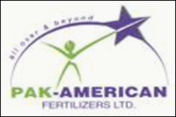

I worked as Process operator at Acid gas removal unit of Ammonia Plant in PAK-AMERICAN FERTILIZER LTD PAKISTAN

Revamp Project
Ammonia Plant Capacity enhanced project was carried out from October 2010 to March 2011.
Ammonia production Capacity increased from 600 MT/D to 750 MT/D. Urea production capacity increases from 1050 MT/D to 1420 MT/D
The revamp involved up gradation from Ben field process to BASF MDEA
The assignment details during revamp are as follow
Steam blowing of lines Solo run test of turbine
Line checking with P&IDs Safe handling of equipments
Chemical cleaning of absorber stripper and LP flash Colum with 3% K2CO3
Chemical handling of K2CO3, V2O5, KNO2, ANTIFOAMING agent, DEA

COMPRESSOR AREA EXPERIENCE

I have also worked as shift operator at Compressor unit of Ammonia plant .unit consist of

Turbo driven NG compressor Turbo driven Air compressor
Turbo driven Refrigerant compressor Vacuum surface condenser
Turbo driven Syn-gas compressor Condensate Recovery system
Lubrication oil console and Control oil console

ACADEMIC QUALIFICATION

2007 DAE Chemical P.B.T.E Lahore
2003 MATRIC Science Sargodha Board

SAFETY TRAINING & CERTIFICATION

Successfully completed H2S Safety Training level-2 by RUTLEDGE SAFETY SERVICES
Fire Fighting & Emergency Response Plan
Fully aware by the use SCBA/ ELSA/full face mask and half face mask.
All types of fire extinguisher and Foam Trolleys
Permit to Work System

SKILLS & INTERESTS

Ability to work under Pressure Good Communication skills
Team Leader Ship Proficient in MS Word
Ms Office

PERSONAL DETAILS

Father name: - Abdul Rasool
Religion: - Muslim
Date of birth: 11 October, 1988
Marital status: Un-Married
NIC No: - 38301-8967568-1
Passport NO: - AL8445682
Permanent address: - P/O kamar Mushani Mohala Tani khel Distt Mianwali Pakistan

