PERSONAL INFORMATION | Mohamedelgazaly Salih Khider Mohamedfadul
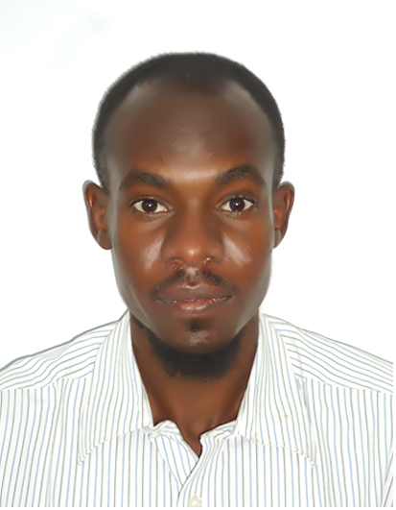 |   Kafory ,Block 3, Khartoum (Sudan) I
 | 249922271696 00249912736918

elgazalysalih2@gmail.com
 | Sex Male | Date of birth 04/12/1990 | Nationality Sudanese

POSITION | Field operator

WORK EXPERIENCE

03/01/2016–up to Now | Operator  In utilities unit
03/01/2016–up to Now | khartoum Refinery Co.Ltd, khartoum (Sudan)
03/01/2016–up to Now | -ability to deal with various equipment professionaly  -Work under high pressure  -work as group  Flxibility

27/12/2013–31/03/2014 | operator
27/12/2013–31/03/2014 | Khartoum Petrochemical Co.Ltd, Khartoum (sudan)
27/12/2013–31/03/2014 | - polymerization & Distillation Operator

27/05/2012–27/06/2012 | Operator
27/05/2012–27/06/2012 | Sudanese Petroleum Products Transport Co.Ltd, khartoum (Sudan)

EDUCATION AND TRAINING

01/01/2013–23/01/2017 | Certificate of Bachelor of technology in petroleum Engineering
01/01/2013–23/01/2017 | Sudan University of Science & Technology, Khartoum (sudan)

01/01/2007–08/12/2010  3/01/2016 – 15/03/2016  3/01/2016 – 15/03/2016 | Certificate of Diploma in Petroleum Engineering
Sudan University of Science & Technology, Khartoum (Sudan)
Certificate of Basic operation course (B.O.C)
Basic DCS Simulator Course
Overhaul training and job during training period
Certificate Of HSE Training Program
Include:
-Basic Safety & Environment Awareness
-Basic Firefighting
-Documents & Records Control
-Work Permit
-Gases Emissions
-First Aid
-Emergency Response
-Accidents Investigation
-Risk Assessment
-Hazards Communication
-Job Saftey Analysis
-Internal Audit
-QMS , EMS & OHSAS Standard

10/11/2012–15/11/2012 | Certificate of Completion (Basic Concepts Of Well Test)
10/11/2012–15/11/2012 | GeoRift Multi Activity Co.Ltd, khartoum (Sudan)

PERSONAL SKILLS

Mother tongue(s) | Arabic
Foreign language(s) | UNDERSTANDING |  | SPEAKING |  | WRITING
Foreign language(s) | Listening | Reading | Spoken interaction | Spoken production
English | B1 | B1 | A1 |  | A2
Levels: A1 and A2: Basic user - B1 and B2: Independent user - C1 and C2: Proficient user
Common European Framework of Reference for Languages

Communication skills | -good communication skills gained through my experince

Driving licence | B

