PROFESSIONAL SUMMARY
My educational back ground as chemical engineer, safety certifications and experience makes me a skilled and career oriented professional. I have the ability to strive under stress and can lead the various tasks at once. I believe on team work for achieving organizational objectives. With technical background, managerial expertise’s and experience in Oil & Gas and Petrochemical industry enables me to lead the Operations and safety team.
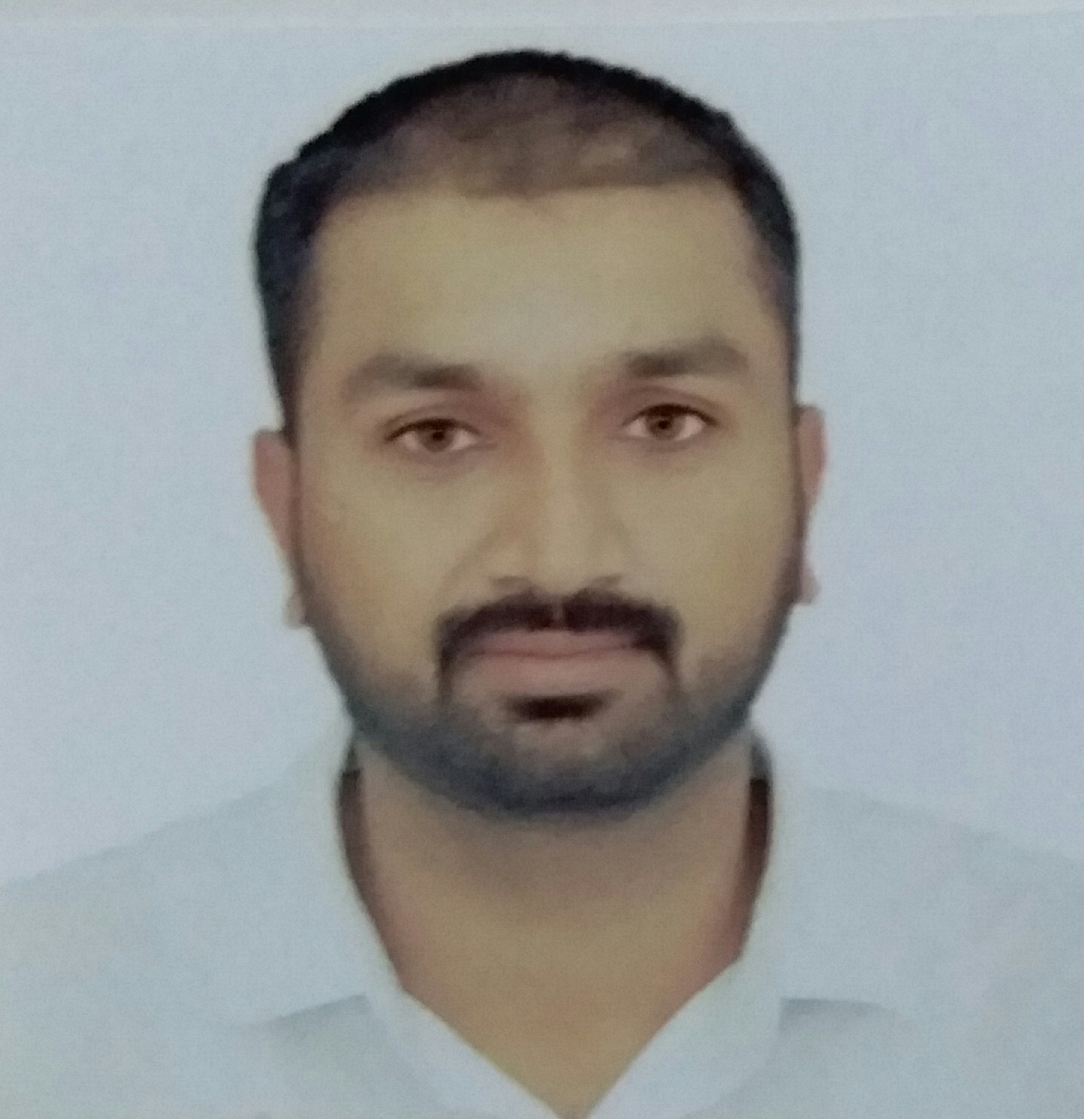
MUHAMMAD HASNAIN AHMAD
CHEMICAL ENGINEER, MBA, NEBOSH & IOSH
Total Experience | 8.5 years
Address | House # N-110, Street # 01, Junejo Town, Karachi, Pakistan
Contact # | +92-333-7479868
Email ID | engineer_hasnain@yahoo.com

National Refinery Limited, Karachi, Pakistan (Jan, 2018- Present)
Operations Engineer (Supervisor)
KEY Responsibilities:
- Supervise the plant operations and equipment as per operating instructions and procedures.
- Supervise all the operational activities for effective, efficient, and safe operation in order to enhance plant reliability and promote health & safety culture.
- Carryout regular field inspections to ensure that safety and hygiene policies and procedures are adhered to.
- Effective communication within the department and between the departments for resolution of issues
- Raised modifications & conduct MOC for operational flexibility and lowering operating cost.
- Ensure the performance of various assigned responsibilities and the conduct of the staff is in accordance with Company policies and procedures.

- Participate in identifying and executing improvement opportunities and action plans based on actual performance.
- Developed and reviewed SOP’s for improvement and safe work

- Participate in risk assessment studies like JSA( Job Safety Analysis)
- Issue work permits and ensure that the plant’s resources are sufficient for meeting operational KPI’s.
- Develop training plans for further improvement and to enhance performance.
- Perform periodic performance appraisals for direct reports
- Supervise critical operational activities such as start-ups and shutdowns, and provide technical guidance.

ENGRO VOPAK/LNG Terminal Limited, Karachi, Pakistan (October, 2014 – Jan, 2018)
Operations Shift Engineer (Supervisor)
KEY Responsibilities:
- Performed MOC, JSA, PSSR, MSA and Incident Investigation of incidents /near-misses
- Directing and supervising firefighting exercises, to train fire-fighting squad for emergencies
- Ensure up keep of firefighting facility of the terminal.
- Maintained SHE system, Emergency Response & Crisis Management and DSCD Manual
- Responsible for a safe, on schedule and trouble-free operation at terminal.
- Supervised the work permit system.
- Provide on the job training, guidance and assistance to workers regarding Operations & SHE
- Attends staff meetings as required i.e. HAZOP, Supervisors and safety committee meeting
- Coordinated with Maintenance, Admin, CRM, and Safety Officer, Cargo surveyors, Customer representatives and Government authorities
- Provided training on MLO to sub-ordinates on Local and VOPAK Global training modules
- Handled ship loading/unloading and tanker loading/unloading operation.
- Lead as Incident Controller (IC-1) and Chaired monthly Safety committee meeting of the shift.
- Developed of shift wise, daily and monthly stock reconciliation reports.
- Took part for Commissioning of Pakistan first LNG project and safely handled RLNG and transfer to SSGC network.
- Reviewed and updated VOPAK and LNG SOP’s.

National Refinery Limited, Karachi, Pakistan (Oct 2011 – Oct 2014)
Operations Engineer (Supervisor)
KEY Responsibilities:
- Responsible for safe, smooth & efficient operation of units
- Monitored and analyzed all unit operations to meet the KPI’S
- Review & check log books, log sheets and suggest corrective actions for resolution of problems.
- Follow up daily & pending jobs and ensure PM of all equipments carried out on time
- Responsible for PTW system and ensuing that all HSEQ procedures are followed.
- Raised modification, P & ID preparation for better performance & operational flexibility
- Suggest Measure for improving operational flexibility, economy and fulfilling of IMS objectives.
- Developed and reviewed SOP’s for improvement and safe work.
- Conducted periodical Appraisal evaluation of foreman, Boardman and area operators.
- Handled startup and shut downs of units.

SKILLS

- Team Player
- Leadership skills
- Operational and interface management
- Safety and operational management
- Managerial skills

ACHIEVEMENTS
- Updated PTW system and introduced new permits at Engro Vopak.
- Carried out Inherent safety survey and implemented recommendations at Engro Vopak.
- Updated and implemented MWR system at Engro Vopak.
- Implemented IMS at Engro LNG terminal and EETL first time certified for ISO-9001, 14001 and OHSAS 18001.
- Accomplishment Award from EVTL CEO for contributions towards record handling of LPG, 226K MT in 2016.
- PX tanker filling enhancement 6-sigma project and saved 03 M PKR of Lotte chemical Pakistan.
- Accomplishment Award from Engro president for contributions towards commissioning of Pak first LNG project
- Won awards on SOR and emergency drills performance at Engro Vopak.
- Remained member of steering committee for IMS at N.R.L, Karachi
- Remained Internal Auditor for oil movement stock inventory audit at N.R.L, Karachi

CERTIFICATIONS
- NEBOSH – IGC
- IOSH (Managing safely)
- Process Safety Management (PSM)
- First Aid Training
- Advance Firefighting Training
- Lean 6-sigma ‘‘yellow belt certification (At Engro Polymer & Chemicals)

SCHOLISTIC
Year | Qualification | Institution | Grades
2018 | MBA (Supply Chain Management) | Preston University, Karachi, Pakistan | 3.1 CGPA
2011 | Chemical Engineering | University of The Punjab Lahore, Pakistan | 3.81 CGPA
2006 | Intermediate (Pre-Engineering) | BISE Bahawalpur, Pakistan | 78.55 %
2002 | Metric (Science) | BISE Bahawalpur, Pakistan | 78.47 %

