CURRICULUM VITAE

SAMER MUSA ALTAIYP KRAMALLA

PERSONAL INFORMATION

Day of birth: 16/1/1987 Nationality :- Sudanese Residence:- Sudan, Khartoum
Marital status: single

CONTACT
+249922288151
+249918316033
samermusa7@yahoo.com

Sudan - Khartoum

LANGUAGE

ARABIC ENGLISH

OBJECTIVE
Seeking opportunities in Oil & Gas sector to utilize my skills and gain further experience while enhancing the company’s productivity and reputation.

EDUCATION
Sudan University of Science and Technology
Diploma Mechanical Engineering Grade
good
2004 – 2007

Bahri Universtiy
Bachelor of Science - BS Mechanical Engineering Grade good
2014 – 2017

WORK EXPERIENCE
Sudan University of Science and Technology
( College Of Technology _ Engineering Studies ) I worked in this department as a technician during the period from February 2008 up to May 2009

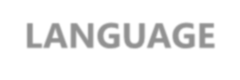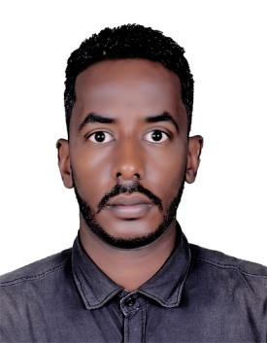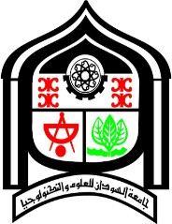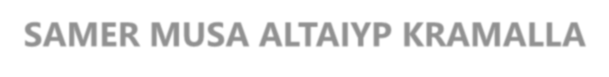

Khartoum Refinery Company LIMITED
Water Treatment Systems ( water supply , cooling water , waste water and water associated with oil ) I worked in this department as a Field Operator the period from 23 November 2012 up to 12 March 2016 .

Sour Water Stripping Unit (remove ammonia (NH3) and hydrogen sulfide (H2S) , Hydrocarbon removal and Condensate water recovery ) I work in this department as a Field Operator the period from 13 March 2016 up to Now . .

Courses
Certified Course in Basic Operation Course at Khartoum Refinery company training center firefighting course at Khartoum refinery company training center

Skills & Endorsements

New Plant Start-up , Shutdown , Data Analysis
Industry Knowledge : Distributed Control System (DCS), Refinery Operations , Troubleshooting , Commissioning
, Analytical Skills

Tools & Technologies :
Microsoft Office , Microsoft Excel
, Microsoft Word Laboratory Information Management System (LIMS)

Other Skills : Operation Monitoring , Fire Investigation , Rotating Equipment , operation , Oil & Gas , safety , Performing routine maintenance

