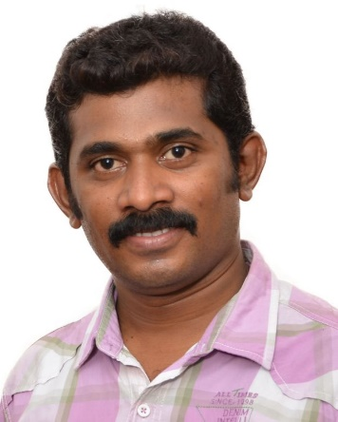
THINAGARAN.M.A.X

: Qatar no +974 74752685 /

India no +91 8870848497.
: thina_68max@yahoo.com

Skype ID: +91 8870848497
LinkedIn ID: https://www.linkedin.com/in/thina-max-a989393b/
BOARD OPERATOR IN GAS REFINERY AND TREATMENT PLANT
Operation / Erection & Commissioning Activities / Vendor Management / Manpower Management / Safety

PROFILE

Result-Oriented Production Operator with significant and progressive experience boosting productivity, enhancing quality standards, Process improvements in a manufacturing setting. Proven track record in motivating team members for continuous process improvements, while strictly adhering to the benchmarks

DCS / Field Operations | Silane gas Refinery / OFF Gas Recovery | EDC / Chloro Alkali Production
Hydrogen / Hydrogen Chloride Handling | Natural gas and Hydrogen Incineration | Pre-commissioning / Commissioning

PROFILE SUMMARY

- Process operator with more than 16 years of rich experience in DCS and Field operations, erection & commissioning, vendor management and manpower management.
- Responsible for complete operations, monitoring and control of distillation columns, strippers, absorbers, fluidized bed reactors, fixed bed reactors, compressors, Pumps, heaters, heat exchangers, incinerator, and storage tanks.
- Expertise at Start up, Shutdown & normal Operation of various units operations including Reactors (Fixed and Fluidized bed), Incinerator, and Continuous Distillation process, Off Gas Recovery, Emergency Vent Scrubber, Tank Farm and Utilities and spearheading the entire operations related to the plant in the absence of Supervisor.
- Trained for Operating Remote fire monitors, foam pourer systems, Fire and Gas monitoring (F&G), Public address and General alarming systems (PA& GA).

SAFETY TRAINING & CERTIFICATION

HAZMAT Hazardous Material Awareness and Operations (NFPA-1072, PRO BOARD)
Incipient Industrial Fire Brigade Member (NFPA-1081, PRO BOARD)
Permit to Work (PTW) / LT & T (LOTO) / Authorized Gas Tester (AGT)

PROFESSIONAL EXPERIENCE


Oct 2017 – Till Date with QATAR FOUNDATION-Qstec Silane gas Refinery,
Recovery, Incineration Plant as an BOARD OPERATOR (2 years as an FIELD
Operation, From Dec 2019 as an BOARD Operation)
Key Result Areas:

- Monitor and Control the DCS (SIEMENS PCS7) / Honeywell, FOXBORO PLC control system to maintain a safe operational plant while supporting production goals.
- Responsible for the operation of the Gas Recovery plant (Filtration, Gas absorption, Azeotrope, Vacuum and Pressure Distillation, HCL drying and Compressing).
- Responsible for the operation of the Incineration Unit.
- Responsible for the operation of the Emergency Vent Gas Scrubbing Unit.
- Responsible for the operation of the H2 recovery and Storage Tank farm.
- Managing Fluidized bed reactor, Silane Refinery Unit, STC Cracker unit and it’s down streams through DCS.
- Supporting Utility operations like Chiller and cooling towers and PSA and Air Compressors, boilers through DCS.
- Performing routine activity & maintain clear log book, shift report, periodic sampling and maintain
Good housekeeping after job complete.
- Contributing to achieve various innovative solutions to avoid repetitive failures & all other problems that adversely affect plant operations including capacity, quality, cost & regulatory compliance issues.

Highlights:

- Led a team of 15 members as well as contractors and subcontractors for activities related to pre-commissioning, commissioning, start-up, stabilization and normal operation.
- Prepare Plant Operating manuals/Shutdown manual, initiated the development of the company system on documentation of major process or equipment breakdown which yield extensive reference(s) for future trouble shooting, minimize problem recurrence and/or reduce downtime during recurrence.
- Performing Plant Safety Operations involving process HAZOP studies, PSSR (pre start-up, safety review), commissioning and decommissioning of process equipment as per Safe Operating Procedures
- Participated Commissioning activities inspection of equipment’s, DCS tags and loops, functional tests of interlocks and raised punch list for graphics corrections and P&ID inconsistencies.


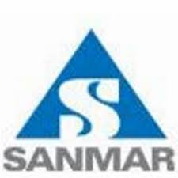
Oct 2003 –Sept 2017 with CHEMPLAST / CABOT SANMAR LIMITED – INDIA as an EXECUTIVE PRODUCTION ( 5 years as an FIELD Operation, 5 years as an BOARD Operation, 3 years as an Shift Supervisor)

Experience in the operation of Ethylene dichloride and Silane refinery and
Gas recovery manufacturing facility.

Key Result Areas:

- Managing production related tasks including planning, procurement, and control &troubleshooting for achieving the planned periodic schedules.
- Joined as Officer Production and promoted to Executive Production.
- Operating and controlling plant for, safe start-ups, emergencies and shutdowns of the EDC Handling Unit, low temperature chlorination reactors, incineration systems and Chloro alkali plant operation.
- Overseeing operations in the Silane Gas Production and Recovery Plant, Chlorosilane, HCl Acid, Chlorine Recovery Plant, Naocl Plant and ETP through DCS and Field study.
- DCS (Delta V-Emerson, YOKOGAWA CS3000), iFix-GE SCADA operations.
- Monitoring storage systems like ethylene, EDC, Hydrogen, Chlorosilane, HCl Acid, Chlorine, and Sodium Hypo Chloride.
- Supervising the man power with assistance of senior technicians for all commissioning and start up support activities for their respective disciplines
- Ensuring that all discipline check sheets requires to be completes after activities detailed on them are completed in the field are checked and submitted to the completions data based on daily basis
- Handover and acceptance procedure and forms for use with system completion data base Involved in Preparing Work plans, preparing punch list, loop diagrams for water flushing, Air flushing, PFD\P&ID review\Control narrative checks, loops& logic checking.

Highlights:

- Supervise tank farm operations, tanker loading and unloading system for all chemical plants.
- Perform HAZOP Studies throughout the Plant units.
- Commissioning and operation of Thermic Fluid and Chiller system, Freon compressors, Nitrogen and Hydrogen compressors.
- Implement SOPs / Quality Systems Documentation work to meet ISO 14001, ISO 9001and ISO 22000, OHSAS 18001, GMP, BSC standards.

Equipment Handled
Vacuum and Pressure Distillations

Incineration and Burner Operations

Reactors (Fixed Bed and fluidised Bed reactors, Agitated reactor and Glass lined reactors)

Vacuum Bagging Machine

ETP and Emergency Vent Scrubbing Systems

Bag Filter, Dryers,

Acid Storage and Handling

PSA Nitrogen generator

Compressors (Reciprocating, Diaphragm
Screw, Lobe type)

Absorbers (Graphite & Packed Towers)

Frick Chiller System

Vent gas Recovery System

Cooling Tower and Liquid N2 Systems

Thermic Fluid Heaters

EDUCATION & PROFESSIONAL DEVELOPMENT

M.Sc. Chemistry
St. Joseph's College, Bharathidasan University, Trichy in 2002.

B.Sc. Chemistry
St. Joseph's College, Bharathidasan University, Trichy in 2000.

DOCUMENTATION TRAINING
Attended training on ISO 9001,14001, OHSAS 18001
Internal Auditor for ISO 22000

OTHER DETAILS:

Civil Status: Married.
Currently stationed at: Qatar.
Willingness to relocate: Anywhere.
Passport Number: N7413587
Time required to relocate / Notice period :2 Months.
Contact phone number(s): Cell: +974 74752685(Qatar), +91 8870848497(India)
Preferred time to be contacted: Morning.
Languages known: Tamil, English.

REFERENCES:

1.Mr. R. Viswanathan, 2. Mr. N. Manikandan,

TCS Supervisor Operations, Technical Engineer,

Qatar Solar Technologies, Cabot Sanmar Limited,

RLIC, Qatar. Mettur, Tamil Nadu, India

Mobile no: + 974 70302907 . Mobile no: +919790382590.

Declaration

I hereby declare that above information is true to best of my knowledge and belief.
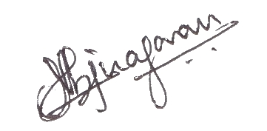

Thinagaran.M.A.X

