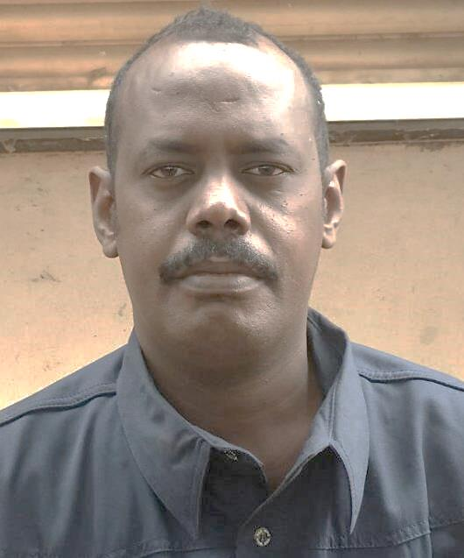

Personal information

Birth Date: 22 july 1975
Gender: Male
Religion: Muslim
Nationality: Sudan
Passport No: P01348969
Marital Status: Married 3 kids
Driving License: Sudan
Call NO: +249912944038
+249123644038
Email Adress: mohdofficial@gmail.com

.

Mohamed Ibrahim Mohamed

Objective

A health safety and environment , mechanical maintenance or training instructor job that suit my education and experience
Summary
17 years of experience in oil and gas industry production maintenance as mechanical technician field base
Able to perform tasks of HSE officer and Mechanical Maintenance in compliance with HSE policy regulations :

Education
Completion of 12 years education followed by 3 years Diploma of mechanical engineering maintenance specialist from Sudan University of science &technology

PROFESSIONAL EXPERIENCE
Oct. 2019 to recent
Senior Mechanical maintenance –TECHNICIAN
Employer: 2B OPERATING PETROLUEM Company Industry: Oil/Gas

Duties included maintenance and repairing activities for Diesel engines types SULZER, etc.
Operation -lined up -Isolation- commissioning-troubleshooting-Diagnose problem-cleaning & draining - all routine checks for:
Pumps (Transfer, recycle, skim pumps & feed pumps) (centrifugal pump/weir & screw pumps, etc);

2015 to SEP 2019
Machinist
Employer: Greater Nile Petroleum Operating Company LTD Company Industry: Oil/Gas

Using hand tools and machine tools to create or modify metal or plastics parts. Set up and operate a variety of machine tools to produce precision parts and instruments. ... May also fabricate and modify parts to make or repair machine tools or maintain industrial machines, applying knowledge of mechanics, shop mathematics, metal properties, layout, and machining procedures.

2003 to SEP 2015
Senior Mechanical maintenance –TECHNICIAN
Employer: Greater Nile Petroleum Operating Company LTD Company Industry: Oil/Gas

  - In June 18, 1997, Greater Nile Petroleum Operating Company Limited (GNPOC) was incorporated to operate as a petroleum company in Sudan. GNPOC is a joint operating company owned by CNPC of China (40%), PETRONAS of Malaysia (30%), ONGC of India (25%) and SUDAPET of Sudan (5%).

Responsibilities:

#-Preventive and corrective maintenance for the static and dynamic mechanical Equipment
Breakdowns; Fabrication
- Hydraulic valves- general fault finding//Pneumatic valves// general fault finding- problem solving// reading engineering drawing// Daily work reports and weekly reports to management beside daily toolbox
# Fault Find and Repair of all mechanical plant equipment
-//Reconditioning of Bornemann , Suluzer , flowserve pumps
- Reconditioning of various types of mechanical seals such as, Flow Serve,Flexi Box.John
General maintenance on Perkins, CAT and Volvo Penta generators.
- Well head Top drives ,changing v-belts, bearings , oil filters and gland packing .Also onsite changing of bearing boxes and polish Rods and complete top drive units..-
Free water knock out drums, do maintenance and internal cleaning and pressure testing after work completion.- Fire heater maintenance.-
Heat exchangers , dismantling, assembling and hydro testing of tube side and shell side.- Alignment of pumps/motors and fin fans.- General maintenance work on air comp such as Atlas Copco.- Daily rigging work with 5 and 20 ton high up cranes.- Weekly temperature and vibration surveys on pumps, motors and compressors,- Support and training of site maintenance staff to assure equipment is being maintained to prevent break down

• Duties included maintenance and repairing activities for Diesel engines types SULZER, etc.
Operation -lined up -Isolation- commissioning-troubleshooting-Diagnose problem-cleaning & draining - all routine checks for:
Pumps (Transfer, recycle, skim pumps & feed pumps) (centrifugal pump/weir & screw pumps, etc);

Quality Management Certifications

- DEC 2017 Integrated QHSE Management System (ISO 9001:2015, ISO 14001:2015 &
ISO 45001:2018) Awareness, Implementation and Internal Audit

- OCT 2018 IRCA Certified ISO 9001:2015 QMS Auditor / Lead Auditor – RICI

HSE Certifications

MAY 2018 IOSH Managing Safely

JUL 2018 NEBOSH International General Certificate in Occupational Health and

Safety – GC3 certified

Jun 2018 Process safety management ( Gnpoc training center )

JUN 2018 Crisis Management, emergency response& contingency planning

SEP 2019 NEBOSH Process Safety Management certified

Technical certification

2018 Technical report writing certification

2007 Screw compressor maintenance and repair (Cairo Egypt)

HSE TRAINING @GNPOC training center (Heglig base camp) &field base within the following

HSE Awareness & Orientation.

Iso 14001

Waste management

HSE Management system

Firefighting training

Risk Assessment (Hazard & Effect Management).

Near Miss & Hazard Identification (Unsafe) Reporting

First Aid. Advance level

Safe Work Permit Awareness.

Safe Work Permit Competency.

Confined Space Entry.

Manual Handling Awareness.

• Hazardous Gas Awareness H2S.
• Electrical hazard.
• Defensive Deriving Course (DDC).
• Environmental Management.
• Oil Spill Control &Cleanup.
• Environmental Impact Assessment.
Environmental Risk Assessment.

Achievements

- Participate and attend Neem FPF construction and commissioning activities 2005
to 2006
- participate with fire team and security to control fire at Heglig base camp block #3 on 2016
- Impalement acid flushing leading the Team at block #4 in-house GNPOC reducing COST of contracting flushing companies With Zero accidents rates record 2012 to 2016
- Impalement hot tapping activities leading the Team performing all hot jobs requests with zero accidents rate 2014 to 2017 included
- Tapping to install auto sampler at CPF &bamboo FPF
- Tapping and modifying TRAY cocks @ Bamboo produced water tank
- Pipeline cleaning scale wax with HCL acid …etc

