PERSONAL INFORMATION |  | MOHAMMED MAIRGHNI MOHAMMED AHMED
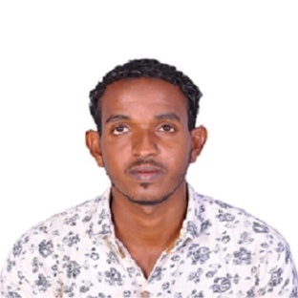 | Housenumber (9), Umbada(4),Khartoum, Sudan.
 | +249927777951 - +249917878087
 | mohammedx1357@hotmail.com
 | Sex Male| Date of birth 9/5/1992| Nationality Sudanese | Marital Status Single.

Objectives | I would like to make use of my educational, professional qualifications and my personal skills to implement a legendary quality service and to lead a challenging career.

EDUCATION | - B.Sc (HONOR DEGREE) In Telecommunication Engineering at Umdorman AL-Ahlia University – Khartoum, Sudan – 2015.  Final year project:  Pico Cell Range Expansion For Performance Enhancement  In LTE Advance  - CCNA Certificate .  - CCNA Security  - CCNP  - CCTV  - Advance System & Network Admin (PC HW, Networking, CCNA, Redhat ,MCSE ,Exchange server ,Wireless Networks, Antivirus Servers, Network Management Tools ,VMware Basic  - MCSE 2016  - LINUX  - Exchange server  - Advance wireless communication(SS7 , Networking ,GSM ,CDMA,GPRS,EDGE,UMTS, VoIP, LTE, VAS, BTS Installation ,OMC-R,RF Planning and TEMS Drive Test and Linux  - Diploma telecommunication( Sudacat Academy)  - Drive Test (DT)  - Integrated Drone Professional Training  - Al-Falah (secondary school).  - Al-Shegla (primary school).
WORK EXPERIENCE

- Training in SUDANI RF department from (30 Oct to 29 Nov 2016).
- Working field maintenance
PERSONAL SKILLS

Mother tongue(s) | Arabic
Other language(s) | UNDERSTANDING |  | SPEAKING |  | WRITING
 | Listening | Reading | Spoken interaction | Spoken production
English | Good | v. good | good | Good | v. good
Student Activities | - Social Secretary of the Association of Telecommunication Engineering students in Future University 2013-2015.  .

Job-related skills | - Excellent oral and written communication skills..  - Good presentation skills.  - Ability to work under pressures  - Excellent reporting skills.  - Ability to manage work priorities efficiently.  - Ability to work effectively and harmoniously with colleagues.  - Excellent analytic skills.  - Excellent on hardware work.

Computer skills | - Computer applications (Microsoft Office, Internet, printer ...etc.  - SYS Administrator  - NET Administrator

 | Interest |  | - BTS installation.  - Microwave handling  - GSM,CDMA,GPRS,EDGE,UMTS, VoIP,LTE  - OFC-R  - RF Planning and TEMs Drive Test  - Hardware maintenance.  - Network installation and configuration  - Linux  - MCSE 2016  - Good on programming languages.  - Good with using MATLAB simulator.

