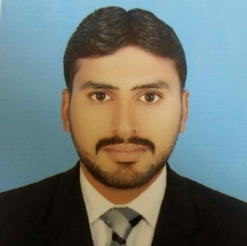

MUHAMMAD USMAN

Address: Muhalla Farooqia Ward no. 9 Tehsil Alipur Distric Muzaffargarh Pakistan.
Cell # +92-303-9880577
Email: musmanjutt577@gmail.com

CAREER OBJECTIVE:

Seeking to establish a career with a progressive company where my ability and performance can have an impact on the company’s productivity.

WORK EXPERIENCE:

Total Experience: 4years
National Refinery Limited

Position had: Officer ( Plant Operator )
Working Since: April, 2016 to Till date
Area Worked on: Crude Distillation Unit (CDU) &MEK Unit.
Equipments worked on: Tower, Furnaces, Reciprocating & Centrifugal Compressors, Pumps and Heat Exchangers, Vessels, Valves.

Major Responsibilities;

- Control the plant according to all operational aspects.
- Pump change over And hand over to maintenance.
- Feed Tank switching with proper procedure.
- Safe Chemical handling & Preparation of chemical solution.
- Perform Planned and Emergency Plant Shutdown & startup activities.
- Troubleshooting equipments and plant problems in order to save its life.
- Monitoring process parameters, quality analysis & take appropriate actions.
- Handle Emergencies on Power Dips, Equipment Failures, and other situations.
- Conduct safety & environmental assessment & focus on continuous improvement in it.
- Attend Fire Drill organize by N.R.L’s Fire & Safety to know, how to use fire equipments
and Control FIRE in Emergency. .
- Conduct and monitor various operational and turnaround activities during turnarounds and startups.
- Logs and records all plant parameters and reports detailed information of any abnormalities and defects.
- Patrols area and inspects equipment, such as furnaces, towers, lines, and pumps, to detect
malfunctions and leakage. Reads flow meters and temperature and pressure gauges, and Records data.

CERTIFICATE COURSES:

- International IOSH managing safely.
- 2 Years Apperenticship Training from National Refinery Limited.

ACADEMIC QUALIFICATION:

2015 D.A.E. (Chemical Technology) 1st Division
Punjab Board of Technical Education, Lahore.

2012 Matriculation Science 1st Division
Board of Intermediate & Secondary Education, D.G Khan.

PERSONAL DETAILS:

Father’s Name : Muhammad Ayyub
C. N. I. C. : 32301-5344289-7
Domicile : Muzaffargarh (Punjab)
Date of Birth : 1st, April 1997
Marital Status : Single
Religion : Islam
:
REFERENCE:

Will be provided on demand.

