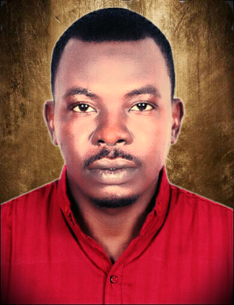

MUZAMEL MOHAMMED ELDOWMA ABDALLA

muzmohad@gmail.com +249911902172

Personal Details Nationality: Sudanese date of birth Jan/1983 Language: Arabic, English
Address: Khartoum Sudan Omdurman Karri Hara 21

My Objectives

To work for a progressive organization in a highly motivating and challenging environment that provides the best opportunities to grow and utilize my potential to the fullest to achieve the organization's goal while achieving my personal goals.
Key Skills

Team leadership, quick learner, hard worker, adaptability AutoCAD (design implementation) Ability to work under pressure, organization and Microsoft office programs Development seeker, empathy, analytical thinking
Computer Skills

Work History

- Semitic for construction and contracting
- Maintenance engineer 2018 to 2019
- Shaban international development Co.ltd
- Oil field service
- Maintenance engineer 2015 to 2018
  - Workshop management
  - familiar with NDT inspection
  - working on both site and office
  - Hard worker, preparing and report
- Sudanese factory for LPG cylinders (SFLC)
- E-mail: abbarcicylinder@yahoo.com
- Maintenance engineer 2014 to 2015
- Design maintenance strategies, procedures and methods
- Motoring and controlling maintenance cost
- Supervise technical stuff
- Improving safety health and procedures
- Scheduling, preparing, report, store keeping & modifying
- Fluent on mechanical hydraulic & pneumatic systems
- Familiar with welding process and material testing

Qualifications

BSC – mechanical engineering university of Khartoum 2013
Area of interesting

Oil & gas, power generation, maintenance,
Installation, automation, construction, Safety,
OSHA, manufacturing.
Specialized Training

  - Graduation project TRIBOLOGICAL consideration in automobile engineering to be familiar to how lubrications help full mechanical rotating parts.
  - I attend general courses for firefighting design & safety in soft stare institute.
  - I attend general course on OSHA- Occupational Safety and Health Administration on alroia alsabaa for management training to be familiar with construction and general industries.
  - Republic palace of the Sudan automobile workshop training.
Driving License Details

Issued from Sudan
Links

https//:www.linkedin.com/in/muzamel-mohammed-eldoma-63bb95135 Skype: live: zzdoma99

