Ayman Yasin Alamin Alfky

Seeking a challenging opportunity where I will be able to utilize
My skills and experience, which will allow me to grow personally and professionally.
About me:-
- Highly motivated, dependable troubleshooter and problem-solver.
- Enthusiastic learner who quickly grasps concepts and technical skills.
- Ability of organizing and interacting with different people within different cultures.
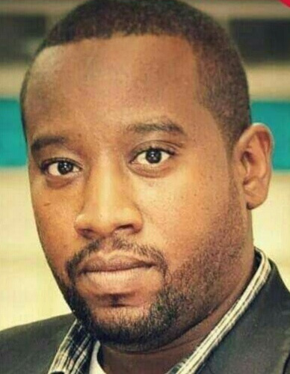

aymanalfky 85@gmail.com +249904626923  Sudan- Khartoum –Eljreaf west
(04) House no (305).
aalamin@petroenergy-ep.com +249121226447

https://www.linkedin.com/in/mohammed-hussien-
Work experience:-
1-AGR operator (associated gas recovery) - in petro energy E&P CO-LTD period from (May-18-2011 till now).
www.petroenergy-ep.com
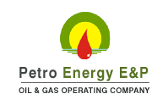
3. CDU Operator in Khartoum refinery company (KRC)

Education:-
1-Bsc chemical engineering (University Of Science and Technology) M ay 2018.


2-Deploma in petroleum engineering (Sudan University of Science and Technology) March 2007.

Courses and certificates:-
- Cambridge international training center - English language for communication.
- The Sudanese international center for administrative sciences and computer – English language “communication & report writing skills” 30/3-12/4 2013.
- The Sudanese international center for administrative sciences and computer – “computer science “30/3-12/4 2013
- KRC firefighting training 2009
- ICQ international center for quality HSE training: -basic safety awareness – basic firefighting –basic first aid 9-11decenber2013.
- AIOSH working safely petroleum training center.
- NEBOSH PSM (process safety management) certificate 2018.
- Oilfield Services Fresh Graduate Training (Schlumberger) Jan-2008
- CNLC Operation & Geosciences Training Feb-2008
- Production optimization using nodal analysis – profile for consultation & management training Egypt 16-25 June2013.
- Natural gas treatment in Petroleum technical center augst2014

Skills:-
- Ability to operate a processing plant with the general objective of maintaining safety, ensuring equipment integrity, maximizing treating efficiency, and minimizing operating costs.
- Working knowledge of PLC’s process controllers, pneumatic and electric devices, motor starters, control panels ,Pumps ,compressors ,valves ,tanks farms, firefighting pumps and etc.
- M.s office (excel-word-power point).
- High team spirit.
- Good reporter and presenter.
- Ability to work under pressure.
- Diplomatic in dialing with others.
- Patient.

Trainings:-
- Khartoum refinery company (KRC).
-As CDU operator (2009).
Languages:-
- Arabic
(Mother tongue)
- English
As second language (good reading, listening and writing).
- Programing language
- good in programing with Aspen Hysys

Duties and responsibilities;-
- Pre-operational phase of new system/equipment :
    - To help develop operational procedures for the designated areas.
    - To contribute to ensuring pre-commissioning/commissioning activities.
- Operational/Normal Running Phase:-
    - Ensure all activities are conducted in accordance with agreed Health, Safety and Environment practices and procedures as outlined in the Site Management System & Asset Local Rules.
    - Ensure that all activities in the day-to-day operation are carried out in a manner safe for personnel and equipment and minimizing the impact on the environment.
    - Associated gas recovery operator, responsible of operate and monitor the gas separation and filtration and pressurize the gas up to 8.5MPA by mover engine CAT3412 and bra mover GE DS504 compressor.
    - General housekeeping, isolation and preparation of equipment for maintenance.
    - Continuously monitors conditions of running and static equipment during the course of the shift, is able to identify problems as they arise and seek appropriate assistance.
    - . Is able to use all Site electronic information systems.
    - Sampling and laboratory testing in plant lab.
    - Logs and acts on Lab results.
    - Liaises with Panel Operator and coworkers.
    - Communication of events to Shift Supervisor and oncoming shift personnel.
    - Liaison with other operators and flexibility to work in other areas should it be required.
    - Trouble shoots and analyzes process conditions continuously during the course of the shift to maintain optimal operation.
    - Understand roles of maintaining the Site Safety and Environment plan.
.

