Nadim Moustafa Badawi
155N Hadayek Al Ahram, Cairo – Egypt  PASSPORT #  MOBILE : +201096790000  HOME : +201005167103  E-MAIL : nbbadawi@gmail.com  Skype : sugarrr_26@hotmail.com | 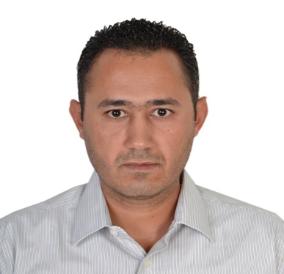

Objective

• A passion for innovative thinking.
• The highest degree of integrity and professional work Ethics.
• An ongoing commitment to a philosophy of knowledge sharing.
• A high regard for collaboration and teamwork.
• A continuous pursuit of learning and personal development.
• The ability to excel in a culture of entrepreneurialism and performance achievement.

Personal Information

- Date Of Birth : 22 May 1979 Beirut, Lebanon.
- Nationality : Egyptian / Lebanese.
- Marital Status : Married.
- Languages: Arabic: Mother language.
English: Very Good Spoken Written, Reading and Understanding.
French: Fair.

Education

- Lebanese university: Business Administration
Graduate: 2002

- Maten Al Chemali High school

Courses:
- HSE Certificate from NIOSH Date: 30/03/2008 Till 10/04/2008
- OSHA Date: 09/09/2017 Till 15/09/2017
- Near Miss/Accident Reporting Date: 14/02/2012 Till 14/02/2012
- HSE MS Date: 13/02/2012 Till 13/02/2012
- Tool Box Date: 16/02/2012 Till 16/02/2012
- ERP Date: 16/02/2012 Till 16/02/2012
- HSE Induction Date: 13/02/2012 Till 13/02/2012
- Incident investigation Date: 14/02/2012 Till 14/02/2012
- JSA Date: 16/02/2012 Till 16/02/2012
- Confined Space Entry Date: 15/02/2012 Till 15/02/2012
- First Aid / CPR Date: 03/03/2014 Till 04/03/2014
- H2S Date: 28/03/2019 Till 21/03/2019
- Fire Safety. Date: 04/04/2019 Till 04/04/2019
- Chemical Handling. Date: 22/03/2019 Till 31/03/2019

Current Job: Q.HSE Supervisor

Tasks:
♣ Prepare Emergency Plan, conduct Fire & emergency drills, and lead the Emergency preparedness team in firefighting drills and spillages .Ensure the compliance with Civil defense conditions.
♣ Ensure implementation of Work permits in site for maintenance department and Contractors.
♣ Induce safety orientation to new comers & contractors & promote safety culture to all employees in site.
♣ Review, participate in Risk assessment studies and follow up the recommended actions to minimize the hazards.
♣ Follow the environmental monitoring on regular basis & take corrective actions
♣ Prepare reports to safety Manager, fuel consumption and generated wastes.
♣ Make Analysis for the reports & numbers of incidents, near miss, potential hazards and first aids and take the necessary corrective and preventive actions.
♣ Implement safety precautions, Safety Operation procedures, Policies & deploy the safe behavior programs to all workers.
♣ Carry out daily inspection, Check the routine inspection is carried out to all work, sections & firefighting equipment’s & review the non-conformities to follow up the actions taken
♣ Prepare & update the semiannual statistics (incidences-occupational disease - chronic disease)
♣ Update the chemical list, MSDS library and classify the hazardous and nonhazardous materials
♣ Check the waste segregation and safe disposal of wastes.
♣ Communicate with governmental authorities; the civil defense, labor office and Environmental affairs for any premises or other documents.
Skills:
♣ Experience 11 Years in Q.HSE.
♣ Fluent in English written & spoken
♣ Good Microsoft office skills (word - Power point -Excel) & internet.
♣ Working under Pressure (War evacuation in Sudan 2011).
♣ Ability to learn and gain new concepts.
♣ Flexibility to work with all departments and different levels of workers and employees.

Work Experience:
. DAPS Energy (2017-2018) Soil treatment bio surfactant working in South Sudan.
. Q.HSE Supervisor in African Drilling Fluids (2010 – Present) Operators: PDOC-GNPOC
. Q.HSE Coordinator in MI-SWACO Drilling Fluids (2008 – 2010) Operators: GNPOC-PDOC-WNPOC-RSPOC
Computer Skills
- Operating Systems: Windows

Hobbies: Reading, Fishing, Car racing.

