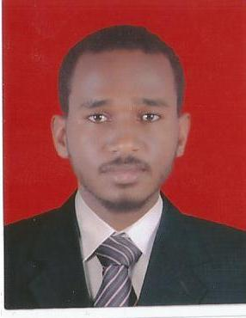

Curriculum Vitae

Nael Azmy Bedry Mohamed

Faculty of Environmental Studies &Disaster Management
B.Sc. Civil Protection (Excellent)
National Ribat University, 2014.
Graduation Project: “Hazard Control and Ergonomics.

Contact number: 00249918936147
00249121154949
00249999460068

Email:Naelazmy55@gmail.com

- Personal Data:
Name: Nael Azmy Bedry Mohamed
Date of birth: March 1993
Place of birth: Khartoum, Sudan
Address: Khartoum, Sudan
Gender: Male
Nationality: Sudanese
Religion: Muslim
Marital Status: Single

- Courses:
- Closed Circuit TV
- H2S Awareness Training
- Lifting Operations and Lifting Equipment Regulations
- Scaffolding Competent person
- NEBOSH International General Certificate in Occupational Health & Safety –IGC.
      - IOSH in managing safely.
      - Integrated Fire Alarm & Fire Fighting System.
- ISO/QMS 9001:2008&14001 Environments – 18001 Health &Safety.
- OSHA in General Construction Industry.
- OSHA in General Industry.
- Individual Strategic Planning.
- Management Skills for NGOs.
- Attended HSE Conference.
- First Aid in the Community.

- Skills:
- Languages:
- Arabic [Mother tongue].
- English [good].
- Computer Skills:
  - Microsoft Office Word& power point.
  - Microsoft Office Excel.
- Work Experiences:
- Savola Edible Oil – Sudan -HSE Supervisor from 1-Jan 2018 up to now.
- Savola Edible Oil-Sudan HSE officer from 1 September 2015 up to 1-Jan 2018.
- Trainee at Savola Edible Oils (Sudan) - From 24 February 2015 up to 24 August 2015 (HSE officer).

- References:
- Savola HSE Manager: Ameer Mohamed 00249912311162

