PERSONAL INFORMATION

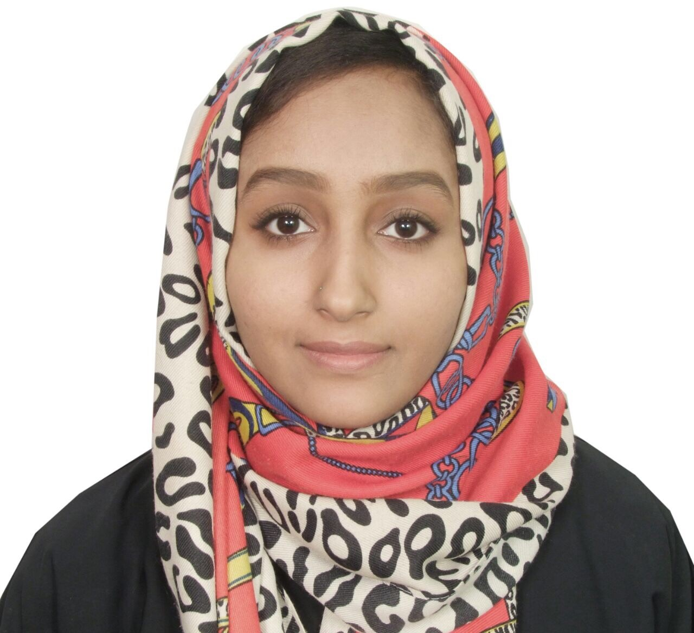
Name: Hala Hassan Elamin Ahmed.
Nationality: Sudanese. Place &Date of Birth: KSA 25/3/1993 Religion: Muslim.
Marital status: Married.
Place of residence: Sudan _Khartoum Mujahedeen
Mobile phone: Sudan: +249128559750,+249906285562
E-mail address:hl0oosh@outlook.sa

EDUCATION

- B.Sc. Degree: from 2010 to 2014, Information Technology (IT) from Mashreq university , Khartoum, Sudan.
- Cisco Certificate Network Associate (CCNA).
- Master's Degree in Information Technology: (Information Technology (Software Defend network - SDN)).
- Sudan Secondary Certificate.

LANGUAGES

  - Arabic: Mother Tongue.
  - English: Good.

SKILLS

- Fundamentals of ethics are not negotiable.
- Polite, cheerful personality and enjoy the ability to build good relations, constructive social and ethical ways grainy.
- Adapt fully to work in a team and a role model at a high level of values and respect for others.
- Ability to perform under the pressure of work, and work for periods of more than basic work.
- Computer skills & applications, Microsoft Office, Internet Explorer.
- Driver's license.

AMBITIONS

- Perseverance to reach the highest level of education and the highest level of values and ethical practices.
- Respect for others and appreciation of hard work and
Teamwork and develop the work according to the possibilities.
- Work in any office or field to gain experience to reach the
Desired goal.
- Personal development and being fully prepared to learn the scientific and practical in all areas and attend training courses for the betterment of my level as all.

HOBBIES

- Sports - Reading - Internet - Participate in the Social activity.

CAREER OBJECTIVE

To secure a rewarding position commensurate with my qualification and professional experience in a dynamic and forward-looking organization that provides real challenges and opportunities to advance my career goals as well as to contribute to the progress of the organization.

