Abu baker Barakat Nour

Khartoum, Sudan
Birth day:12/10/1992
+249912420764 / +249127707010
bakri4barkat@gmail.com.
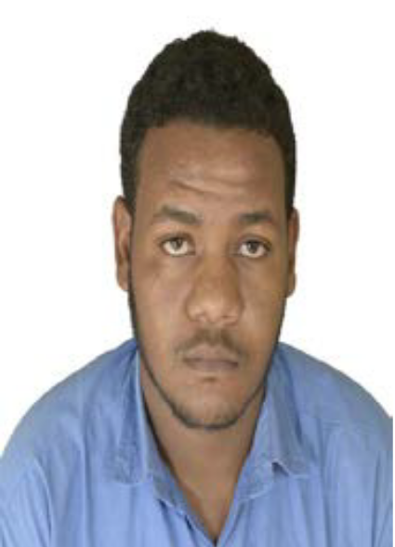
Professional Summery
Accomplished and energetic Mechanical Engineer with a solid history of achievement in Maintenance. Motivated leader with strong organizationaly and prioritization abilities. Areas of expertise include Automotive,Oil and Gas, Pipe Lines, Pumps, Water Treatment and Boiler.
Skills
• Telecommunications.
• Communications and Media.
• English Language.
• Active Learning.
• Computers and Electronics.
• Engineering Report Writing “ Shifiled University “.
• Hvac.
• Fire Fighting.
• Autocad.
• OSHA.

Experience

• Baleela Field – Petro Energy (Oil and Gas) January 2020- Present.
Development and production department, maintenance mechanic at CPF work shop , PCP, PCM, Heaters, Heat Exchanger, Air Comp, Nitrogen Comp ,Centrifugal Pumps, Water Treatment and Boiler.
• Baleela Field_ Petroneeds Service International (Oil&gas) Aug 2017- Dec 2019.
Development and production department, maintenance mechanic at CPF work shop , PCP, PCM, Heaters, Heat Exchanger, Air Comp, Nitrogen Comp ,Centrifugal Pumps, Water Treatment and Boiler.

Training
• Harees International Co.Ltd (Automotive) March 2016- Jun2017.

Maintain programming logs, as required by station management and the Federal Communications Commission.
Monitor and log transmitter readings.
Report equipment problems, ensure that repairs are made, and make emergency repairs to equipment when necessary and possible.

Education
Bachelor of Science, Blue Nile University college of Engineering Mechanical department 2016.

