Omer Abdalla alsideeg  Al-Khartoum, Sudan  Nationality : Sudan Language : (Arabic & English)  Email: omerabdalla123@gmail.com  Mobile: + 249 92 4047500  : + 249 91 14 58898 | 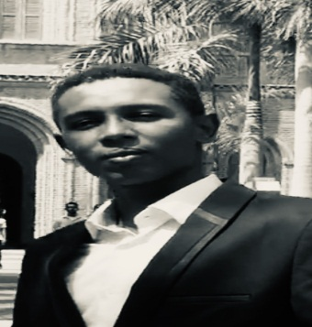

Summary
An electrical engineer seeking to develop himself in different aspects, both in technical and administrative departments, also to obtain a challenging and responsible position in a professionally managed organization. I am looking forward to an opportunity where I can utilize my skills in constituting effectively to the success of the organization and further improvement of my personal skills.

Key Areas of Expertise
- Projects planning, scheduling, managing and directing.
- Management Reporting
- Problem Solving
- Able to deal with complicated situations with calm and clear thinking.
- Analytical Mind
- Fast learning and adaptation skill
- Methodical approach to all tasks.
- Good IT Knowledge
- Presentation Skills
- High Levels of Integrity
- High sense of responsibility
- Negotiating
- Communication Skills
- Team work and solo work compatibility.
- Multi-tasking skills.
- High adaptability to new and foreign cultural.
- High research skill.
- Teaching.

Professional Experience
SEGAN PIPELINE & PETROLEUM (F Z E), Sudan
Project Manager September 2017 – April 2018

Office administration
- Reporting to general manager.
- Preparing bidding documents.
- Contact with clients.
- Review contracts.
- Attending all projects meeting and negotiating agenda with clients.
- Preparing invoice payments according to work progress.
- General office duties
- Answering of all telephone calls
- Maintain all office equipment eg computers, mobile phones, printers etc.

Technical duties:
- Lead and manage the team of work to finish a DCVG pipeline survey of 150 km and coating repair of 400 points along PETROLINES pipeline.
- Planning. Scheduling and directing daily activities.
- Preparing technical reports.
- Budget Controlling.
- Sending the daily report to general manager.
- Contact with client to install CP system.
- Prepare and sign all documents related to site work.

PETROLINES FOR CRUDE OIL LTD, Sudan
Project Engineer July 2017 - September 2017

Work at Technical Services Department and attended many projects:
- Installing solar system at oil security sites
- Installing a new PETRODAR’s oil metering station near al Khartoum refinery.
- Commissioning for oil auto sampler at Khartoum Metering Station (KMS).
- Provision of CP remote monitoring system for Marine Terminal (MT) storage tank.

Ministry of Oil and Gas, Sudan
Pipelines – Maintenance and Operation & Technical services FEB 2016 - FEB 2017

- General office duties.
- Travelling to many places of oil fields as the ministry representative.
- Prepared and introduced many presentations which are related to oil industry.
- Working as the ministry office manager at PETRODAR's Central Processing Facility (CPF) and pump station 2 near aljabaleen town as government’s representative.

PETROLINES FOR CRUDE OIL LTD, Sudan
Software programming OCT 2014 - AUG 2015

- Visiting oil field studying how oil metering stations are work.
- Studying all oil metering stations regulations and standards.
- Understanding all oil metering stations equipment’s.
- Build an image to connect and control all oil metering stations components.
- Using SCADA software to simulate the physical station.

Professional and Academic Qualification

- Master of Science in Engineering Management. 2018 –– 2020 Khartoum University
- Bachelor in Electrical Engineering (Control Engineering). 2010 –– 2015 Sudan University of Science and Technology
- Intermediate in Khartoum – 2009 Khartoum

IT Skills
- Proficient user of MS Office.
- Fluent in English and Arabic
- Good Team work
- Can handle and work in pressure situation

