OMER ELHAJ ABDALLA ALI
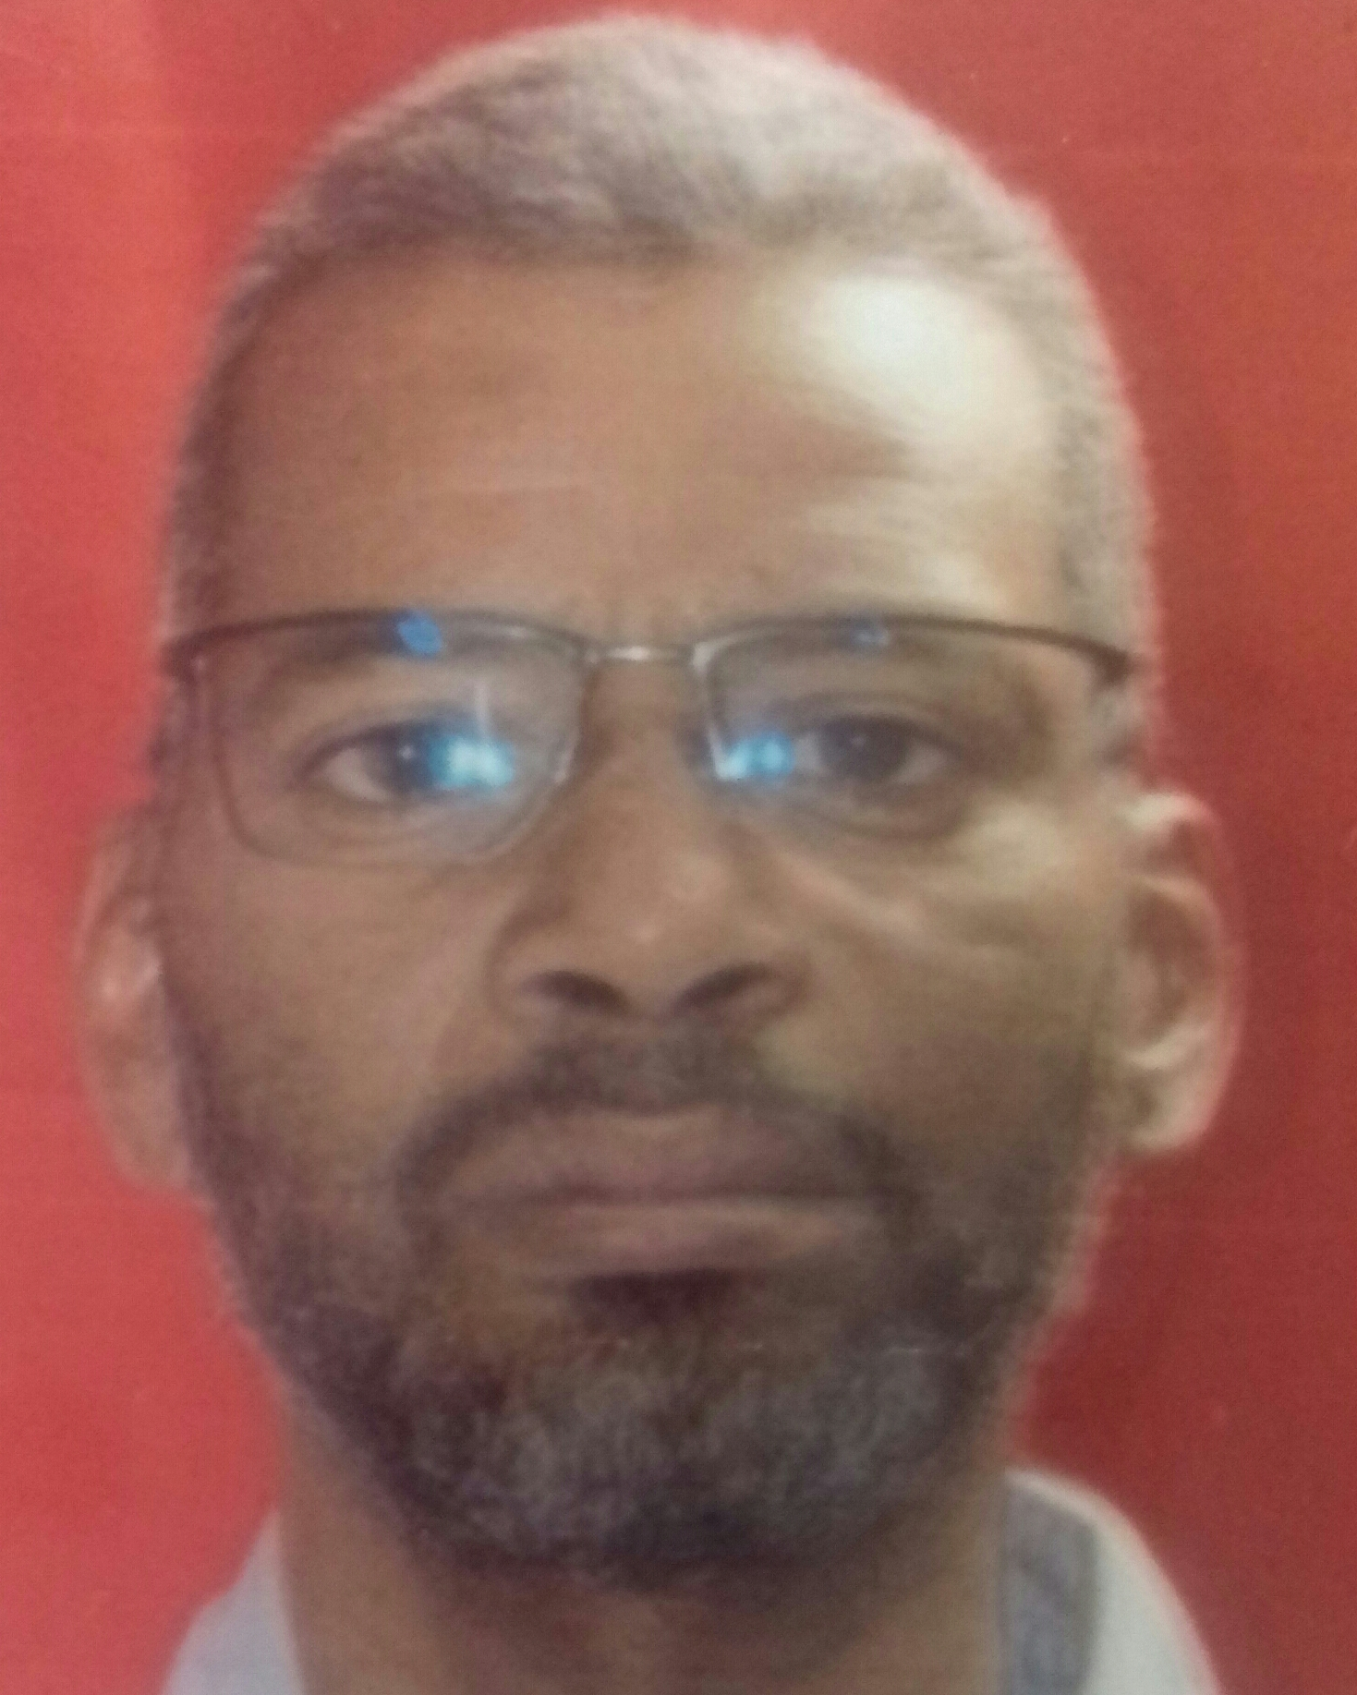
Contact No.: +249 911174537 +249 912357193
E-Mail: omerkkk@krcsd.com

Profile
- Mechanical engineer with twenty-five years in various mechanical engineering fields, from which eighteen years in refinery mechanical maintenance and turnarounds planning.
- Presently fill the position of turnaround section head in Khartoum Refinery Co. Ltd.
- Good knowledge in pumps, turbines, compressors minor & medium maintenance; familiar with static equipment types and functions, have fair understanding of basic refinery operation and production principles.
- Good skills in turnarounds planning and cost estimates.
- Have the skill to evaluate contractor’s competency and quotations accuracy.
- Good experience in maintenance planning & scheduling using MS Project.

Work Experience:
Since 27 July 2004 to present - Khartoum Refinery Co. Ltd., as maintenance mechanical engineer, turnaround engineer and turnaround section head.

From 13 November 2000 to 21 July 2004 – White Nile Battery Company – Khartoum – Sudan, as mechanical supervisor.

From 25 November 1997 to 18 November 2000 – Gunied Sugar Factory– Sudan, as assistant shift mechanical engineer.

---------------------------------------------------------------------------------------------------------------------------- ----------
Education
Academic Certificate
B.Tech in Mechanical Engineering, Second Class Division II - 1996
Faculty of Engineering
Sudan University for Science & Technology- SUDAN

Professional Certificates
AACE Certified Cost Professional CCP
July 2019

IT Skills
- MS Office package (Excel, Word, and Project).
- Familiar with Primavera P6.
- Familiar with AutoCAD.

Personal Information

Date of Birth: 15 June 1971
Address: P.O Box 15125 Khartoum Refinery Co. – Khartoum Sudan
Languages: Arabic, English
Nationality: Sudanese
Marital Status Married
No. of Dependents: 5

