Curriculum Vitae | 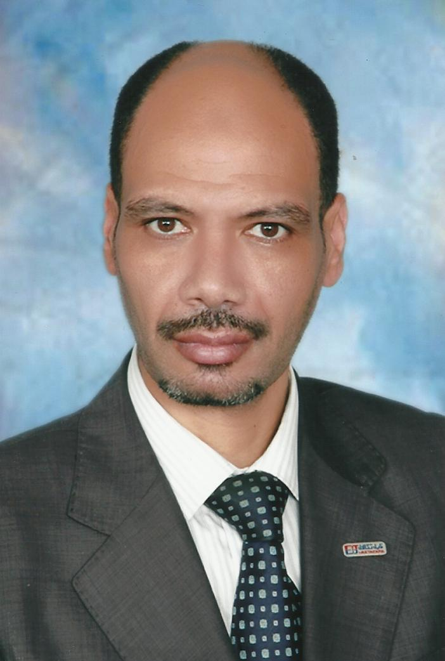
PERSONAL INFORMATION
First name(s) / Surname(s) | Ahmed Abdel Khair Salem
Address(es) | 217, Mostafa Kamel St., Alexandria, Egypt
Telephone(s) | +20 1011577574
E-mail | ahmed.salem769@gmail.com
Video Zoom | ahmksr@gmail.com --- (PMI – 416-266-8218)
Nationality | Egyptian
Date of birth | July 13, 1970
Gender | Male
DESIRED EMPLOYMENT | OPERATION MANAGER O&G – NATURAL GAS PLAN -
SUMMARY | 20 years + global experience in Oil & Gas facilities (Onshore/Offshore), Refinery & Petrochemical projects,Sub STATION (400-750 Kv) Utilities and other Process industries-  . Responsible for direction and supervision, of the continuous operation of the Gas Plant. Coordinates and directs all personnel and actions necessary to ensure the plant operating conditions are always kept within optimum limits. Compose and maintain necessary records, procedures and paperwork associated with the operation of the plant. Creates and maintains a safe work environment.  * Plans, organizes, monitors and coordinates staffs’ daily work assignments  * • High level of energy and motivation required to maintain engagement with Operations workforce.  • Exhibit strong leadership capabilities.  • High level collaboration skills.
WORK EXPERIENCE
Dates | April, 2010 – Dec,2019
Occupation or position held | OPERATION MANAGER -- UAE-ITALIA- LYBIA
Project | Member of CCC group ON/OFFSHORE
Name and address of employer | Sicon Oil & Gas S.P.A. – ITALY
Main activities and responsibilities | - Bu Hasa Shuaiba Unit “HGAS PLANT Enhancement for five Clusters include 16 wells. – ADCO – UAE. Project includes-  - Arabian Power Company- Fuel Oil Transfer from Takreer Refinery to APC through 12” Oil transfer pipe line with Custody meter technology and Automatic Tank Gauging system- Project Includes Fuel oil metering system at both end, Radar Tank Gauging, Configuration and data transferred at both end DCS. Toshiba DCS (APC side), Honeywell DCS ( Takreer Side).  - RESPONSIBILITIES AND DUTIES:  - Oversee all plant environmental activities are conducted in compliance with procedures and permit conditions while ensuring that Operations personnel are trained to respond as needed to environmental problems.  - Supervise and oversee the Operations department skill improvement, training and safety programs. Ensure that an adequate number of trained personnel are available to maintain continuous and safe operation, even under adverse conditions.  - Provide operations training for the maintenance technicians by presenting instruction on equipment operating procedures.  - Issue new operating procedures, as required, and periodically reviews existing operating procedures and issues revisions, as deemed necessary, to ensure that they reflect correct and safe operating practices.  - Completes and maintains reports and any other related paperwork.  - Updates skills by attending training sessions and seminars.  - Demonstrates positive problem solving and communication skills when interacting with internal/external personnel.  - Communicates memos and other related BWL business to staff.  - Trains, coaches and evaluates staff in the performance of their job.  - Assists in budgetary responsibilities.  - Oversee and provide guidance to the Maintenance Supervisor relative to equipment conditions and required maintenance activities.  - Analyze operating results and equipment failures. Improve plant efficiencyand performance by developing and implementing new methods to improve plant operation and reduce operating costs.  - Oversee and ensure that the water chemistry program for the plant is properly implemented, including testing, inspections, and maintenance of water treatment program  - Ability to plan, coordinate, work between different work groups  - Manage deliverables from reports – i.e. Subsurface Teams, Plant Managers, Downstream Manager, Well Services Engineer,  - Develop and implement policies and ensure effective monitoring and control measures are in all plan  - Produce & development well designs, plans and procedures to enhance the value of assets  - development of quality and safety standards and policies relating to operations  - Manage Site Engineers & Well Site onshore/offshore training programmes and performance appraisals  - Mintoring and implement policies and ensure effective monitoring and control
Dates | January, 2008 – March, 2010
Occupation or position held | SECTION HEAD – EC&I- (ON/OFF SHORE)
Project | Detail design project – Hydrogen Gas Plant Hydrogen Make-up Compressor for Kuwait National Petroleum Ltd. (KNPC- Mina Abdulla Refinery1000 I/O’s, Brownfield) – AHMADY OFF SHORE PLANT
Name and address of employer | Arebi Enertech – KUWAIT
Main activities and responsibilities | - provide technical assistance at an early stage of engineering phase, project execution and commissioning phase of hydrogen make up compressor;  - participate in design review, HAZOP, technical review meetings;  - involve during construction, engineering, equipment selection process, calculation process and electrical & instrument issues;  - preparation of instrument design basis, control & automation philosophy, control system overview diagram, specifications (field instruments, control valves, MOV & PSV'S) for hydrogen make-up compressor;  - review Yokogawa (CENTUM CS 3000 R3 – Emerson and DLTA V) design documents - function design specifications for DCS/ESD, GA drawing, system & marshalling cabinet drawing, power calculation, interlock logic diagrams FAT procedure and closed out FAT punch list items;  - prepare mapping lists for DCS-ESD, DCS-MMS and ESD-MMS system;  - prepare RFQ'S, datasheets, instrument index, wiring diagram, loop diagram, hook up diagram, cable schedule, bulk MTO and cause & effect diagram.  - prepared alarm list based on the criticality and priority of operational requirements (trip, high/low priority, common alarm);  - prepare technical reports for project management meetings, cost estimates and input to monthly budget submissions;  - involved in commercial negotiations with local instrument vendors and compressor package vendor;  - carry out the following function relative to vendor documentation;  - issue material requisitions (MPR) for material department for enquiry and order placement;  - liaise with project groups in relation to inst. & control associated with packages to ensure compliance with project standards & requirements;  - coordinating with project engineer in matters of project coordination & program, plant safety & work scope that could constitute a contract change;  - construction engineering of preparation of fabrication of support drawings/ routing and layout drawing;  - effective interface with suppliers and vendors to perform factory acceptance test [FAT], review and coordinate their day to day work at their factory works for technical issues;  - evaluation of vendor's quotation, prepare technical bid evaluation (TBE), commercial quotation evaluations;  - witnessed the functional checks before transfer the instrument item shipments to site for transmitters, control valves, MOV’s, Gauges, Switches, JB, instrument Cables etc;  - to carryout technical discussion and Factory Acceptance Test (FAT) for Honeywell DCS/ ESD system at Netherlands.
Dates | January, 2003 – December, 2007
Occupation or position held | Senior Engineer – Instrumentation-control
Project | SAUDI ARAMCO KHURAIS PROJECT KFJ- OFF SHORE  (ARAMCO KUWAIT OIL &GAS)- off shore
Name and address of employer | HYUNDAI ENGINERING COMPANY – KINGDOM OF SAUDI ARABIA
Main activities and responsibilities | - to direct engineering design team in development projects throughout the entire cycle from initial concept through successful completion.  - to finish assigned engineering projects in accordance with customer specifications and within schedule and budget limitations, coordinating activities of engineering team, contractors, and vendors. Role includes analysis, design, specification, selection, implementation, commissioning, cutover and start-up for Instrumentation, plant automation and process control systems. Discipline Lead role on project team providing analysis and design of instrumentation and control systems. Responsible for developing design basis documents, technical studies and reports. Being involved in the preparation of bid specifications, and evaluations.  - responsible for the development and design of control systems hardware & software architecture along with specifications & operating guidelines.  - other responsibilities include the participation in safety reviews, hazard analysis and coordination of engineering and design activities with other project disciplines.  - Detail Experience:  - Expertise in Proposals, Design, Development, Implementation and Execution of Project.  - Performs technical planning, system integration, verification & validation analysis & FAT.,SAT  - Ability to develops and integrates ESD, PSD, PLC, DCS and SCADA.  - All aspects of control system project engineering such as drawing developments and evaluation and application of project specification from conceptual design thro’validation.  - perform Basic Engineering by Understanding Process and Control parameters with Piping & Instrumentation Diagram (P & ID) with control philosophy FSD & HAZOP, SIL 2.  - design developing Instrumentation Specification sheets, preparing of Instrument Index sheets, loop Wiring details, Installation Details with Hook-up diagram, Cable Schedule, Junction Box details, Detailed Bill of Materials, Bid Evaluation:  interlock systems/Cause and Effect diagram.  - Control Valve, Orifice and Transmitter sizing Calculations. Particular about Material;  project planning, estimation and implementation;  risk analysis and HAZOP study and SIL2. SAFE charts and Cause and Effect analysis;  maintaining GPM level, ISO requirements, Instrumentation standards, ISA and IEC standards, API, IEC, ADCO AND SHELL STANDARD, SAUDI ARAMCO standards & MARAFIQ STANDARDS and developing policies & procedures, trouble shooting and debugging of software and hardware;  worked with ISO 9001, 2000, ISO 14001 and ISO 18001 certifiedcompany, SiemensS7-300 -S7-400PLC programming/coding along with connectivity of systems using Ethernet, Profibus, Modbus and their application within process plant design and engineering.
Dates | January, 2000 - December, 2002
Occupation or position held | Instrumentation Construction Supervisor
Project | Revamping and Maintenance Project for Kuwait National Petroleum Ltd. (Shuaiba Refinery Base design: Foster wheeler, UK, Brownfield
Name and address of employer | Kharafi National - KUWAIT
Main activities and responsibilities | - involved in Modernization of control room - Installation, Commissioning, start up and on line change over the control room instruments and DCS/ESD system.  - re-vamping operations – replacement of pneumatic instruments to new electronic instruments for Unifier, H2s plant, Gas treating area, Heavy oil and Utility area.  - carried out on line release up gradation of the old pneumatic System in to Honeywell TPS system.  - commissioning of Honeywell - TPS System configuration to new version i.e. GUS and High Performance Manager (HPM).  - replace the existing hardware and install the new hardware’s for the control room equipments.  - programming of Digital Controllers (Yokogawa).& SIEMENS  PCS 7-300 & PCSS7-400  - core team member of Alarm Management Group for complete Shuaiba Refinery and pumping area.  - carried out complete logic study, undertaken implementation check, installation and maintenance of Air Compressor (Cooper Beesmer, AC, AEG etc.) with lube oil and seal oil system, pumps and turbine.  - to plan and execute call out duty, shift duty, shutdown, start up activities.
Dates | October, 1996 – December, 1999
Occupation or position held | Engineer - Instrumentation
Project | Project Engineer (Instrumentation)
Name and address of employer | SUEZ Petrochemical Company - EGYPT
Main activities and responsibilities | The job involves up gradation of existing Honeywell MC to HPM, Industrial control (ICS) Fail safe system to Honeywell FSC and Bentley Nevada 3300 series vibration monitoring system for refinery Vacuum and Coker units.  - Preparation of Basic Engineering and Detail Engineering package for Distributed Control System(Honeywell TDC-3000), Emergency shutdown system(Honeywell FSC ) with M/s Honeywell  Engineer for preparing Functional Design Specification and Detail Design Specification for various system like MMS, HPM, FSC;  - Reviewing of specification sheets,Cause and effect charts,Interlock Diagrams,Logic Description sheets, Termination Schedule, Cable Schedule, Instrument index, Instrument hookup drawings, Instrument loop drawings, System Architecture drawings, Power Distribtion and Panel Drawings;  - Preparation of Functional Logic Diagram(FLD) and Ladder programming for Honeywell FSC-QMR, AB-PLC in refinery units;  - Involved in subsequent erection of system at site and commissioning of both DCS and ESD with all networking capabilities and maintenance of the same. Also involved in process loop checking and control algorithm checking,Logic checking after installation.  - Involved in HAZOP study of various refinery units and implementing the same;  - Involved in Machine Monitoring system Technical specification .
EDUCATION AND TRAINING
Dates | 1992-1996
Title of qualification awarded | Bachelor’s degree in Electrial (Electronics and Communications)
Name and type of organisation providing education and training | Faculty of Engineering - Alexandria University – Egypt (passed with first class)
STANDARDS KNOWN | ANSI, ISA, KNPC, PDO, API 617/ 618, Australian
Training/Special Assignments | - Project Management Professionals by PMI Jubail, KSA  - Triconex TMR ESD System, Jubail, KSA  - SAP System, Financial and Eng Project Management (PS Module) Jubail  - SAP System, Investment Management (IM Module) - KSA  - SAP System, Materials Management (MM Module) - KSA  - Yokogawa Centum CS3000 DCS system, Jubail, KSA  - Application Software FAT at Oxy-Vinyl, Jubail, Saudi Arabia  - Engineering and design review at Mustang Jubail, KSA  - Engineering and Design review at KTI, Zotermeer, the Netherlands  - Bosiet Certificat from INASEA Academy –GERMANY  Valid up to 06/2018
PERSONAL SKILLS AND COMPETENCES
Mother tongue(s) | Arabic
Other language(s) | English, French
Self-assessment
European level (*)
English  French | Understanding Speaking Writing  Listening Reading Spoken interaction Spoken production  C2 C2 C2 C2 C1  B2 B2 A1 A2 A2  (*)Common European Framework of Reference for Languages
Social skills and competences | Comunicative person, optimist person, adaptable & flexible to change
Organisational skills and competences | Leader, good organizer, experience working in/with a team
Computer skills and competences | - SOFTWARE:  - Ladder Logic, Structure text, Function blocks, MS office, MS Project.  - HMI software, Wonder ware, I Design, ORICAL, FLOWCAL, CV.  - SIZING, Safety Valve Sizing, SAP, BaanN-5 , INST. Tools  - Instrumentation sizing software:  - AutoCAD/Micro station/PDMS/PDS/ Proprietary Control Soft wares (ICSS, SCADA, DCS, PLC, OPC server etc.)
Experience with instruments | - DCS: “APACS “Moore Controls. FOXBORO, YOKOGAWA, (CENTUM CS 3000 R3) - Honeywell –SIEMENS S7-300 " SIEMENS S7-400 HE &SW detailing and I/O listing.  - Cabinet and remote module PLC, SCADA: Allan Bradley, Mitsubishi, Messung, Siemens, Moore, Yokogawa , ABB, Telemechanique.  - Single Loop Controller: Yamatake Honeywell, Yokogawa, Moore, Fuji, Masibus.  - Transmitters: Fisher Rosemount, Honeywell, Yokogawa, E & H, Krohne Marshall.  - Final control Elements and MOV’s:-:BIFI, Valveitalia, BTG-CCI, FISHER, CVS, Arca, Dembla, Samson, Honeywell, El-omatic, Rotex.  - Temperature sensors , Flow sensors- Variable area flow meters, Mass flow meter, Mag flow meters, Vortex flow meter, Ultrasonic flow meters, Orifice and D/P Trans. Level measuring Instruments , Pressure Measuring instruments, Analytical instruments like pH meter, DO meter;  - Various Type of Gas detecting systems: General Monitor, MSA, ABB, UPL, Pentax, Fisher-Xomox, Servomax, Variable Frequency Drives and Vibration Monitoring.
Driving licence | Full current driving license (Saudi Arabia)

