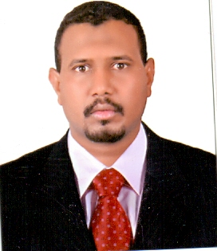
Personal information
Name: Haythem Ahmed Ali Mohammed
Address: Sudan - Khartoum - Jabra square 9 house 227.
Date of Birth: 1/1/1978.
Place of Birth: Khartoum, Sudan.
Current Occupation: Supervisor of the Technical Support Unit at the Library of the University of Digital Science and Technology
Phone: Mobile: 0906679756
Email: haythem07@gmail.com
Marital status: Married .
Qualifications
- Master of Business Administration (MBA), University of Science and Technology, 2011
- Higher Diploma in Information Technology, University of Juba 2009
- Bachelor of Computer Science, University of Science and Technology, 2002.
Practical experiences
1 / Supervisor of the technical support unit in the digital library University of Science and Technology
September 2004 to 2017
- Horizon Database Management System
- Maintenance and follow-up of computers and accessories in the library.
- Installing and following up the local library network.
- Designing the electronic archive of the books in the library.
- Designing an electronic archive for university theses in the library.
- Electronic indexing of books using the horizon system.
- Providing technical support to the library staff.
2 / Electronic Library Officer, Faculty of Nobles for Science and Technology
November 2017 to date
- Management of the electronic index of the college library using Koha system.
- Design and management of digital content (Dspace) for the Nobles College of Science and Technology.
- Providing technical support to the library staff.
- Participation in the global scientific databases (Agora, Hinari, PubMed)
Training courses
Sudanese Association for Libraries and Information
The Sudanese National Commission for Education, Science and culture
The United Nations Educational, Scientific and Cultural Organization (UNESCO) Training program in :
Research in Scientific Databases
Khartoum-Sudan-National Research Center
From 24 march to 28 march 2019

College Of Technological Science
Capacity Building Center
Training Course In :
Oracle9i DB Oracle Developer 6i
On 21 June 2006 ( 3 months )
Khartoum-Sudan-College of Technological Science
AGRIS-IMARK Capacity Building Workshop
From 8 to 16 March 2006
Training Program in:
Management Of Electronic Agricultural Information Resources & Digitization and Digital Libraries Module.
Held From 8 to 16 March 2006 at the ARC, Wad Medani , Sudan including software installation, troubleshooting and updating office application.
Aspects of personal recipes
- Punctuality .
- Ability to take responsibility.
- Ability to deal and cooperate with others.
- The constant desire to develop performance and performance flexibility.
- Permanent insistence on finding the best solutions to problems that may arise during the work.
References:
Dr. Ahmed Mohamed Osman
Librarian
Nobles College of Science and Technology
+ 249912216803
Sumaya Sobky Khaled
Vice Dean of Libraries
University of Science and Technology
+249837573172

