AHMED Kamaleldin

Contact: +966 562452629 +249915517080 a7mdkamal89.ak@gmail.com
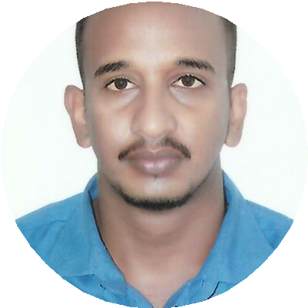

Mechanical engineer
Being a lifelong learner in Automobile, Hydraulic and fluid dynamics field, i would like to seek a challenging career in the field that encourages continuous learning, creativity and gives exposure to new ideas.

AREAS OF EXPERTISE

- Mechanical | - maintenance | - Resource management
- Multitasking | - Team player | - Strategic Planning
- Mechanical overhaul | - Performance Management | - Process Improvement
 |  | - Attention to detail
.
SYNOPSIS

- Able to quickly determine the proper course of action in various situations to keep things under control and to influence the best outcome
- A team oriented professional with excellent leadership and interpersonal skills, with the ability to build consenses and establish commitment
- Possess in-depth knowledge of the various oil and gas field procedures and practices
- Ensure success of projects through creation of multiple tools and strategies, defined procedures for communicating with stakeholders and developed analytics used by senior leaders to understand impact
- Possess excellent organization, communication and interpersonal abilities, time management, multitasking, supervisory skills, and computer competences
- Well spoken, approachable, with great attention to detail and a professional attitude.

CAREER PROGRESSION

Field service engineer March 2018 to present
Dal group , Khartoum, Sudan

- Perform mechanical overhaul and maintenance of (ROLLS-ROYCE ALLEN GENERATORS)
- Perform troubleshooting, adjustments and repair services on all mechanical & instrumentation systems in the field.
- Complete related paper work and access database required to complete the job (work order, spare parts) accurately and timely.
- Remove and install parts, disassemble and assemble components, test and adjustment assemblies.
- Assume responsibility of mechanical work in the project and certify progress of works on completion the installation.
- Carry out the final inspection for certification of final completion and handing over the work.

MEP Engineer Jun 2017 to FEB 2018
Conems Engineering & Trading , khartoum , Sudan

- Provide technical support to the clients in solving quality problems with existing products.
- Coordinated operations, maintenance, and repair activities for existing projects
- Developed the company's standard methods and procedures for testing products
- Oversaw fabrication and installation activities to ensure products and systems conform to engineering design and customer specification.

MAINTENANCE & QUALITY CONTROL Engineer Apr 2016 to May 2017
SABINTOD INTERNATIONAL CENTERS FOR VIHACLES & SERVICE , khartoum , Sudan

- Supervise the maintenance & repair of diesel & petrol power equipment and vehicles over 200 transport fleets consisting of CARS – Toyota, Hyundai, Honda , Suzuki , Isuzu Etc..
- Supervising and controlling the overall activities related to the workshop section
- Sales & service responsibilities include sales and back up V-MECH industrial equipment.
- Making testing schedules’ and arranged each schedule to testing sites.
- Daily monitoring, maintenance and anomaly support of assigned vehicles .

Trainee Mechanical Engineer Aug 2015 to Jan 2016
Sudan Railways, khartoum ,Sudan

- Provide mechanical support when required.
- Carry on mechanical overhaul & regular maintenance.
- Repaired diesel engine, air compressor, and other locomotive mechanical system malfunctions.
- Fabricated a wide array of items for use of trains due to damage.

EDUCATION

Bachelors (BE), Mechanical Engineering 2015
Mehran University of Engineering & Technology, Pakistan

Course, Managing Safety Course 2015
Institution of Occupational Safety and Health (IOSH), Pakistan

Scaffolding safely Safety Trends International 2015

Course, Confined space safety 2015
Safety trends international, Pakistan

Course, Engine overhauling 2015
Mehran skill development center, Pakistan

Certification, Proficiency certificate in AutoCAD 2D & 3D
Aptech 2011

