RESUME
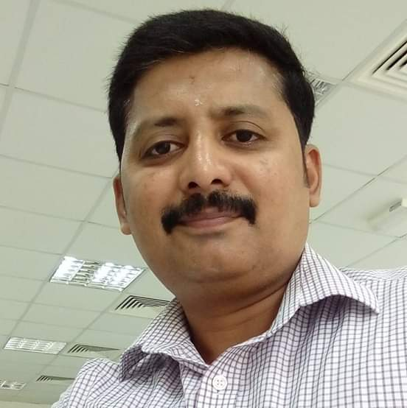
PRADEEP KUMAR K.S.
COIMBATORE (SOUTH INDIA)
MOBILE :+968 72441485 ; +91 9150413322
EMAIL: pradeep_71@live.com

OBJECTIVE:
A highly dedicated multi tasked professional with 9 years of experience in purchasing seeking a position where my procurement skills will be effectively utilized.
WORKING SKILLS:
- Excellent negotiation, organization, communication, and time management skills.
- Excellent skills in handling correspondence and ability to communicate effectively and professionally across multiple departments and all levels of management.

EMPLOYMENT HISTORY:

PURCHASE OFFICER - DAWOOD CONTRACTING CO. LLC – MUSCAT (2016-PRESENT)

- Projects handled – ROP/RCA/AL MEERA/SALALAH RESORT/LNG/Oman Aviation etc.
- Prepares requests for quotes and proposals, including precise specifications, supporting spreadsheets, comparisons, recommendations, and issuing purchase orders.
- Provides liaison services between suppliers and departments for order status, procurement procedures, and problem resolution, researches sources of supply; advises departments on cost effective alternatives.
- Arranges for technical evaluation of all bids received and carries out commercial evaluation with reference to price, delivery, payment terms etc.
- Responsible for drafting and reviewing contract, agreements with for sub-contractors /suppliers/services provider’s and other documents related to purchasing activities
- Responsible for MAS submittal & coordination between planning, projects, consultant & client.
- Following up material delivery, stock maintenance, stock reporting etc.
- Effectively handling invoices and delivery orders against material delivery.
- Handling payroll and petty cash and submit statements to accounts department.
- Responsible for ISO audit in procurement department.

PURCHASE OFFICER-DOHA PEST CONTROL & CONTRACTING, QATAR (2013-2016)
- Manage the day-to-day activities and provide administrative support to the top management.
- Independently handling internal and external correspondence effectively.
- Drafting letters, memos, agenda, effectively.
- Designs and implements office policies by establishing standards and procedures; measuring results against standards; making necessary adjustments according to the company processes.
- Responsible for vehicle maintenance, repairs, service, insurance renewals etc.
- In charge of facility services like security, housekeeping and building maintenance.
- In charge of executing purchase order, vendor and material management etc.
- Following up material delivery, stock maintenance, stock reporting etc.
- Preparing cost comparative statement, supplier over dues, etc.
- Effectively handling invoices and delivery orders against material delivery.
- Handling payroll and petty cash and submit statements to accounts department.
- Responsible for ISO audit in procurement department.

ADMIN & PURCHASE OFFICER – A.TOSH & SONS (I) LTD. COIMBATORE- (2012-2013 June)
- Responsible for the entire administrative tasks of the office.
- Responsible for handling correspondence, generating reports and documents.
- In charge of facilities management such as security, transport, housekeeping, etc.
- Building maintenance, managing utility services like water, electricity, repairs,etc.
- Liasoning with govt. departments for smooth running of the office.
- Monitoring staff movements, purchase, stores, etc.
- Handling employee files, leave details, timesheets, attendance, etc.
- Preparing payroll, PF, supplier account statements etc.
- Coordinate and communicate with suppliers, transporters, warehouse and subcontractors for timely execution of the work.
- Monitoring materials movement, delivery and quality and enter the same into the system.
- Entering purchase details in Tally ERP.

ADMIN/PURCHASE COORDINATOR - KRITHI INTERIOR & GENERAL CONTRACTING -ABUDHABI [FEB 2011- JUNE 2012]

- Broad-based experience covering a full spectrum of administrative duties, including
executive support, facility management, office management, billing/invoicing
appointments, calendars etc.
- Maintaining employee files, handling ticket booking and updating vacation details.
- Coordinates with PRO on employee visa status, trade license, insurance etc.
- Payroll processing, ordering office stationary, handling petty cash, updating and
editing staff database in ERP package and database backup.
- Handling logistical operations between site, suppliers, warehouse and sub contractors.
- Preparing Request for Quote, Material requisition, LPO’s, coordinating LPO follow up,
handling
purchase documents, etc.\
- Coordinate and communicate with suppliers, transporters, warehouse and sub contractors for prompt material delivery.
- Assisting the purchase/accounts department for supplier payments, material follow up
etc.
- Tracking do’s and invoices against the material delivered and arranging proper filing.
- Generating supplier pending material list, payments and inputting payment details in
ERP.

II) ADMIN/PURCHASE ASSISTANT (WORLDMART HYPERMARKET- DUBAI (Choithram group) [2008-2011]

- Responsible for the entire admin activities of the store.
- Organising meetings, coordinating tasks across various departments, handling day to day admin tasks etc.
- Creating, editing and modifying fmcg retail items, barcodes, and supplier details
- Inputting inventory details, generating inventory checklist and variance reports
- Inputting stock adjustments, wastage details for maintaining proper stock
- Generating Purchase orders, printing shelf & barcode labels.
- In charge of promotion items creation and follow up.

III)COMPUTER/ADMIN INCHARGE IN BEST TEA BROKERS [1997–2002]

Duties Accomplished
- Processing purchase data and generating reports using Brokerage Software.
- Follow up logistical operation between suppliers, warehouse and buyers.
- Updating tea invoice details and generating catalogues.
- Maintain and input Export and shipping documents in the system.
- Attending tea auctions and general admin work.
- Printing out buyer contracts and warehouse delivery orders.
- Generate buyerwise and sellerwise sales and purchase reports.
- Attending calls, ordering stationary, checking mails, filing, etc.
- Telephone/mail correspondence & data backup.

ACADEMIC BACKGROUND:
- Graduation B.A. (Bharathiyar University)
- Higher secondary Science - Hr. Sec. School-Coonoor
- Matriculation Kathiravan Matriculation School

PERSONAL DETAILS:
Place of Birth Trivandrum
Marital status Married
Passport No:- g 6274177

DECLARATION:
I hereby declare that all the details are correct to the best of my knowledge.

Yours sincerely,
(K.S. Pradeep Kumar)

