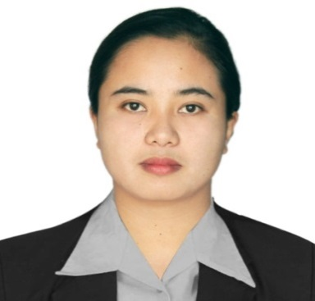
0977 398 3069
Poblacion General Natividad
Nueva Ecija, Philippines
lachicafrancisco117@gmail.com

LACHICA S. FRANCISCO

Summary___________________________________________________________________
Hard-working business-management graduate with 2 years of effective community organizing and facilititation experience overseeing abidance functions pertaining empowerment and management. Solid knowledge of business marketing and community organizing.

Employment Record__________________________________________________________
Municipal Community Empowerment Facilitator
February 3,2020-January 29,2021
DSWD KALAHI CIDSS NCDDP- General Mamerto Natividad Nueva Ecija

- Empower Community Volunteers to achieve improve access to services and to participate in more inclusive local planning,budgeting,implementation and disaster response operation .
- Assist Barangays and LGUs facilitate the participation of communities in project activities,strengtening transparency and social inclusiveness.
- Facilitate and organize meetings on Barangay Levels/Local Government Unit.
- Aggregate and consolidates community data and formulate project proposal.

ENUMERATOR,ENCODER/OFFICE STAFF(Government Internship Program)
August 02,2019 – December 27,2019
Department of Labor and Employment Field Office III

- Visit residents,completing survey sheets,obtaining pertinent data,interpreting interview questions,and explaining surveys form to people.
- Encoding and recordkeeping on gathered data of surveyed residents.
- Talk to others in an effective way to convey information.
- Cultivating relationships with all types of people while demonstrating independence thinking.

Education__________________________________________________________________
Bachelor of Science Major in Hotel and Restaurant Management-2019
Nueva Ecija University of Science and Technology
Skills______________________________________________________________________
- Good in communication | - Can work under pressure and meet deadlines with minimum supervision.
- Computer Literate | - Lady Driver
- Can adapt all environment changes in the organization. | - Community Organizing, Facilitation

Personal Data _________________________________________________________
Age: 26
Height: 5’1
Weight: 68 kg
Civil Status: Single
Religion: Roman Catholic
Permanent Address: Purok Narra 1, Poblacion General M. Natividad Nueva Ecija

Character References _________________________________________________________
Aladin L. Naje
Project Development Officer IV
DSWD Regional Office III
09276904423

Nicasio F. Ramos
OIC,MSWDO
Gen. Natividad Nueva Ecija
09173238793

Hon. Benigno d. Vendicacion
Barangay Captain
Brgy.Kabulihan Gen. Natividad Nueva Ecija
09361287843

