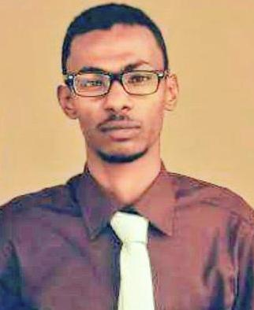
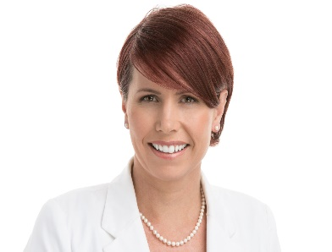
gmail@gmail.com

Telephone Number

Your Address here

123.456.7890

Your web address

ABOUT ME
Gender: Male
Marital status: single.
Nationality: Sudanese
DOB: 26-07-1991
University of science and technology
in Overall GPA: 3.11/4.00

B.Sc.Honrs in : Chemical Engineering.

Aboubaker Kamaladein Hassan

- Worked for ALITMAADFOR THE PROCESSING THE GOLD TAILING company, position the
Safety Engineer, since15/5/2016 to 26/5/ 2018.
Responsibility:
-Analyze data related to work accidents, occupational injuries and serious accidents, and draw up recommendations necessary to prevent accidents.
-participate with the administration planning training programs for technicians.

WORK EXPERINECE:

worked for Algunaid mining company ,position the safety engineer, department of HSE, since 5/6/ 2018 to 13/1/2020
OBJECTIVE
I am seeking a job opportunity to start my career in the HSE industry to practice my chemical engineering principles. To expand my engineering, knowledge with a focus on the occupational safety engineering, utilizing all my resources to engage in waste treatment and water treatment engineering industry and mining processing safety
Responsibility:
-Supervise HSE
-Provide feedback on analysis and evaluation of Risks.
- Develop technical specifications for equipment and devices and personal protection tasks and verify their effectiveness.

WORK EXPERINECE Mangeil for catering enterprise COMPANY

kamalabubaker435@gmail.com
https://www.linkedin.com/in/abubaker-hassan
kamalabubaker435@gmail.com Phone: +249907015789

Phone: +249907015789

. • Worked for mangel for catring company,position the office safety since 1/3/2015 to 2/4/2016.
Responsibility:
-identify risks in the environment.
-training workers to work safety in the work environment.

Technical SKILS:
Job TRAINGING :

-Practical training in mud engineering "AFRICAN DRILLING FLUIDS COMPANY"
-Practical training in Khartoum Refinery Company (KRC) in all existence units Oil refining units
-Training excel Advanced the center Vision Seven training.

EDUATION & Qualification:

    - Project Management Professional course(PMP) – Institute CEO (sudan)-2020/February

- ISO (9001:2015) 2018_ 7vision training& Development

- Excel advanced-2018 - 7vision training& Development

- HSE program OSHA in general industry2016 _ Charisma Development training.

- Bachelor of chemical Engineering 2011- 2016University of science and technology,Sudan.

INTEREST AND HOBBIES:

- Natural curious about how things work
- Chess
- Table games
- Football
- A team player achieved through participating in several group projects, extracurricular and team sports.
- Ability to inquire knowledge very fast utilizing all available resources "internet", books, and contact with high profile engineers.
- A good listener with excellent all-round communication skills.
- Excellent leadership skills that led to heading many projects and presentations.
- Conversant in using process flow sheeting software HYSYS.
- Proficient with MS Office, windows XP(seven) and MATLAB.

LANGUAGES:
- Languages: Arabic native , English (very good academic,
good speaker)

Reference:
Eng. Ahmed imead
Line manager
ALITMAD Mining company ltd.
Khartoum North-Sudan
Mobile: 00249904336855

