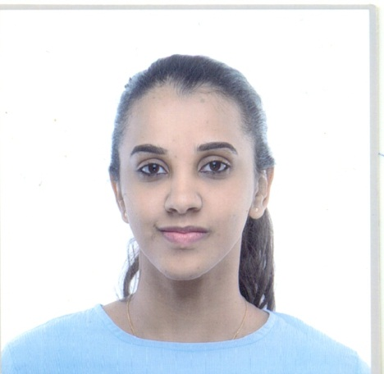

Objective

Seeking a position where my experience in marketing, banking and positive interaction skills, ability to work well with people can be effectively utilized for
.increasing profitability and make positive contribution to the company

Name Sarah Galal Abdelgader Hassaballa
Date of Birth 20 –October 1992
Place of Birth UAE-Abu Dubai Religion Muslim
Nationality Sudanese
Address Riyad
Driving license
Contacts sroor_92@hotmail.com

+971567317332
+971526501016

Education

University:
2010 - 2014 University of Garden City.
Bachelor degree of BusinessAdministration - Marketing.
Honors Degree.
2014 - 2016University of Garden City.
MBA(Master of BusinessAdministration).
CHRMP(Certified Human Resource Management Professional) Secondary School:
2006 - 2009 El-Maali Secondary School Khartoum

Work Experience

Aljazeera Sudanese Jordanian Bank
Human Resource Department
Human Resource officer April 2017 - up to date

- recruiting, training and developing staff
- making sure that staff get paid correctly and on time
- pensions and benefits administration
- approving job descriptions and advertisements
- looking after the health, safety and welfare of all employees
- organizing staff training sessions and activities
- monitoring staff performance and attendance
- advising line managers and other employees on employment law and the
  - employer's own employment policies and procedures
- ensuring candidates have the right to work at the organization
- negotiating salaries, contracts, working conditions or redundancy

Customer Service Department May 2016 – March 2017
El Amarat Branch
- Attracts potential customers by answering product and service questions;
- suggesting information about other products and services.
- Opens customer accounts by recording account information.
- Maintains customer records by updating account information, Resolves product
- or service problems by clarifying the customer's complaint; determining the
- cause of the problem; selecting and explaining the best solution to solve the
- problem; expediting correction or adjustment; following up to ensure resolution.
- Maintains financial accounts by processing customer adjustments and Recommends potential products or services to management by collecting customer information and analyzing customer needs.
- Prepares product or service reports by collecting and analyzing customer information.

Marina Company for Concerts and Conferences June2014 –April 2016
Marketing Coordinator
- Implements marketing and advertising campaigns by assembling and analyzing sales forecasts; preparing marketing and advertising strategies, plans, and objectives; planning and organizing promotional presentations; updating calendars.
- Tracks product line sales and costs by analyzing and entering sales, expense, and new business data.
- Prepares marketing reports by collecting, analyzing, and summarizing sales data.
- Keeps promotional materials ready by coordinating requirements with graphics department; inventorying stock; placing orders; verifying receipt.
- Supports sales staff by providing sales data, market trends, forecasts, account analyses, new product information; relaying customer services requests.
- Researches competitive products by identifying and evaluating product characteristics, market share, pricing, and advertising; maintaining research databases.
- Plans meetings and trade shows by identifying, assembling, and coordinating requirements; establishing contacts; developing schedules and assignments; coordinating mailing lists.
- Monitors budgets by comparing and analyzing actual results with plans and forecasts.
- Updates job knowledge by participating in educational opportunities; reading trade publications.
- Accomplishes organization goals by accepting ownership for accomplishing new and different requests; exploring opportunities to add value to job accomplishments.

Sudanese French Bank May 2014 – June 2014

Customer Service –Training

- Deal directly with customers either by telephone, electronically or face to face.
- Respond promptly to customer inquiries.
- Handle and resolve customer complaints.
- Obtain and evaluate all relevant information to handle product and service
- inquiries
- Provide pricing and delivery information.
- Perform customer verifications.
- Set up new customer accounts.
- Process orders, forms, applications and requests.

Systematic Electronic Computer Company March 2014 –April 2014

- Listening to customer requirements and presenting appropriate offers to make a sale deal.
- Maintaining and developing relationships with existing customers in person and via telephone calls and emails.
- Cold calling to arrange meetings with potential customers to prospect for new business.
- Responding to incoming emails and phone enquiries.

Skills & Languages

- Demonstrated skill in managing change and maintaining flexibility in a variety of challenging environments.
- Ability to work in diverse teams and to communicate well with others, good team player
- Ability to work under pressure to deliver a professional result in addition to task to task skills.
- Great communications and presentation skills

Computer Skills

- Experience in using the library and the internet to locate and retrieve valuable information & data for both academic and community service projects.
- MS Excel
- MS PowerPoint
- MSAccess
- MS Word

Language

- Arabic, mother tongue.
- English,Ability to write clear comprehensive and professional documents, fluent
reading and speaking.

Activity

- Reading
- Swimming

ReferencesAzzashakirSamasu group
Tel: (+2499)17596987)

Manal Kamal Osman
Compliance Manager
Tel: (+249122279136)

Ahmed Ali Yaasin
Senior of Networking and Telecommunication Engineer
Tel: (+249918012332)

