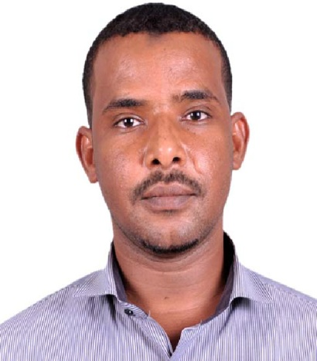 sOBHI AMEEN Ahmed HASSAN

+249918372200 - +249922520825
SKYPE ID: sobhigona @live.com

Sobhigona@live.com

Career Objective:
To pursue a career in a company where my inter-personal skills can be utilized
To achieve the objective of the organization & which provides me an opportunity of
Continuous learning.
Challenges:
• Works in a high pressure, high risk and high H2S environment.
• Compliance to process safety requirements.
• Ensures a high reliability and availability of production facilities and equipment.
Summary of Qualifications:
- Hands-on experience in the operation of oil and gas production.
- A good knowledge of E&P operations and procedures and practices.
- Knowledge on HSE and process safety requirements.
- Familiarity with Hazardous Materials Transportation Regulations.
- Ability to work with and around combustible and flammable gas and liquids.
- Excellent decision making skills and strong mechanical skills.
- Good written and verbal communication and computer skills.
- Immense ability to follow plant and company processes.
- Exceptional ability to operate and troubleshoot pipeline and compressor equipment.

Work Experience Highlights:

PETRO-ENERGY E&P SUDAN
Production Operator from 2015- up to Now
*Undertakes and ensures that the FPF is operating in a satisfactory and safe manner.
* Reports any maintenance needs and near misses.
*Supervises the regular recording, metering and checking of the control parameters for the FPF.
*Reviews any abnormal readings and takes corrective action, drafts requests to deal with unresolved problems.
*Following up on maintenance work until successful completion, final inspection and acceptance of the work.
*Undertakes other similar or related duties such as maintaining high level of housekeeping.
*Responsible for ensuring that the company Health, Safety and environment (HSE) policies and procedures are fully implemented and adhered to, so that loss prevention is maximized.
*Responsible for the regular recording, metering and checking of the FPF operational production parameters, such as various flows, levels, pressures and temperatures to ensure that there are within specified operation limits.
*Reviews any abnormal readings and takes corrective action, drafts requests to foreman to deal with unresolved problems.

PETRODAR OPERATING COMPANY SOUTH SUDAN
Field operator: from 2007 up to 2011
Monitored all pumping wells and ensure its proper functioning beside pigging & Flushing for wells.
- Ensured that all wells were producing at maximum rates.
- Identified and reported any safety problems to field supervisor.
- Carrying out normal start up and shut down.
- Log all relevant data relating to the production of Hydrocarbons - for entry into the Production Management System)
- Interface with service department staff to coordinate breakdown and routine maintenance work in facilities and plants to ensure minimum deferment of production.
- Signatory for Permit to Work activities within area of responsibility as licensed and advised by Supervisor.
- Give guidance to Assistant or Trainee Operators in the team in aiding towards their development.
- Take effective action to control emergencies and contain hazards within area of responsibility.
- Order spare parts and consumables to maintain an adequate supply for use in the area and keep record of same.
- Maintain a high level of safety awareness and standards in all daily duties and tasks and guide the subordinate staff and contractors on safe working practices.
- Proactively manage all HSE aspects of Production activity execution and compliance with directorate HSE plan
- Ensure HSE and PTW systems are followed before starting a job, ensure proper use of tools and PPE, conduct regular site visits, advice co-workers on potential hazards, check safety equipment, notify management of unsafe working conditions, report HSE incidents, actively participate in HSE meetings and tool box talks.
- Ensure that Critical Tasks related to Asset Integrity-Process Safety Management (Al-PSM), as defined in the Procedural Manual, are undertaken and executed.
- Greater Nile operator company
Production operator on job trainee:
  - 3 month classroom in intensive professional English language in H&H institute under PDOC.
  - 4Ohours in introduction to petroleum industry by BRIEF institute under PDOC
  - Basic safety program QUITE under PDOC.
  - 3 month technical oil field class room training in GNPOC training centre.
  - Field base on job training at greater Nile Petroleum Company including l2 courses in HSE, defensive driving course, and practice covered all oil process Operation such as rotating drives, oil separation process F&G, DCS and ESD system pigging, micro motion, multiphase, water injection system and metering.
- Tiger Oil Services (Drilling Company):
  - From 2004 until 2007.
- *Undertakes and ensure that rig floor is in a good condition and safe to do drilling work.
- *Prepare and check all tools which needs in the normal drilling job.
- *Undertakes normal drilling job (connecting joints, POOH and RIH).
- *Assist in the work over jobs (casing, cementing, well logging, well testing, etc).
- *Prepare chemical mud and check mud density if match with required density.
- *supervise shale shakers, sand shaker, mud tanks and pumps.

Education certificates:

M.Sc. in Chemical Engineering from University of Science and Technology (2019)
BSC in Chemical Engineering from University of El Imam El Mahdi (2014)
  - Three years diploma in Petroleum Engineering from Sudan University of science & technology (2003).
  - NEBOSH.
Training Courses:
- First Aid from KHARTOUM UNIVERSITY
- Process Safety Management
- PTW
- Enhanced Oil Recovery course (PTC,Sudan)
- Safety Training courses Sudan.
IT SKILLS:
SAP, Outlook, Microsoft applications

Personal data:
  - Gender : male
  - Language: English – Arabic (native).
  - Nationality: Sudanese.
  - Date of birth: 01/01/1981.
  - Marital status: Married.
  - Driving license: Sudan.

