C.V
8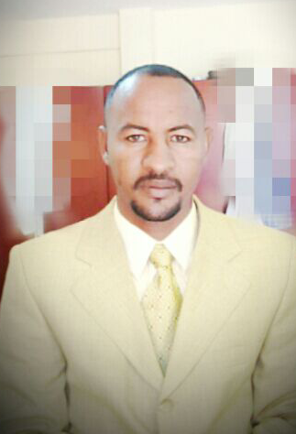
Name Suliman Abdelmajeed Suliman
Date of Birth 1983/1/1
Nationality Sudanese
Address :
Tel no: +249918237002
Email address :semokrc31@gmail.com
Skype :semokrc4
All experience. 13years
Experience in downstream 9years CCR&GDHT
Experience in downstream 4 years CDU

Qualifications & Certificates: -
3years Diploma in mechanic engineering Omdurman Islamic university
- Training course of basic & advance refinery operations (Training Center) held by Khartoum Refinery(2006)
- Courses in English language
- Training courses in Safety Plants & Fire Fighting System.
- Training courses in Safety osha
Responsibility & duties:
- Khartoum Refinery Company as field Operator-from 2006 to 2009 and panel operator from 2009 to 2015 inCCR & GDHT units
CDU from September 2015 up to now as field Operator.
- Responsible for the safety and operation of the assigned unit(s
- Coordinates with shift supervisor for keeping plant normal running
- Checking and stroking instruments devices from control panel with instrument crew
- To be sure it’s working properly
preparing the unit daily, weekly, monthly and yearly technical and Process reports.
Contributing implementing unit start up, shut down, test run and overhaul .
- Experience in all Duties during Major shutdown and startup of the plan
operating and shutdown Procedures of (centrifugal, reciprocating and steam turbine compressors) also have the necessary capability to analyze and troubleshoot pumps problem
Well versed with all type of heat exchangers used in refinery.
Procedure of Furnaces, Compressors - pumps - heat exchangers - boilers and all equipments in your refinerys.

