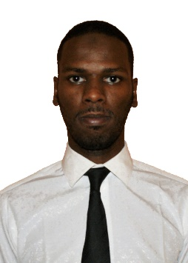
Tarig Hyder Babo Nimir
+249908885929
thbn@live.com
Sudan, Omdurman, Wadnubaui

Objectives
Seeking a challenging and rewarding position at a major Oil Company where I aspire to get the sufficient knowledge that will help me with my career. And looking forward to deal with the challenging tasks to enhance my practical abilities.

Education

China University of Petroleum (Beijing)
July 2015| Bachelor of Petroleum engineering
- One-year course of Chinese language, Sep 2010 to Jul 2011 at Beijing, China.
- Certificate of IELTS with a band score of 7.5.

Experience
- Trainee December 2015 – December 2016
At Ministry of Petroleum & Gas | Khartoum, Sudan
- Freelance Translator 2016 –2017
Chinese to Arabic and vice versa.
- FPF operator December 2017– to date
At Petro-Energy E&P Co., LTD. | Sudan Branch

Languages
- Arabic (mother tongue)
- English (Speaking, Reading and Writing)
- Chinese (Speaking, Reading and Writing)

Skills
- Translating
- High Computer Skills

Personal Characteristics
- Quick learner
- Self-motivated
- Capable to coordinating, managing, motivate and leading
- Active member and team worker

