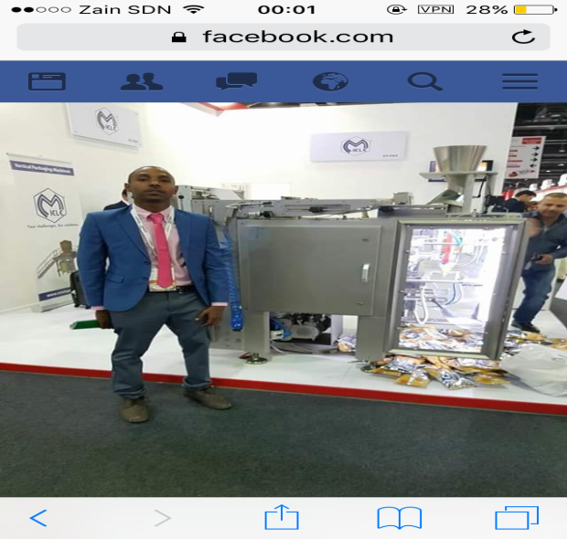

ElshiekhMustafa Elhag
Curriculum vitae
Address: 16N, air port Street, Khartoum 1 near Canadian embassy
Telephone Number: 00249902205600 / 00249183466661
Email Id: shikooo9999@gmail.com
Career Objective
To perform duties as an professional Auditor, Financial Analyst and chief Accountant and utilize my knowledge in Accounting and finance in order to help the firm to Maximize their Market Share ,shareholder wealth and organization Value. Also inspecting and authenticating the organization's documents as true and legal.
Key Skills
- Extensive knowledge in Financial Accounting, Management Accounting and Financial Reporting.
- Extensive knowledge in the fields of Auditing and finance.
- Accuracy.
- Initiative thinking and self starting.
- Dedication and work under pressure.
- Ability to work in any type of teams.
- Proficient at application of GAAP, IFRS principles and IAS to accounts.
- Superior data interpretation and data formatting skills.
- Ability to study data, draw conclusions and prepare financial reports.
- Strong observational, analytical and error detection skills.
- Strong skills for financial Reporting.
- Leadership, managerial and professional’s skills.
- Deep understanding of CFU audit policies and procedures.

Educational Qualifications
- Master degree in (Finance specialization) from University of medical sciences and technologies.

- Bachelor's Degree in Business & administration Accountancy specialization from University of medical sciences and technologies.
- Expected to be fully CFC member in November 2019 (certified Financial Consultancy) online certification from California FINRA.
- ACCA seeker and already completed one subject rather than 5 subjects exceptions in the ACCA courses.

Work Experience
- External Auditor
worked as an Auditor at Mubarak for accounting, auditing and financial consultancy (correspondents to earnest & young) from the period of October 2013 - till 30 /4/2014.
- Completed young Talents professional program in CTC GROUP from May 2014 until April 2015.(Selected from more than Two hundred Applicant) .
- Account Receivables Analyst at Moawia Elberier Group, industrial complex from june 2015 untill july 2016.
- AR, AP and then Chief Accountant Rotto Garvin Factory (Moawia Elberier Group, industrial complex) starting from July 2016 until March 2018.
- Chief Accountant at Cartobest Factory (Moawia Elberier Group, industrial complex) starting from March 2018 Till 14/4/2018.
- Chief Accountant at Stationary Factory (Moawia Elberier Group, industrial complex) starting from 15/4/2018 Till To 01/8/2018.
- Senior Treasury Analyst at CTC group corporate finance department from 1/10/2018 until now.
- Year of graduation:
_ 2013

Responsibilities:
1- Auditing at Mubarak for accounting, auditing and financial consultancy

Primary Responsibilities:
- Audit Financial, Information’s, Accounts and policies.
- Verify the accuracy And legality within the documents and approve them with a signature
- Make sure that Financial Statements are represented fairly and with high degree of Relevance.
- Review the financial documents to judge the liquidity, solvency and credibility of the organization besides to ratio Analysis & interpretations.
- Draft audit report to point out the discrepancies within the data and make suitable suggestions to correct them.

Secondary Responsibilities
- Request the organization heads and collect the requisite documents for performing the audit
- Compare and inspect the departmental accounts, supporting documents against ledger accounts.
- Draft account reconciliation report, audit report and assets revaluation reports as required.
- Prepare the audit program by defining time limits and allotting responsibilities to team members.
2-CTC Talent program Details:
Completed the requisite internship with CTC GROUP The internship gave me an opportunity to become proficient with the finance activities, accounting principles and develop my analytical skills that help read and understand the financial data.
The Talent program four rotations:
- Finance department (Account payable, Account receivable, Cash and Bank at Degitch Company.
- Marketing department.
- Corporate finance and treasury control in additional to budget construction at CTC GROUP.
- Sales department (corporate Sales).
- HR department.

3-Responsibilities at Moawia Elberier Group: (Chief Accountant)
- Control All Kinds of Revenues & expenses on the ERP System.
- Estimate future cash balances.
- Responsible of the bookkeeping system
- Chief of budgeting committee.
- Preparation of sales and collection reports on a monthly basis.
- Responsible of Sales forecasting for the budgeting purpose.
- Sales analyst (market estimates for seasonality, dispatched Goods, free financed Customers, Stock movements, PSI,….etc).
- Preparing of Financial Statements, (Profit & Loss Statements, Statement of Financial Position, Cash Flow Statement).
- Responsible of Fixed Assets & Deprecation.
- Monthly Preparation of Tax enquires.
4- Treasury Analyst at CTC group (corporate finance department:

- Analyze & report financial Activities for more than 8 Subsidiaries companies.
- Determine the most appropriate conduct of finance for each subsidiary firm.
- Control financial position for CTC group.
- Conduct discounted cash flows methods (NPV, IRR…) to Access investment decisions.
- Analyze investment alternatives.
- Track Cash inflows & Outflows.
- Prepare & validate financial statements for CAD on a monthly basis. Prepare interpretations & Ratios for top management.
- Manage working capital for CAD SBU in coordination with BU finance teams.
- Assist in Budgeting process & preparation of BU / corporate division budgets for approval.
- Prepare Daily report for CTC group credit cover with bank dues.

Achievements

- Promoted to chief Accountant Role within a period of 4 months in the manufacturing complex of Moawia Elberier.

- Represented Moawia Elberier Group at Gulf Food Manufacturing Exhibition in Dubai November 2016.

- Played an influential Role to build a budgetary control and evaluation system for the first time at the carton factory by fulfilling the Role of head operational officer of the budget committee at Moawia Elberier Group and achieved all of the predetermined goals of the committee by working closely with the general manger (head of the committee) and with the different departments mangers such as (sales, production, supply chain and HR).

Computer skills:
- M.S Windows:
- M.S Word: ( full knowledge )
- M.S Excel: ( Expert ,completed an advanced course of Microsoft excel )
- M.S Power Point : ( full knowledge)
- Adobe
- Word press certified developer.

Technical Skills
- Highly efficient in using different types of ERP systems accounting software of Peachtree and QuickBooks for formatting the accounting data.
- Full knowledge of journal entries, double entry book keeping, Bank Reconciliation. And knowledge of IAS, conceptual framework, financial reporting and interpretations of financial statements.
- Practical experience in Sales forecasts and Sales analysis, Besides to administrative skills.
Personal Details
Name: Elshiek Mustafa Elhag
Sex: male
Marital Status: Single
Date of Birth: 7th august 1991
Nationality: Sudanese
Tel: 00249902205600 / 00249912145282
E-mail: shikooo9999@gmail.com
References:
Mr/ Moawia Elberier
Chair Man of Moawia Elberier Group, international Investor and president of the Sudanese industrial Rooms.
Mr. / Hassan Abd Almoniem , General Manger of Moawia Elberier Industrial complex of printing and Packaging (Rot to Garvin ,Carton and Stationeries )00249912324275
Mr. / Hassan Ali
Sales Manger of Moawia Elberier Industrial complex of printing and Packaging (Rot to Garvin, Carton and Stationeries) 00249123411812

Mr. / Osama Suleiman
HR director for CTC Group

Mr. / Ahmed Osman
CTC Group financial director , ACCA, CVA, MBA

Mr. / Hassan Noraldaiem
CTC Group Treasury manager

Mr. / Ahmed Hamza ACCA holder and Senior Auditor at Mubarak for accounting, auditing and financial consultancy.

Mr./ Mohamed Alfaki Mustafa
Supply chain Manager at Digitech (CTC Group)
Mr. / abbes magzoub
CTC Group financial controller and head of budget construction committee CVA, CMA.

Mr. / Mubarak CPA holder
General Manger of Mubarak for accounting, auditing and financial consultancy (correspondents to earnest & young.

