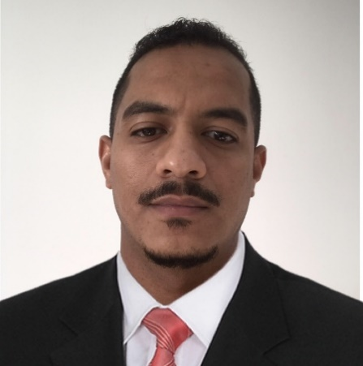

* **NEBOSH - 2022**
* **PTW Permits To Work System (Dec 2019)**
* **Task Risk Assessment (Dec 2019)**
* **Confined Space Awareness (Dec 2019)**
* **H2S Training level 2 (Mar 2021)**
* **Defense drive license Course Certificate (2014)**
* **Production Optimization Analysis System Certificate (2013)**
* **Gas Lift Tools and Water Flood Equipment Certificate (Jul 2012)**
* **Petroleum Engineering Training Certificate (Aug 2009-Aug 2010)**
* **PMI-PMP, Training course (On Going) Nov 2018**

Plant Operator with more than 11 years of experience in Oil & Gas Company (Petro energy E&P) supporting production processes. Ability to work independently with an interest in learning and developing. Technically natured provides accurate results for the company.

**EXPERIENCE**

**PROFILE**

**Field Processing Operator - Dec.2010 – Jan.2019**

**Petro energy E&P, Khartoum, Sudan**

**DCS Operator**

Is responsible for performing all tasks assigned in a safe and responsible manner in accordance with the established operating procedures and written and oral instructions from the Shift Supervisor and sending daily production report and dealing with emergencies shutdowns also Operate DCS control console to coordinate and regulate process variables and to direct flow rates of various process and utility streams according to prescribed schedules · Read processing schedules, operating logs, test results of samples, and laboratory recommendations to determine changes in equipment controls required to produce specified quantity and quality of product. · Set controls to adjust process variables, such as flows, temperatures and pressures. Responsible for recording, compiling, reporting and documenting operating data, and monitoring process indicators. · Coordinate the start-up, shut-down (normal & emergency) and normal operations with lead operator and field operators. · Perform basic calculations for determining process parameters and material balances. · Responsible for preparation such as plant isolation etc., for day-to-day maintenance work. Work directly with the foreign experts in the transfer of technical advice during the initial period of operation.

* **SUDAN UNIVERSITY OF SCIENCE AND TECHNOLOGY - Khartoum, Sudan**

**Diploma of Petroleum Engineering**

**GJHJH**

* **MASHREQ UNIVERSITY - Khartoum, Sudan**

**Bachelor of Mechatronics Engineering**

**CERTIFICATES**

**EDUCATION**

CURICULUM VITAE

**OSAMA MOAWAD**

**EXPERIENCE**

**SKILLS**

**Plant Process Operator**

Oversee and manage the full production process of a manufacturing plant or other industrial facility. They monitor equipment to ensure the quality, efficiency and safety of the plant, work as part of a team and provide leadership.

* Team Work Skills.
* Work under pressure.
* Problem Solving Skills
* Microsoft Office Suite.
* Changeover communications.
* Health and safety reporting.
* Drive and Enthusiasm.
* Good health and Fitness.
* Microsoft Office (word, Excel, PowerPoint, Outlook), AutoCAD.
* Communication Skills
* Daily Progress/ Work Completion Reporting
* Technical leadership Skills
* HSE Policies & Compliance
* Troubleshooting
* Inspection/ Supervising
* Well Operations Monitoring
* Cross Functional Coordination
* Decision Making

**Pigging Operator**

-Send & receive all types of Pigs to clean different types of flow line pipes from sand, wax and solids.

-Carry out periodic oil and water line pigging in addition to Intelligent Pigging.

-Clean all sand traps by schedule.

-Flow line flushing by unit trucks as required.

**Safety Officer - Jan.2019 – Sep.2021**

**Fantasia trading Co, Khartoum, SUDAN**

**HSE / Safety Officer**

## -Implement HSE Policy and Plans with particular reference to projects / activities concerned.

## -Participate in meetings with Project Manager, Construction team and Site HSE Advisors.

## -Prepare Activity Risk Assessment.

## -Reporting Incidents and Near Miss.

## -Monitor safety aspects at Project sites during periodic visits.

## -Discuss with Project Manager and interact on the improvements on HSE matters and related programs concerning projects and to make decisions accordingly.

## -Develops HSE-training programs appropriate to the project.

## -Submitting Monthly HSE Reports.

## -Participate in Emergency mock drills and Medical evacuation.

**CONTACT**

Osamahmoawad487@gmail.com

🖂

+971547675898

✆

Osamahmoawad487@gmail.com

Microsoft Teams



UAE – Abu Dhabi