Yassmein bahig Mohammed Ahmed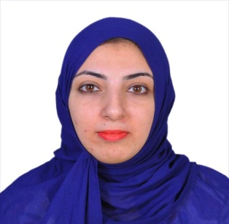
+249909000561
Ybahig99@gmail.com
Personal Information's:
Name : Yassmein Bahig Mohammed Ahmed
Date of birth : 18/12/1984
Place of birth : Saudi Arabia
Gender : Female
Marital status : Married
Nationality : Sudanese
Address : Khartoum- Sudan
Khartoum (2) street (49) home (38) near Khartoum 2 pharmacy.
Mobile +249909000561
Email:ybahig99@gmail.com
Education:
1995-1998
Primary school: Union Girls school.
1999 -2001
Secondary school: Al- Manar Secondary Girls for high school.
2002-2007
Jordanian Sudanese College of Science and Technology.
b.sc information technology administration .
2007-2007
Basic passenger fares & ticketing
2007-2007
Amadeus basic reservation course
2012-2013
Sudan Academy for Administrative Sciences.
Business administration
Language
Mother Language: Arabic
English : Good (Spoken & Written)
Computer skills:
Microsoft office (word, Power Point & Excel ).
Operation system (Instillation and administration)
Internet using (General and searching and E-learning)
Dealing with office machines , printer , scanners , Faxes and telephone .
Experience:
- Secretarial Sales Manager of Saudi Airlines ( august 2007)
- Sales Officer, Arkan Travel & Tourism Agency (February 2008 )
- Customer service in Saudi airlines ( may 2008)
- A consular officer in the embassy of the united Arab emirates ( august 2008 – April 2016 ) .
Personal talent:
Very good communication presentation and instruction skills -
-Ability to work under pressure
-ability to work in team
Controlling a team and assigning their task, ability to learn new task quickly -
Ready to travel indoors and outdoors and to relocate in different sites-
Ready to work in multinational companies.-

